S2 Protocol. Directed acyclic graph with code (below) displaying the selection of covariates for the analysis of association of body mass index combined with adherence to a Mediterranean-like diet with mortality

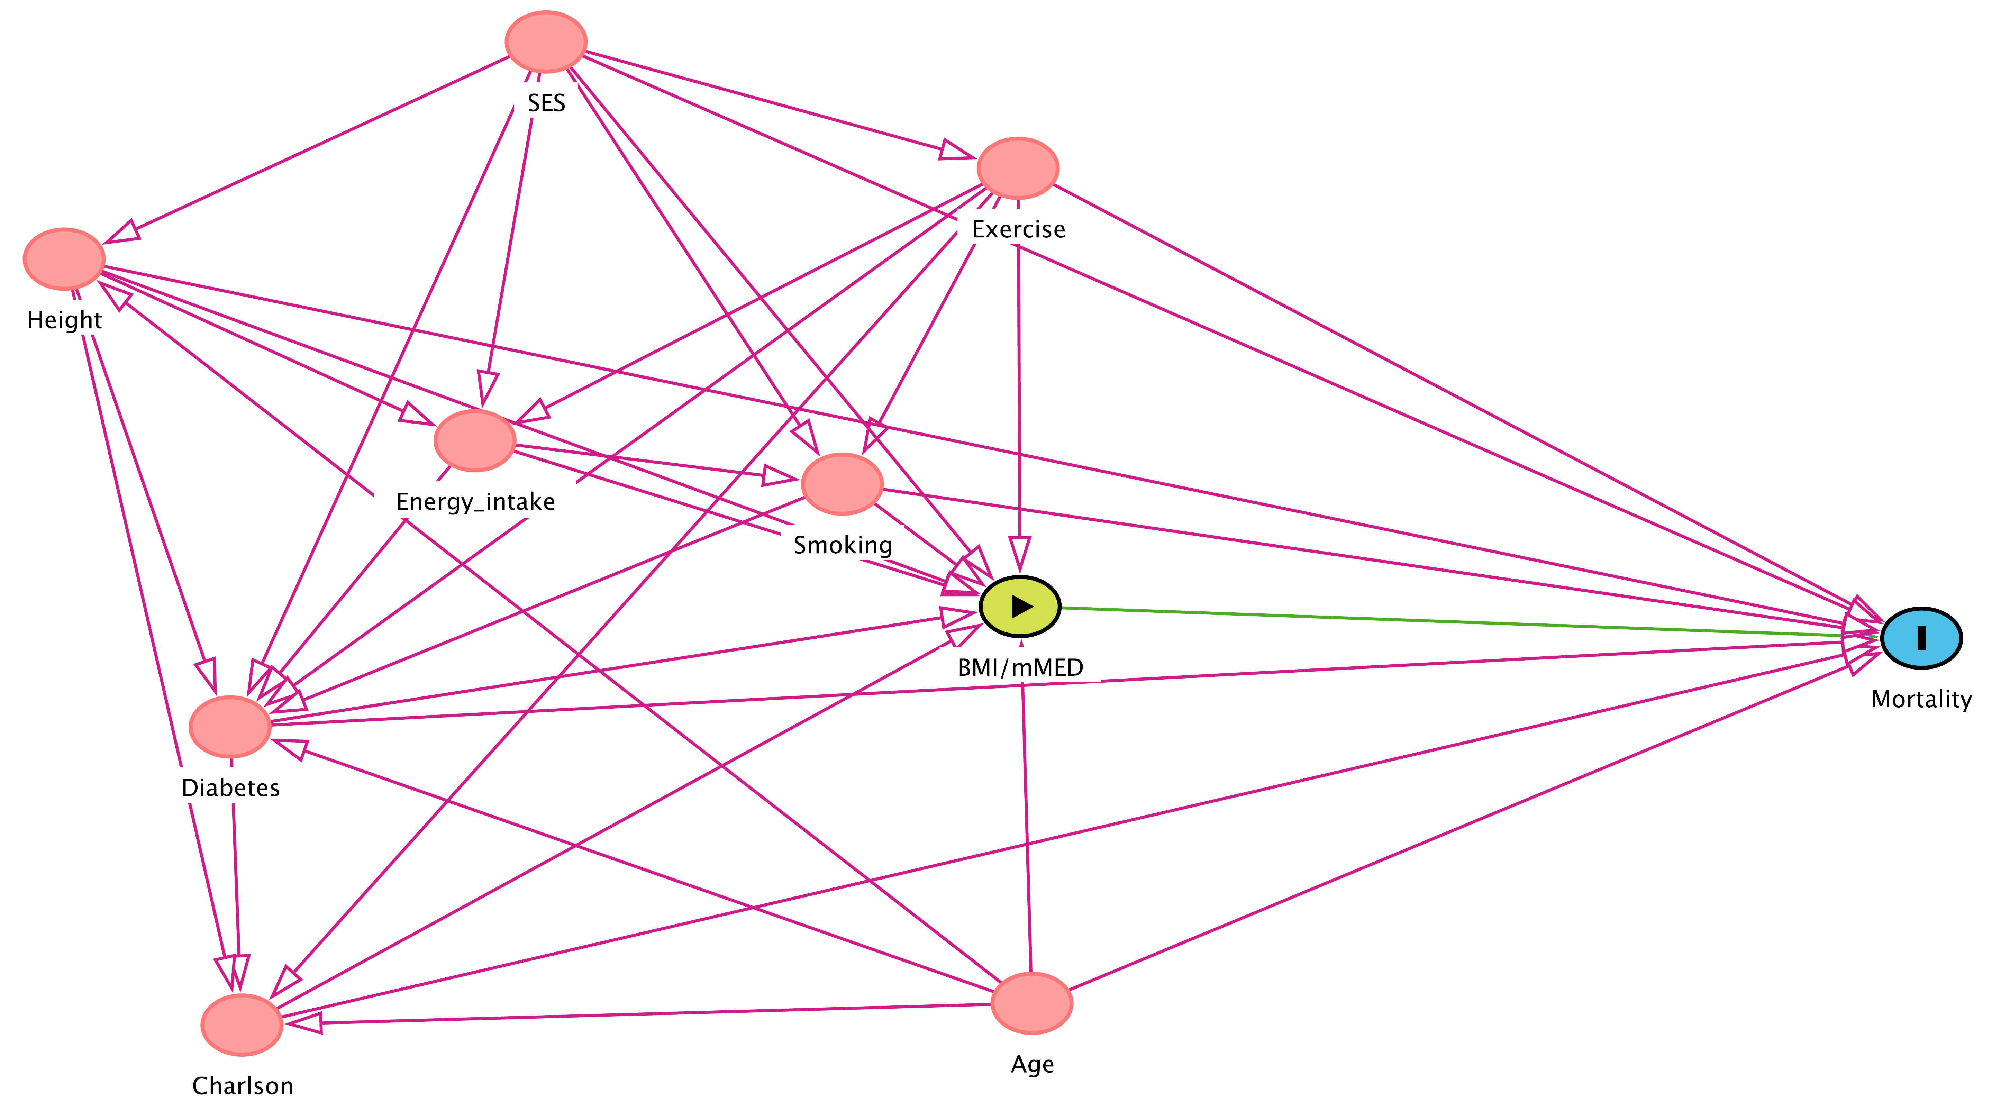
dag {
"BMI/mMED" [exposure,pos="0.461,0.445"]
Age [pos="0.467,0.817"]
Charlson [pos="0.110,0.838"]
Diabetes [pos="0.104,0.558"]
Energy_intake [pos="0.215,0.290"]
Exercise [pos="0.461,0.034"]
Height [pos="0.029,0.119"]
Mortality [outcome,pos="0.869,0.475"]
SES [pos="0.247,-0.084"]
Smoking [pos="0.381,0.331"]
"BMI/mMED" -> Mortality
Age -> "BMI/mMED"
Age -> Charlson
Age -> Diabetes
Age -> Height
Age -> Mortality
Charlson -> "BMI/mMED"
Charlson -> Mortality
Diabetes -> "BMI/mMED"
Diabetes -> Charlson
Diabetes -> Mortality
Energy_intake -> "BMI/mMED"
Energy_intake -> Diabetes
Energy_intake -> Smoking
Exercise -> "BMI/mMED"
Exercise -> Charlson
Exercise -> Diabetes
Exercise -> Energy_intake
Exercise -> Mortality
Exercise -> Smoking
Height -> "BMI/mMED"
Height -> Charlson
Height -> Diabetes
Height -> Energy_intake
Height -> Mortality
SES -> "BMI/mMED"
SES -> Diabetes
SES -> Energy_intake
SES -> Exercise
SES -> Height
SES -> Mortality
SES -> Smoking
Smoking -> "BMI/mMED"
Smoking -> Diabetes
Smoking -> Mortality
}

