S5 Fig

S5A Fig
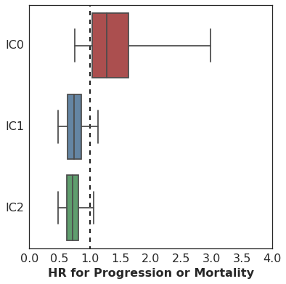
Hazard associated with log(missense SNV count per megabase) by level of immune cell (IC0, IC1 or IC2) PD-L1 expression.

S5B Fig
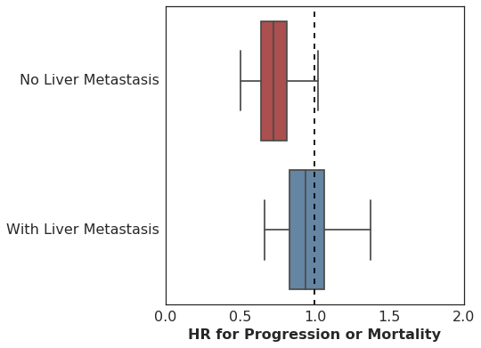
Hazard associated with log(missense SNV count per megabase) by presence or absence of liver metastasis at enrollment.

S5C Fig
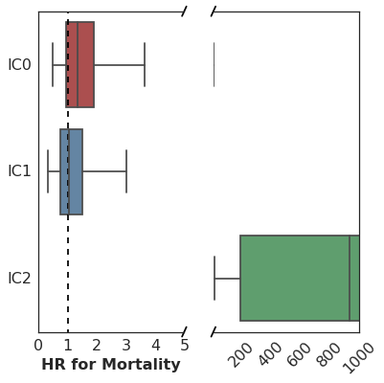
Association of peripheral TCR clonality prior to treatment with time to mortality (OS) varies according to immune cell (IC0, IC1 or IC2) PD-L1 expression.

S5D Fig
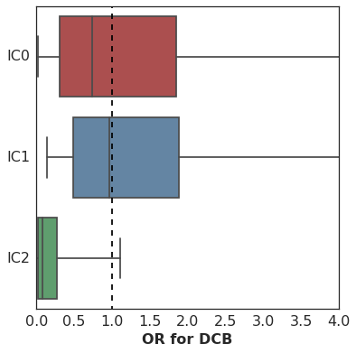
Association of peripheral TCR clonality prior to treatment with DCB varies according to immune cell (IC0, IC1 or IC2) PD-L1 expression.

S5E Fig
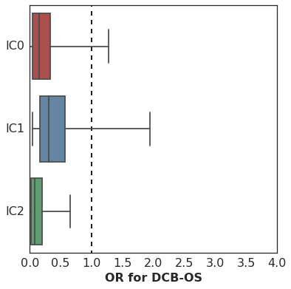
Association of peripheral TCR clonality prior to treatment with DCB (OS) varies according to immune cell (IC0, IC1 or IC2) PD-L1 expression.

S5F Fig
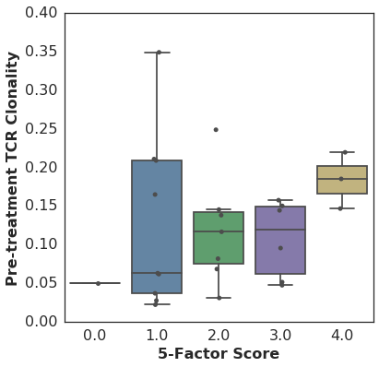
There was no significant relationship between 5-Factor score and pre-treatment TCR clonality (n=26, Spearman rho=0.25 p=0.22).

S5G Fig
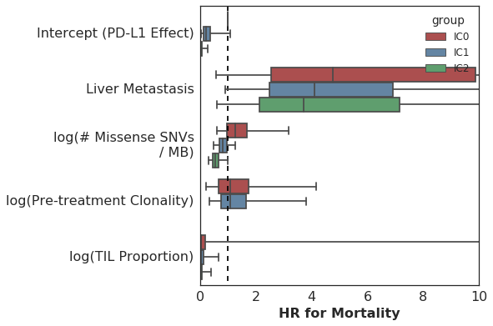
Multivariate survival analysis of various clinical, peripheral and intratumoral biomarkers for association with time to mortality (OS), utilizing a varying-coefficient model which allows the hazard associated with a one-unit increase in a biomarker’s value to vary according to level of intratumoral PD-L1 expression (IC score). Note that the x-axis has been truncated at a value of 10 for clarity even though this results in the exclusion of some estimated HR values (specifically that for pre-treatment peripheral TCR clonality among IC2 patients).

