S1 Fig. Hazard ratios with 95% confidence intervals for ischemic stroke, heart failure, and all-cause death according to the change of exercise status calculated from the various multivariable-adjusted Cox proportional hazard models.
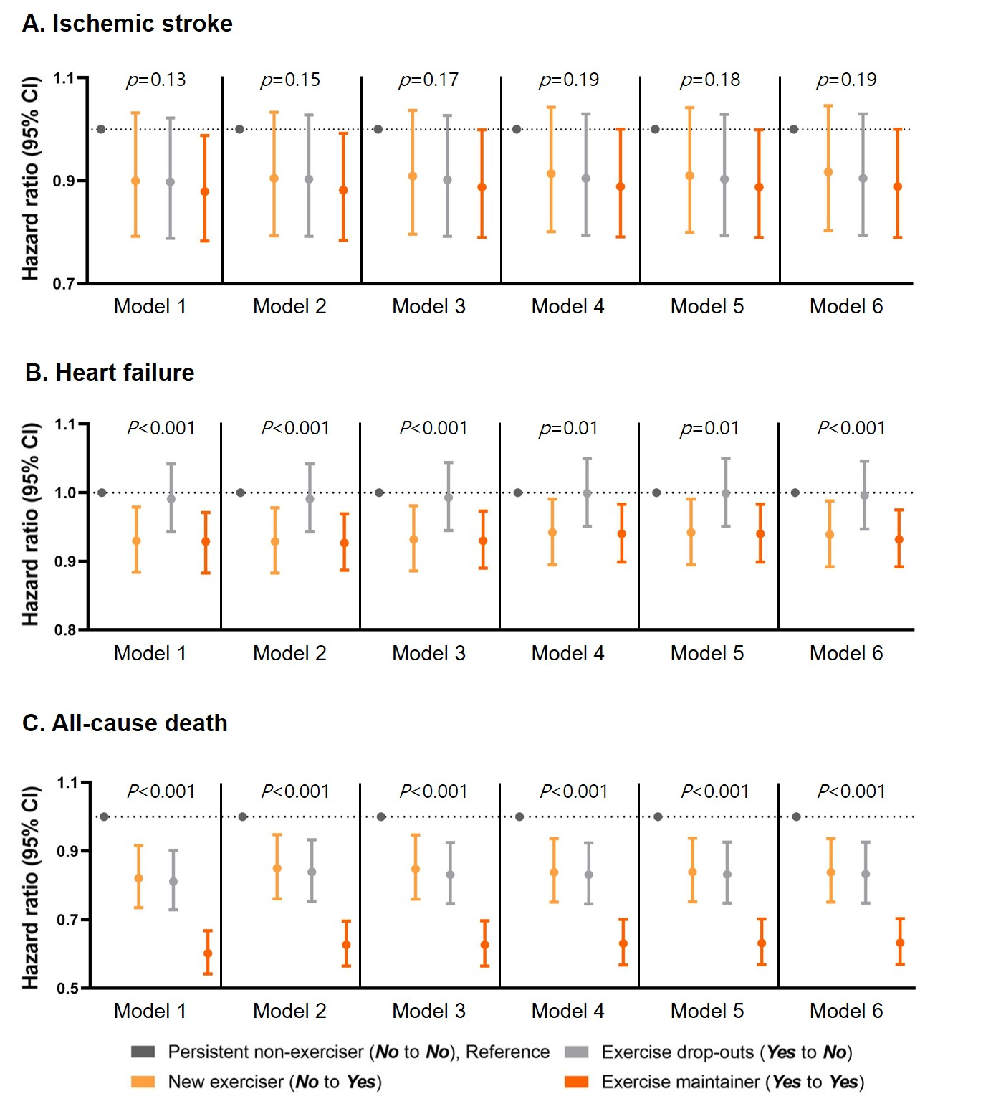

Abbreviation: CI, confidence interval.
Model 1 adjusted for age and sex.
Model 2 adjusted body mass index (BMI), smoking, heavy drinking, and low income in addition to Model 1.
Model 3 adjusted diabetes mellitus, hypertension, dyslipidemia, and previous myocardial infarction (MI) in addition to Model 2.
Model 4 adjusted peripheral artery disease (PAD), chronic obstructive pulmonary disease (COPD), cancer, and chronic kidney disease (CKD) in addition to Model 3.
Model 5 adjusted CHA₂DS₂-VASc score in addition to Model 4.
Model 6 adjusted the use of oral anticoagulation (OAC), use of antiplatelet agents in addition to Model 5.
P values were evaluated by the likelihood ratio test. The dots denote hazard ratios, and the whiskers denote 95% confidence intervals computed by multivariable Cox proportional hazards models.

