S5 Fig

Internet search of “bebida” and related terms
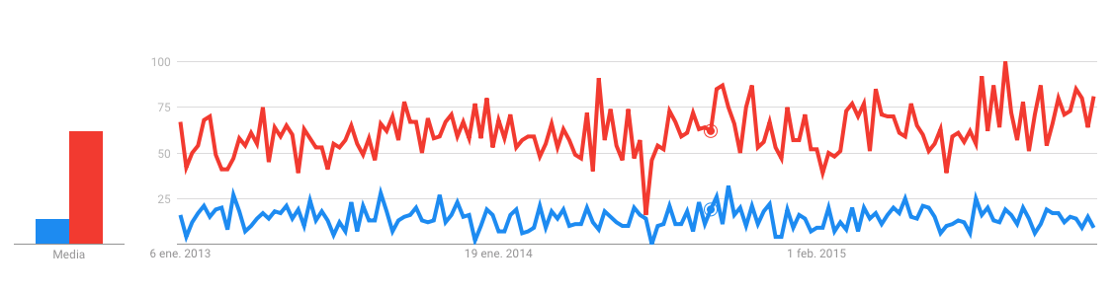

Source: https://trends.google.es/trends/explore?date=2013-01-01%202015-12-31&geo=CL&q=%2Fm%2F06qrr,bebida

