Supplementary figure 4. Model of vaccine efficacy against all episodes of clinical malaria (primary case definition) over time (per-protocol population)
A. Children 5-17 months of age at enrollment | B. Infants 6-12 weeks of age at enrollment
Overall - model=group*(stop**(0.5)) | Overall - model=group*(stop**(0.5))
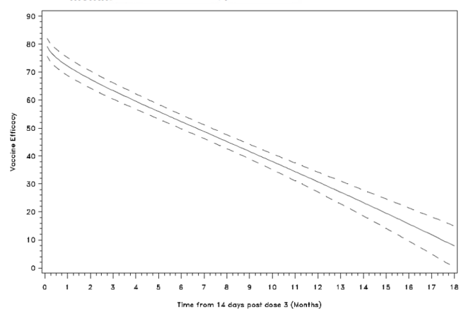 | 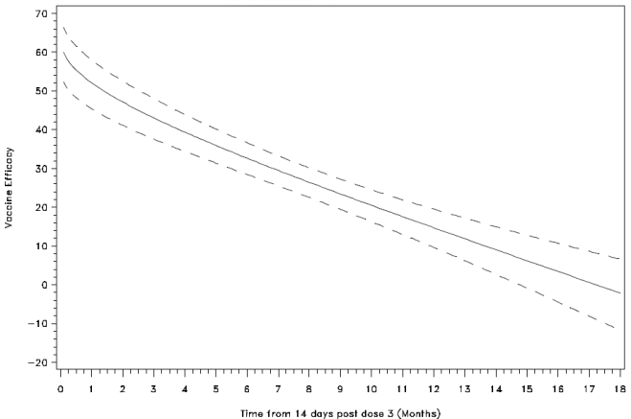
Kilifi - model=No time-varying covariates | Kilifi - model=No time-varying covariates
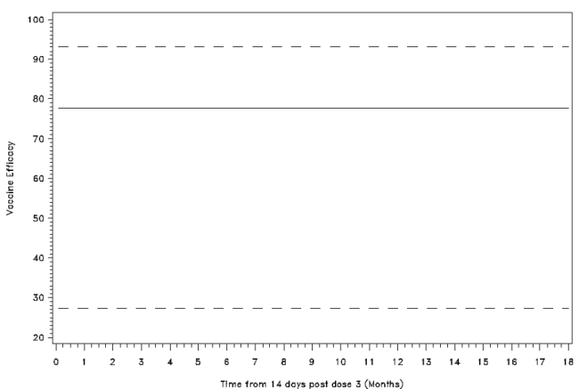 | 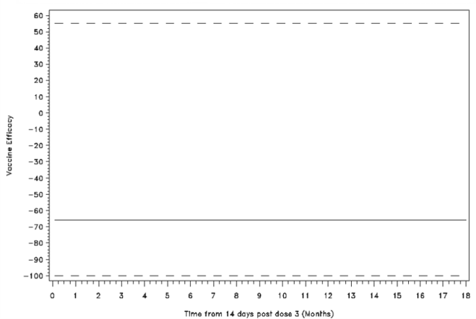
Korogwe - model=No time-varying covariates | Korogwe - model=No time-varying covariates
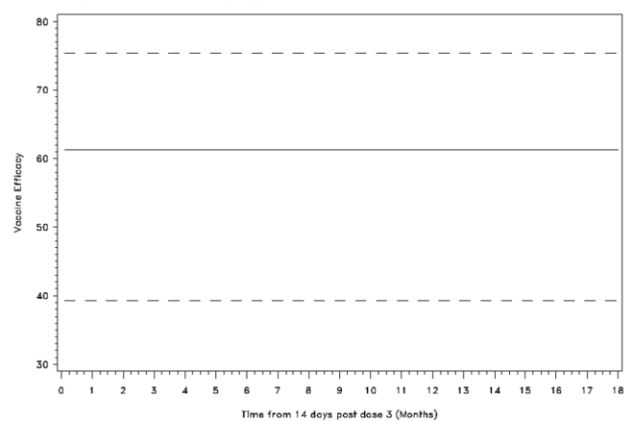 | 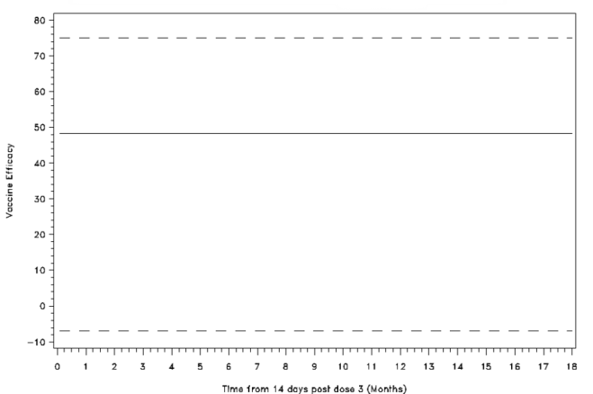
Figure continues on next page
A. Children 5-17 months of age at enrollment |  |  | B. Infants 6-12 weeks of age at enrollment
 |  |  | Manhiça - model=No time-varying covariates
 |  |  | 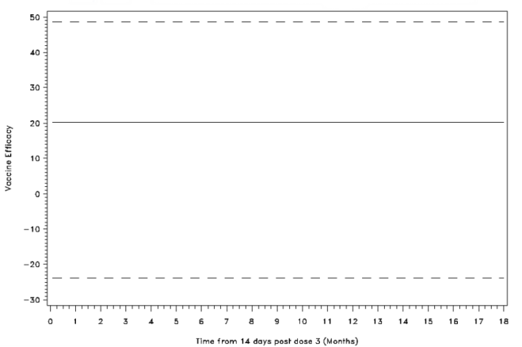
Lambarene - model=group*(stop**(-1)) |  |  | Lambarene - model=group*(stop**(-2))
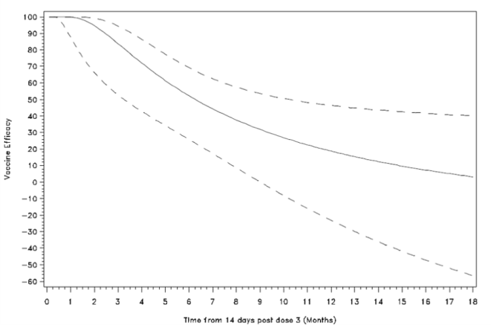 |  |  | 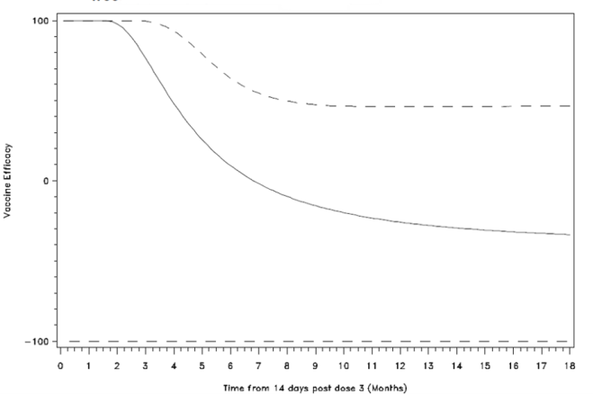
Bagamoyo - model=group*(stop) |  |  | Bagamoyo - model=No time-varying covariates
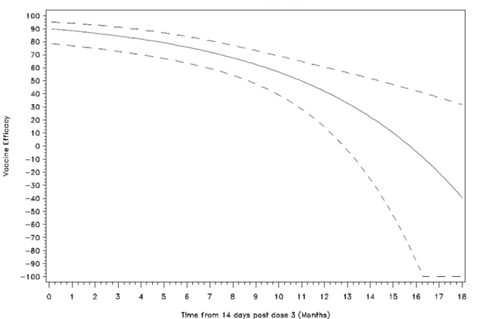 |  |  | 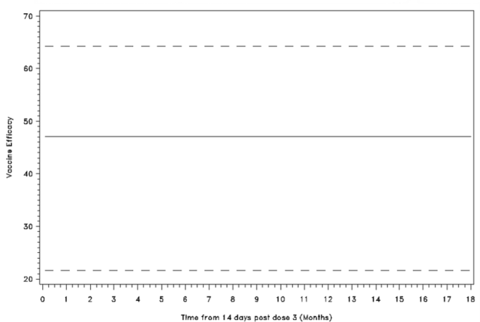
Lilongwe - model=No time-varying covariates |  |  | Lilongwe - model=group*(stop**(0.5))
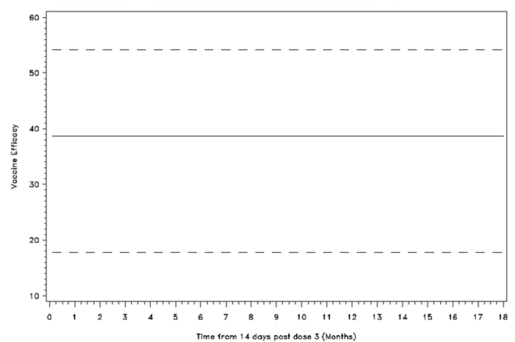 |  |  | 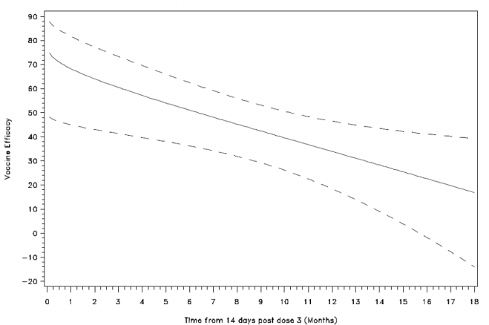
Figure continues on next page
 |  | A. Children 5-17 months of age at enrollment |  |  | B. Infants 6-12 weeks of age at enrollment
 |  | Agogo - model=group*(stop**(0.5)) |  |  | Agogo - model=group*(stop**(0.5))
 |  | 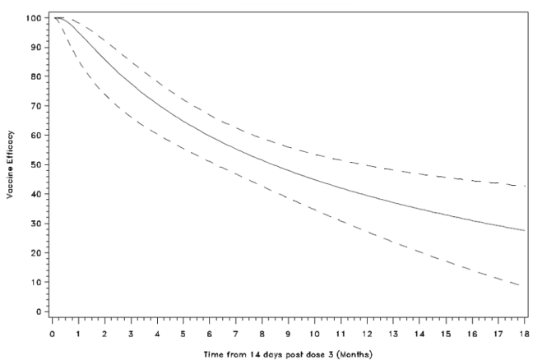 |  |  | 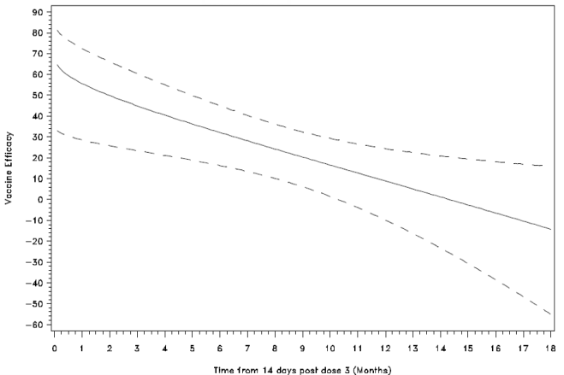
 |  | Kombewa - model=group*(stop**(0.5)) |  |  | Kombewa - model=group*(stop)
 |  | 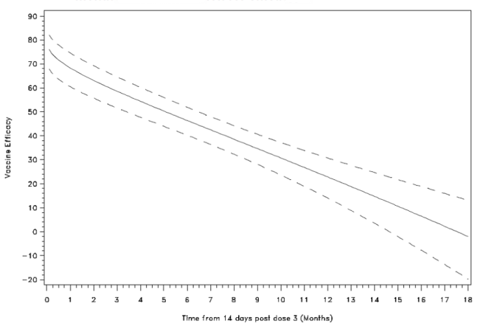 |  |  | 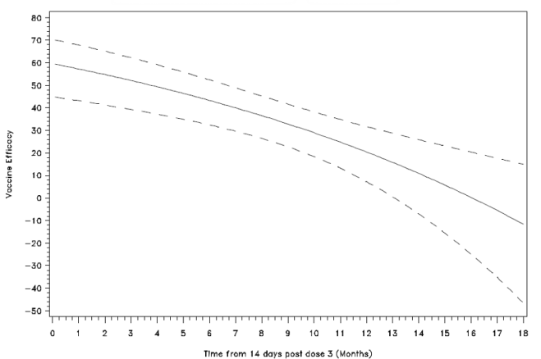
 |  | Kintampo - model=group*(log(stop)) |  |  | Kintampo - model=No time-varying covariates
 |  | 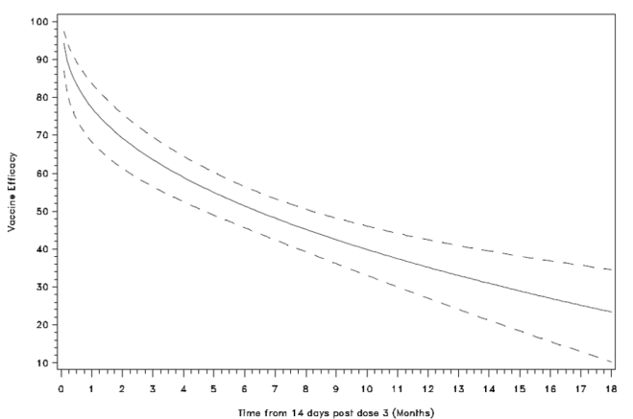 |  |  | 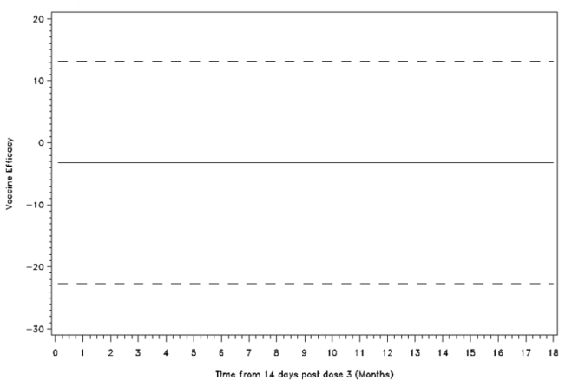
 |  | Nanoro - model=group*(log(stop)) |  |  | Nanoro - model=group*(stop**(0.5))
 |  | 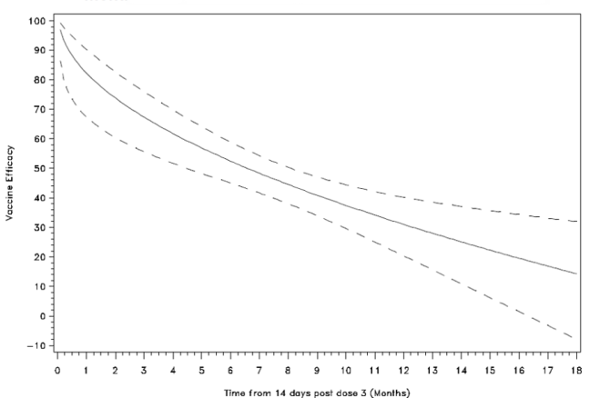 |  |  | 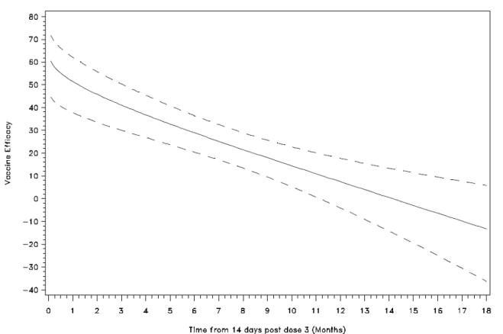
 |  | Figure continues on next page
 | A. Children 5-17 months of age at enrollment |  |  | B. Infants 6-12 weeks of age at enrollment
 | Siaya - model=group*(stop**(0.5)) |  |  | Siaya - model=group*(log(stop))
 | 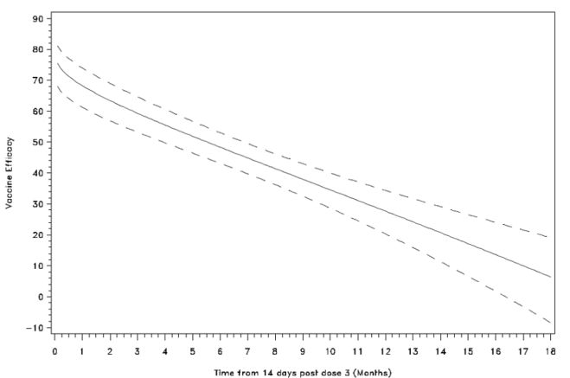 |  |  | 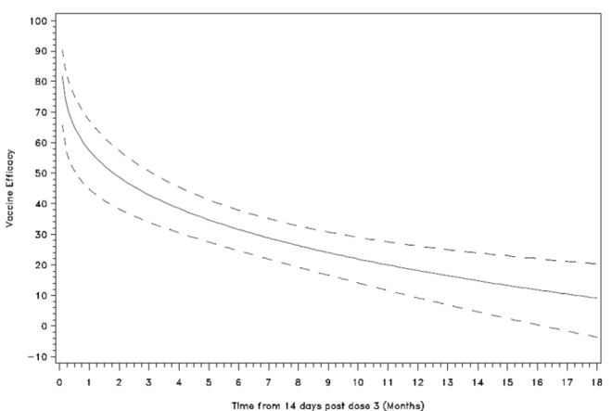
Note that analyses to detect differences from constant efficacy are dependent on the number of malaria episodes. As a (mathematical) result, low transmission sites are less likely to show waning efficacy.

