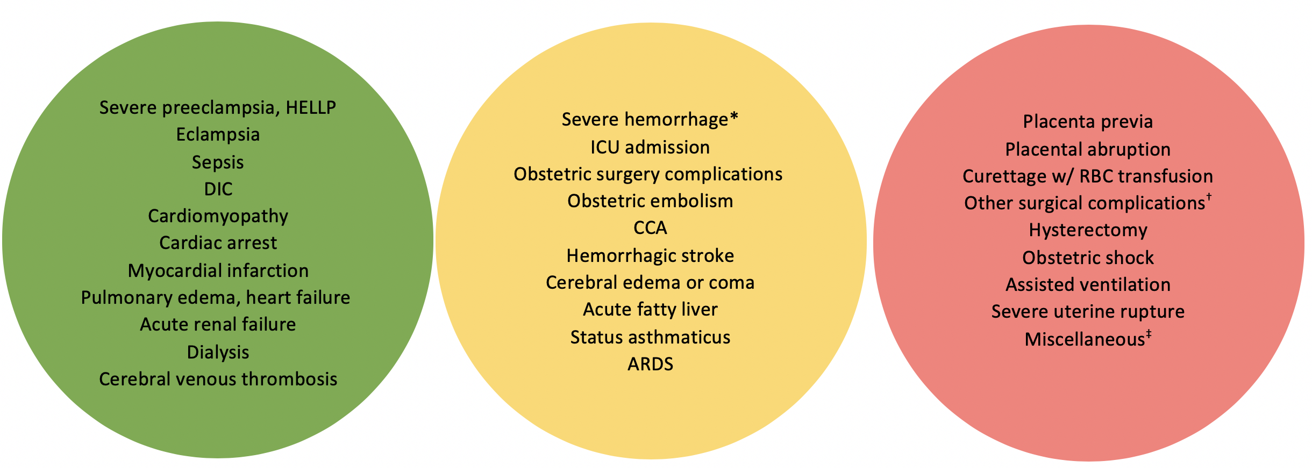
S1 Fig. Conceptual framework of the relation of pre-pregnancy maternal glycemia and bundles of severe maternal morbidity (SMM) indicators (additional analysis 11). Green indicates a strong theoretical relation, yellow indicates a possible relation, and red indicates an unlikely relation. For specific codes and terms, see S3 Table.

HELLP: Hemolysis, elevated liver enzymes, and a low platelet count
DIC: Disseminated intravascular coagulation
CCA: Cardiac complications of anaesthesia
ARDS: Adult Respiratory Distress Syndrome
RBC: Red blood cell

* Includes antepartum hemorrhage with coagulation defect; intrapartum hemorrhage with coagulation defect; intrapartum hemorrhage with RBC transfusion; and postpartum hemorrhage with RBC transfusion, procedures to the uterus or hysterectomy
† Includes evacuation of incisional hematoma with RBC transfusion; procedures to the uterus with RBC transfusion; and repair of bladder, urethra, or intestine
‡ Includes acute abdomen; correction of inverted uterus for vaginal births; sickle-cell anemia with crisis; acute psychosis; and status epilepticus

