Figure S1. Overview of the quality control pipelines used for the metabolite measurements pre-processing

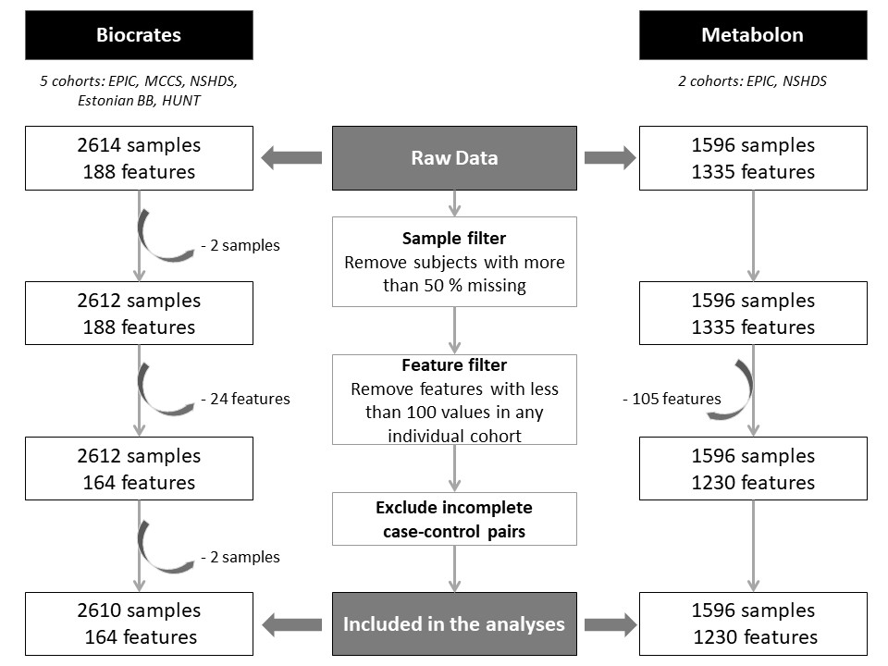
EPIC: The European Prospective Investigation into Cancer and Prevention; Estonian BB: University of Tartu- Estonian Biobank; HUNT: The Trøndelag Health Study; MCCS: The Melbourne Collaborative Cohort Study; NSHDS: Northern Sweden Health and Disease study.
The number of features is the maximum number of features measured across all cohorts. Some are only measured in one cohort.

