S6 Appendix

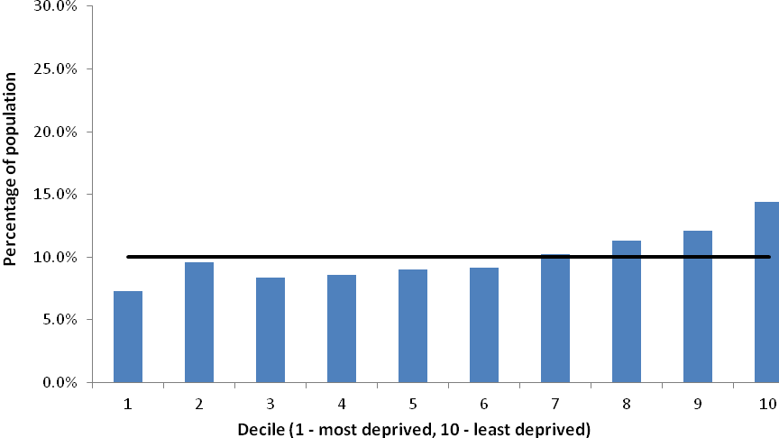

The proportion of people from the RCGP RSC cohort with index of multiple deprivation scores in each decile of deprivation (based on the national average).

