Supplementary Data
S4 Fig: Subgroup analyses and funnel plots
Calcium-channel blockers
a) trials reporting “measured and validated” OH outcomes only
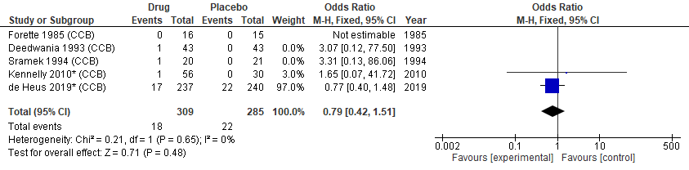
b) trials at low risk of bias
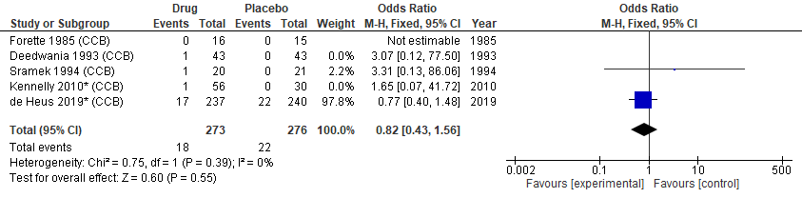
c) older participants ≥ 65 years
d) participants with cardiovascular conditions
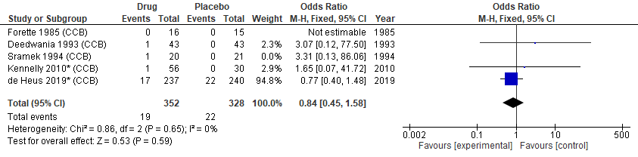

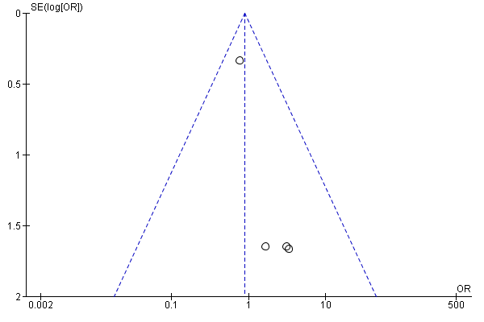

ACE inhibitors/ARBs
a) trials reporting “measured and validated” OH outcomes only
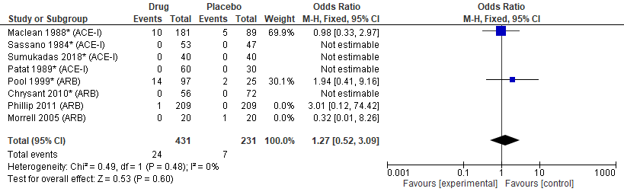
b) dose
low dose
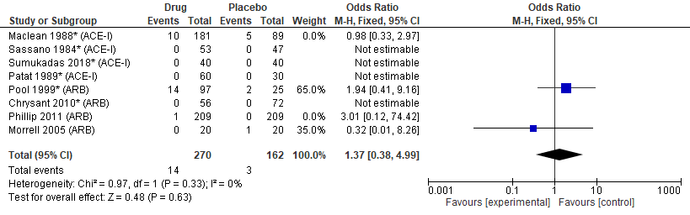
high dose
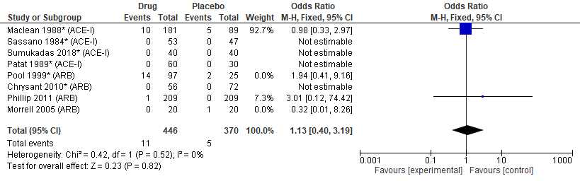
c) populations at greater risk of OH (excluding healthy volunteers)
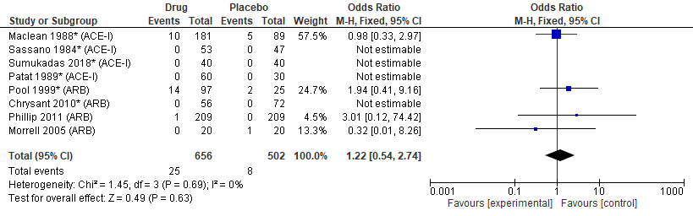

Funnel plot
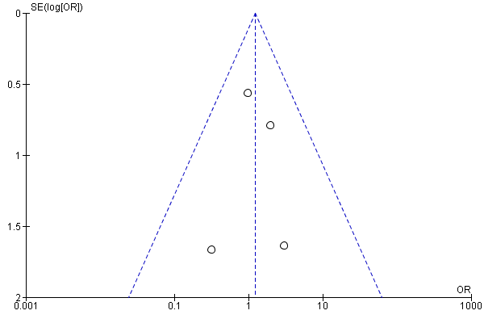

SSRIs/serotonin modulators
a) trials reporting “measured and validated” OH outcomes only
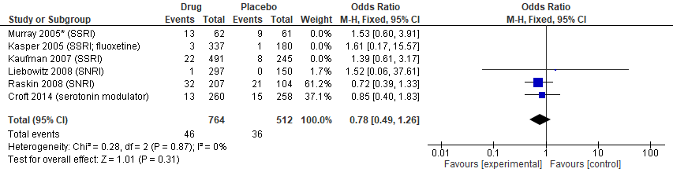
b) drug dose
Low dose
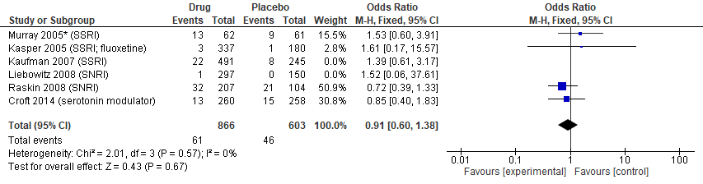
High dose
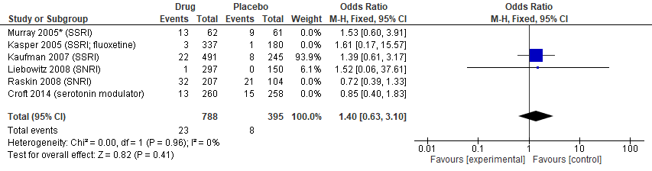

3) older patients ≥ 65 years
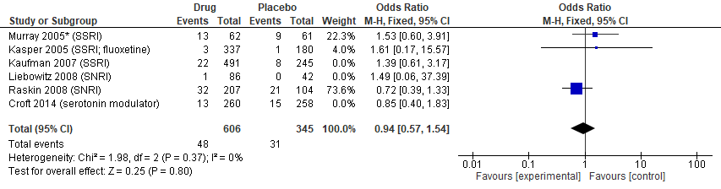

Funnel plot
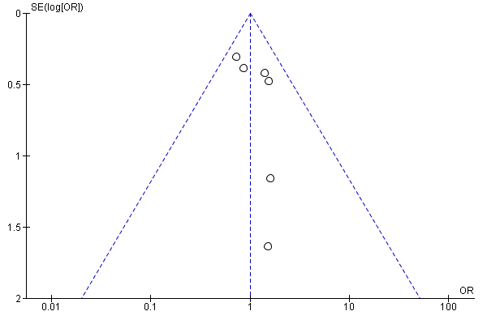

SGLT-2 inhibitors
a) trials at low risk of bias (excluding trials with an overall score of “high”).
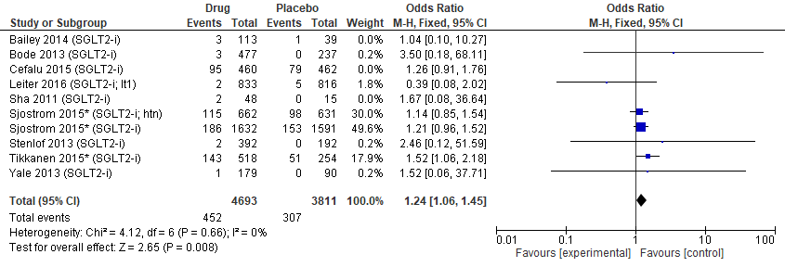
b) trials in patients with T2DM
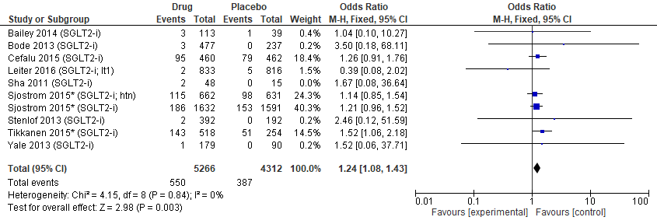
c) trials in patients with T2DM and cardiovascular disease
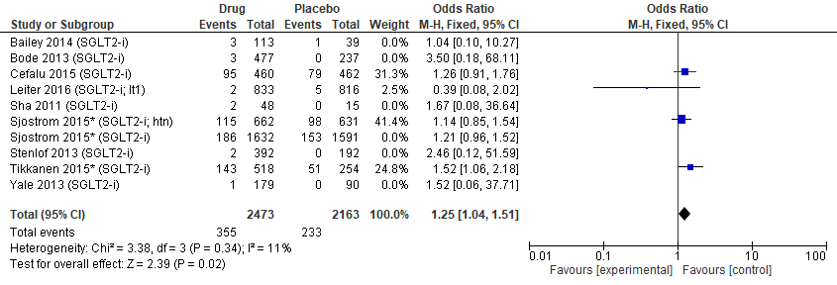
Funnel plot
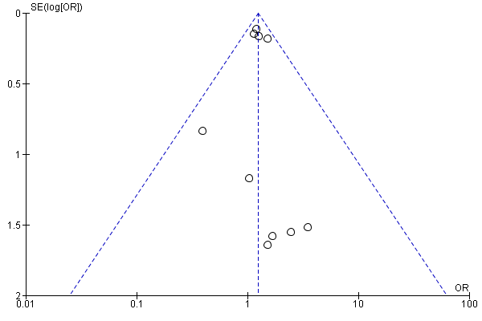
Alpha-adreno receptor blockers
1) trials reporting “measured and validated” OH outcomes only
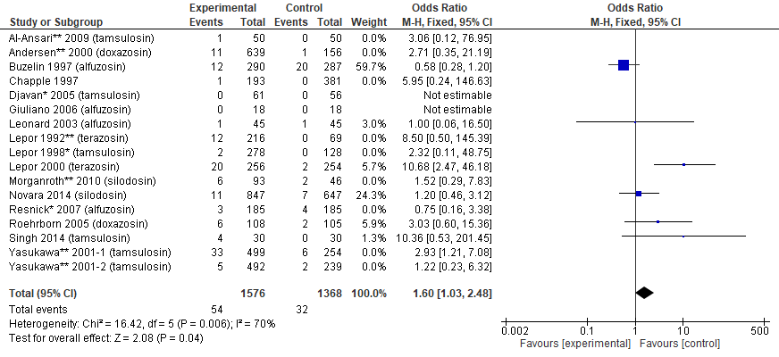
Funnel plot
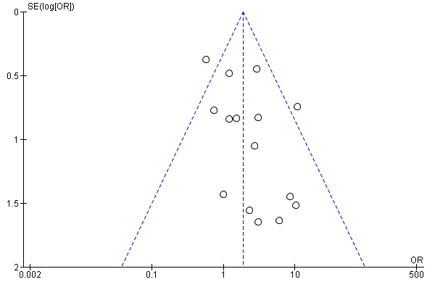
Centrally acting antihypertensives (alpha-agonists)
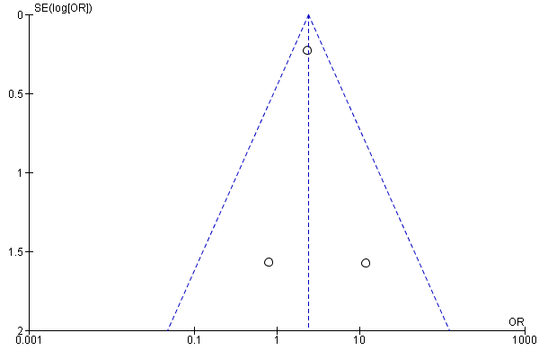

Second generation antipsychotics
1) trials reporting “measured and validated” OH outcomes only
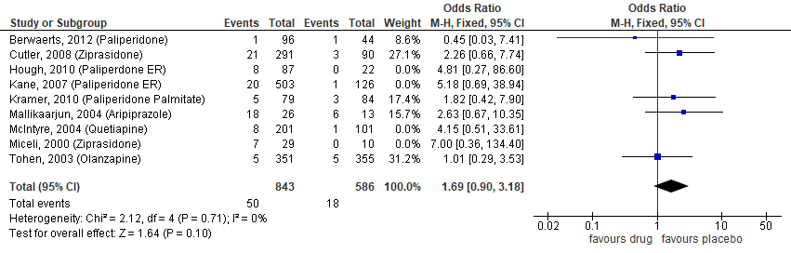
b) dose
low dose
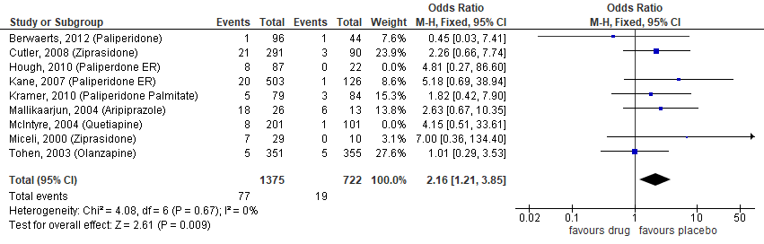
high dose
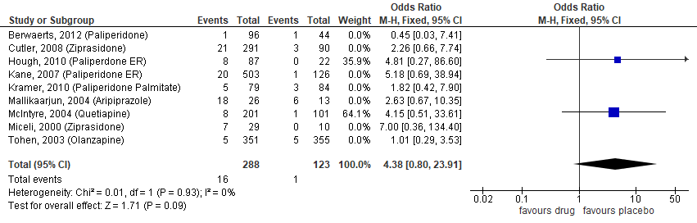

c) populations with mental health conditions (excluding healthy volunteers)
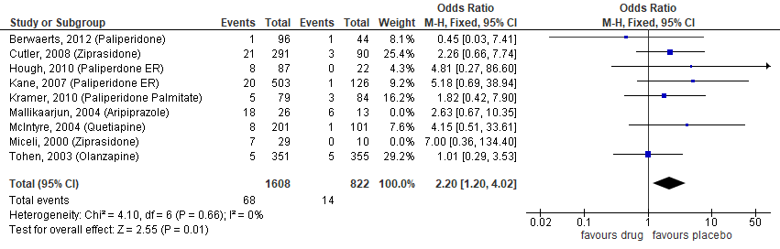

Funnel plot
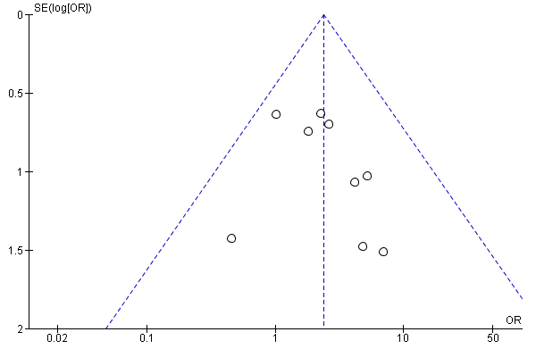

Beta-blockers
a) trials with “measured and validated” OH outcomes
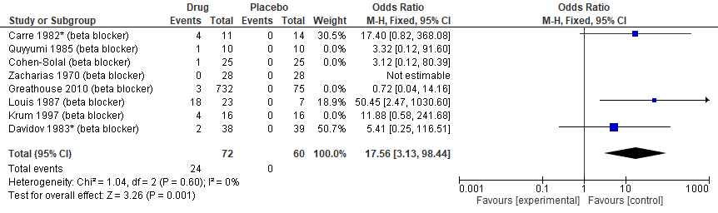
b) low dose (excluding 1 trial with high dose)
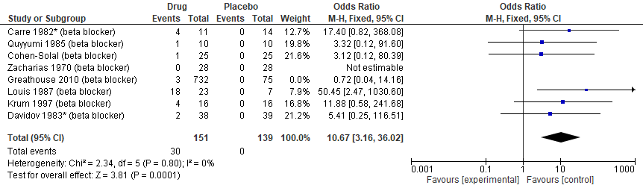
c) population at higher risk of OH (hypertension; angina; heart failure)
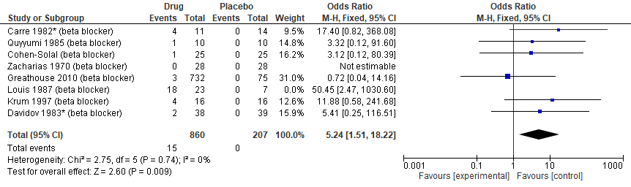
Funnel plot
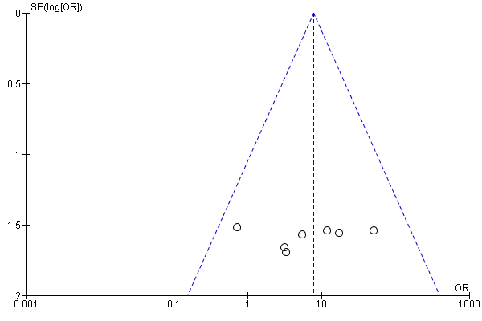
Tricyclic antidepressants (TCAs)
Funnel plot
