Universal Healthcare Coverage and Health Service Delivery in Times of Public Health Crises: A Difference-in-Difference Study of Childhood Immunization Coverage from 195 Countries Before and During the COVID-19 Pandemic

Supporting Information 3

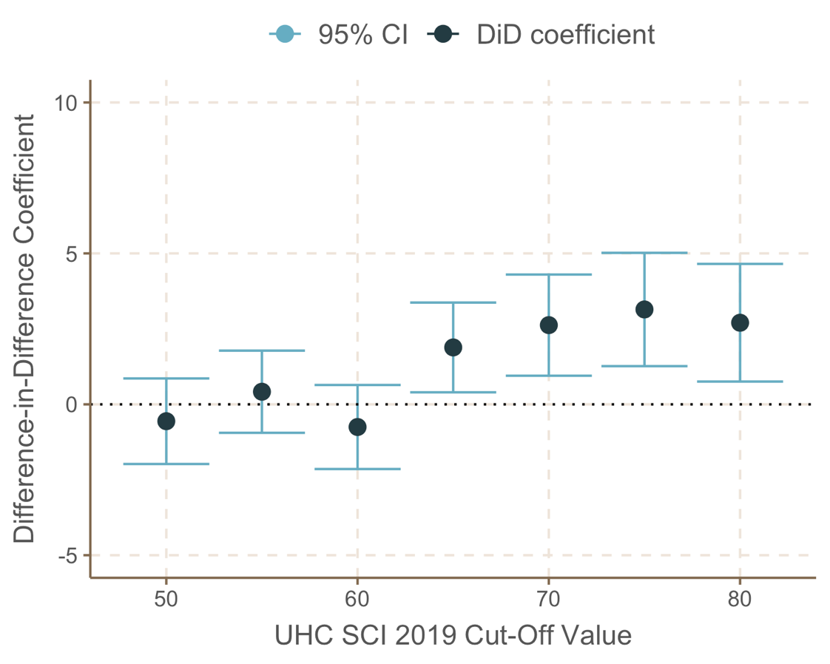
Figure A. Adjusted difference-in-difference coefficient from the analysis replicated with a range of cutoff values threshold (50-80) for UHC SCI 2019

Table A. Adjusted difference-in-difference coefficient from the analysis replicated with a range of cutoff values threshold (50-80) for UHC SCI 2019
UHC SCI 2019 cutoff threshold | Difference-in-difference coefficient | 95% confidence interval | p-value
50 | -0.561 | (-1.978, 0.856) | 0.4378
55 | 0.416 | (-0.945, 1.778) | 0.5491
60 | -0.753 | (-2.145, 0.640) | 0.2894
65 | 1.884 | (0.397, 3.371) | 0.013
70 | 2.623 | (0.947, 4.299) | 0.0022
75 | 3.142 | (1.264, 5.020) | 0.001
80 | 2.702 | (0.754, 4.650) | 0.0066

Replicating the analyses using the shortened pre-period (2015 – 2019)

Table B. Difference-in-difference regression analysis of overall immunization coverage after COVID-19 pandemic by UHC SCI 2019 (>= 80 vs. the rest) from 2015 to 2020 – Unadjusted
 | Base model |  |  | Difference-in-difference model
Variable | Coefficient | 95% CIª | p-value | Coefficient | 95% CIª | p-value
Intercept | 86.04 | (85.71, 86.36) | <0.001 | 86.1 | (85.78, 86.43) | <0.001
Pre/Post | -3.38 | (-4.16, -2.59) | <0.001 | -3.82 | (-4.67, -2.98) | <0.001
UHC SCI^{b} 2019 >=80 | 6.96 | (6.22, 7.70) | <0.001 | 6.57 | (5.77, 7.36) | <0.001
Pre/Post * UHC SCI^{b} >=80 |  |  |  | 3.11 | (0.88, 5.34) | 0.006
a: Confidence Interval
b: UHC Service Coverage Index

Table C. Difference-in-difference regression analysis of overall immunization coverage after COVID-19 pandemic by UHC SCI 2019 (>= 80 vs. the rest) from 2015 to 2020 - Adjusted for calendar year, pandemic preparedness, country income group, geographic region, and vaccine types
 | Base model |  |  | Difference-in-difference model
Variable | Coefficient | 95% CIª | p-value | Coefficient | 95% CIª | p-value
Intercept | -74.76 | (-461.04, 311.53) | 0.704 | -74 | (-460.21, 312.21) | 0.707
Year | 0.08 | (-0.12, 0.27) | 0.438 | 0.08 | (-0.12, 0.27) | 0.44
GHSI^{b} 2019 | 0.07 | (0.05, 0.10) | <0.001 | 0.07 | (0.05, 0.10) | <0.001
World Bank Income Group (Reference category: Low)
Lower-middle | 6.93 | (6.06, 7.81) | <0.001 | 6.93 | (6.06, 7.81) | <0.001
Upper-middle | 10.85 | (9.88, 11.83) | <0.001 | 10.85 | (9.87, 11.82) | <0.001
High | 17.03 | (15.94, 18.13) | <0.001 | 17.02 | (15.93, 18.12) | <0.001
WHO Region (Reference category: Americas)
Europe | 2.87 | (2.05, 3.69) | <0.001 | 2.86 | (2.04, 3.68) | <0.001
Western Pacific | 0.64 | (-0.28, 1.56) | 0.173 | 0.64 | (-0.27, 1.56) | 0.169
Eastern Mediterranean | 0.25 | (-0.72, 1.23) | 0.609 | 0.26 | (-0.71, 1.23) | 0.599
Southeast Asia | 5.07 | (3.80, 6.34) | <0.001 | 5.07 | (3.81, 6.34) | <0.001
Africa | -0.02 | (-0.95, 0.90) | 0.966 | -0.02 | (-0.94, 0.91) | 0.969
Vaccine type (Reference category: BCGº)
DTP1^{c} | 0.81 | (-0.38, 2.00) | 0.182 | 0.81 | (-0.38, 2.00) | 0.183
DTP3^{d} | -3.69 | (-4.89, -2.50) | <0.001 | -3.7 | (-4.89, -2.50) | <0.001
HEPB3e | -4.31 | (-5.51, -3.11) | <0.001 | -4.32 | (-5.52, -3.12) | <0.001
HEPBB^{f} | -10.33 | (-11.81, -8.84) | <0.001 | -10.31 | (-11.80, -8.83) | <0.001
HIB3^{g} | -4.42 | (-5.61, -3.22) | <0.001 | -4.42 | (-5.61, -3.22) | <0.001
MCV1^{h} | -4.57 | (-5.76, -3.38) | <0.001 | -4.57 | (-5.77, -3.38) | <0.001
MCV2^{i} | -10.51 | (-11.75, -9.28) | <0.001 | -10.51 | (-11.75, -9.27) | <0.001
PCV3^{j} | -8.98 | (-10.29, -7.68) | <0.001 | -8.99 | (-10.29, -7.68) | <0.001
POL3^{k} | -3.78 | (-4.98, -2.59) | <0.001 | -3.78 | (-4.98, -2.59) | <0.001
RCV1^{l} | -3.07 | (-4.32, -1.82) | <0.001 | -3.07 | (-4.32, -1.82) | <0.001
ROTAC^{m} | -12.06 | (-13.51, -10.61) | <0.001 | -12.07 | (-13.52, -10.62) | <0.001
Difference-in-difference variables
Pre/Post | -2.9 | (-3.81, -1.99) | <0.001 | -3.25 | (-4.21, -2.30) | <0.001
UHC SCI^{n} 2019 >=80 | -3.76 | (-4.80, -2.72) | <0.001 | -4.05 | (-5.11, -2.98) | <0.001
Pre/Post * UHC SCI^{n} >=80 |  |  |  | 2.41 | (0.39, 4.42) | 0.019
a: Confidence Interval
b: Global Health Security Index
c: diphtheria, tetanus toxoid, and pertussis containing vaccine – first dose
d: diphtheria, tetanus toxoid, and pertussis containing vaccine – third dose
e: hepatitis B vaccine – third dose
f: hepatitis B vaccine – birth dose
g: Haemophilus influenzae type B containing vaccine
h: measles containing vaccine – first dose
i: measles containing vaccine – third dose
j: pneumococcal conjugate vaccine – third dose
k: polio containing vaccine – third dose
l: rubella containing vaccine – first dose
m: rotavirus vaccine – second or third dose
n: UHC Service Coverage Index
o: Bacille Calmette-Guérin

Table D. Difference-in-difference regression analysis of overall immunization coverage after COVID-19 pandemic by UHC SCI 2019 (< 50 vs. the rest) from 2015 to 2020 – Unadjusted
 | Base model |  |  | Difference-in-difference model
Variable | Coefficient | 95% CIª | p-value | Coefficient | 95% CIª | p-value
Intercept | 79.2 | (78.71, 79.68) | <0.001 | 79.15 | (78.64, 79.67) | <0.001
Pre/Post^{b} | -3.11 | (-3.86, -2.37) | <0.001 | -2.84 | (-4.12, -1.56) | <0.001
UHC SCI^{c} 2019 <50 | 11.5 | (10.93, 12.06) | <0.001 | 11.56 | (10.94, 12.18) | <0.001
Pre/Post * UHC SCI^{c} <50 |  |  |  | -0.41 | (-1.99, 1.16) | 0.607
a: Confidence Interval
b: Pre period refers to the years 2015-2019 and the Post period refers to the year 2020
c: UHC Service Coverage Index

Table E. Difference-in-difference regression analysis of overall immunization coverage after COVID-19 pandemic by UHC SCI 2019 (< 50 vs. the rest) from 2015 to 2020 - Adjusted for calendar year, pandemic preparedness, country income group, geographic region, and vaccine types
 | Base model |  |  | Difference-in-difference model
Variable | Coefficient | 95% CIª | p-value | Coefficient | 95% CIª | p-value
Intercept | -96.67 | (-476.30, 282.96) | 0.618 | -96.99 | (-476.64, 282.66) | 0.617
Year | 0.09 | (-0.10, 0.28) | 0.365 | 0.09 | (-0.10, 0.28) | 0.364
GHSI 2019 | -0.02 | (-0.05, -0.00) | 0.042 | -0.02 | (-0.05, -0.00) | 0.041
World Bank Income Group (Reference category: Low)
Lower-middle | 4.64 | (3.75, 5.53) | <0.001 | 4.64 | (3.75, 5.53) | <0.001
Upper-middle | 7.38 | (6.36, 8.39) | <0.001 | 7.38 | (6.36, 8.39) | <0.001
High | 11.59 | (10.50, 12.69) | <0.001 | 11.59 | (10.49, 12.69) | <0.001
WHO Region (Reference category: Americas)
Europe | 3.07 | (2.29, 3.86) | <0.001 | 3.07 | (2.28, 3.86) | <0.001
Western Pacific | 3.35 | (2.40, 4.29) | <0.001 | 3.35 | (2.41, 4.29) | <0.001
Eastern Mediterranean | -0.12 | (-1.08, 0.83) | 0.8 | -0.13 | (-1.08, 0.83) | 0.796
Southeast Asia | 6.81 | (5.55, 8.06) | <0.001 | 6.8 | (5.55, 8.06) | <0.001
Africa | 0.96 | (0.04, 1.87) | 0.04 | 0.95 | (0.04, 1.87) | 0.041
Vaccine type (Reference category: BCGº)
DTP1^{c} | 0.65 | (-0.52, 1.82) | 0.273 | 0.65 | (-0.52, 1.82) | 0.273
DTP3^{d} | -3.85 | (-5.02, -2.68) | <0.001 | -3.85 | (-5.02, -2.68) | <0.001
HEPB3e | -4.46 | (-5.64, -3.28) | <0.001 | -4.46 | (-5.64, -3.28) | <0.001
HEPBB^{f} | -10.29 | (-11.75, -8.83) | <0.001 | -10.29 | (-11.76, -8.83) | <0.001
HIB3^{g} | -4.56 | (-5.73, -3.38) | <0.001 | -4.56 | (-5.73, -3.38) | <0.001
MCV1^{h} | -4.73 | (-5.90, -3.56) | <0.001 | -4.73 | (-5.90, -3.56) | <0.001
MCV2^{i} | -10.82 | (-12.04, -9.61) | <0.001 | -10.83 | (-12.04, -9.61) | <0.001
PCV3^{j} | -8.94 | (-10.22, -7.65) | <0.001 | -8.94 | (-10.22, -7.65) | <0.001
POL3^{k} | -3.94 | (-5.11, -2.77) | <0.001 | -3.94 | (-5.11, -2.77) | <0.001
RCV1^{l} | -3.41 | (-4.64, -2.18) | <0.001 | -3.41 | (-4.64, -2.18) | <0.001
ROTAC^{m} | -12.02 | (-13.45, -10.60) | <0.001 | -12.02 | (-13.45, -10.60) | <0.001
Difference-in-difference variables
Pre/Post | -2.85 | (-3.74, -1.95) | <0.001 | -2.63 | (-3.95, -1.31) | <0.001
UHC SCI^{n} 2019 <50 | 7.67 | (6.96, 8.38) | <0.001 | 7.72 | (6.98, 8.47) | <0.001
Pre/Post * UHC SCI^{n} <50 |  |  |  | -0.34 | (-1.81, 1.14) | 0.655
a: Confidence Interval
b: Global Health Security Index
c: diphtheria, tetanus toxoid, and pertussis containing vaccine – first dose
d: diphtheria, tetanus toxoid, and pertussis containing vaccine – third dose
e: hepatitis B vaccine – birth dose
f: hepatitis B vaccine – third dose
g: Haemophilus influenzae type B containing vaccine
h: measles containing vaccine – first dose
i: measles containing vaccine – third dose
j: pneumococcal conjugate vaccine – third dose
k: polio containing vaccine – third dose
l: rubella containing vaccine – first dose
m: rotavirus vaccine – second or third dose
n: UHC Service Coverage Index
o: Bacille Calmette-Guérin

