S1 Appendix – Expansion of the Estratégia de Saúde da Família by municipal population, poverty rate, and black/pardo population.

Larger municipalities, those with lower poverty rates, and those with lower proportions of the population classifying as black or pardo exhibited slower uptake of the ESF over the period 1998-2013.

Fig A - The percentage of municipalities reaching 50% ESF coverage by municipal population (in 2000) for the years 2000-2013

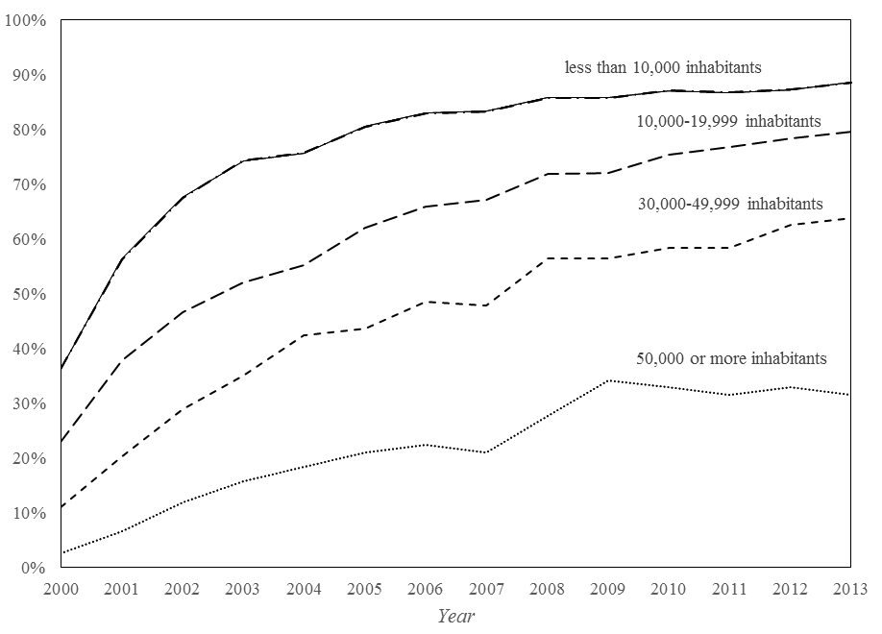

Fig B - The percentage of municipalities reaching 50% ESF coverage by municipal poverty rate (in 2000) for the years 2000-2013

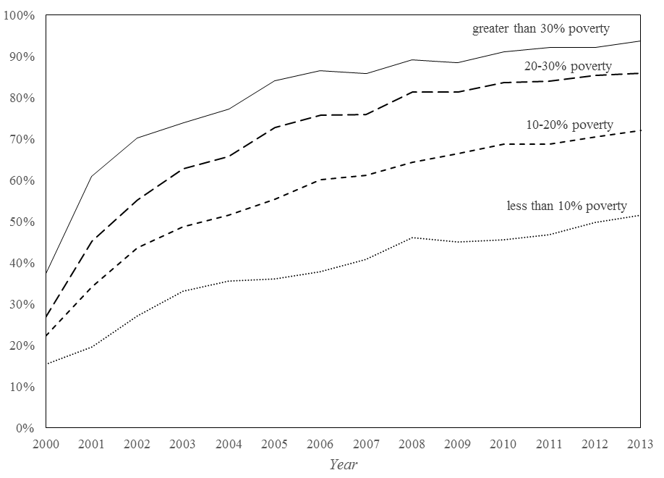
Note: Poverty rate is defined as the per capita household income of less than R$255 (in 2010 R$);

Fig C - The percentage of municipalities reaching 50% ESF coverage by municipal poverty rate (in 2000) for the years 2000-2013

