S1 Fig. Adjusted hazard ratios and 95% confidence intervals for incident metabolic syndrome according to the continuous overall plant-based diet index, healthful plant-based diet index, and pro-vegetarian diet index using restricted cubic splines with 4 knots at the 5th, 35th, 65th, and 95th percentiles

Overall plant-based diet index | Healthful plant-based diet index
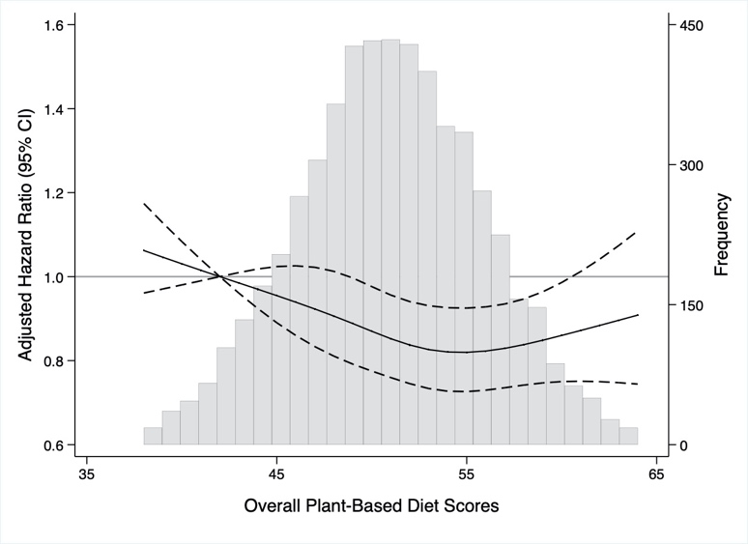 | 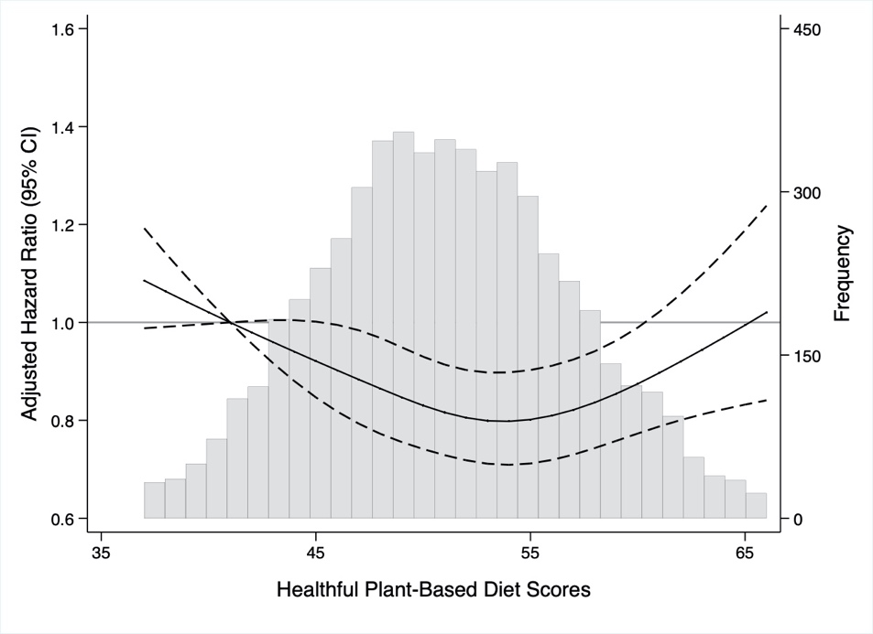
Pro-vegetarian diet index
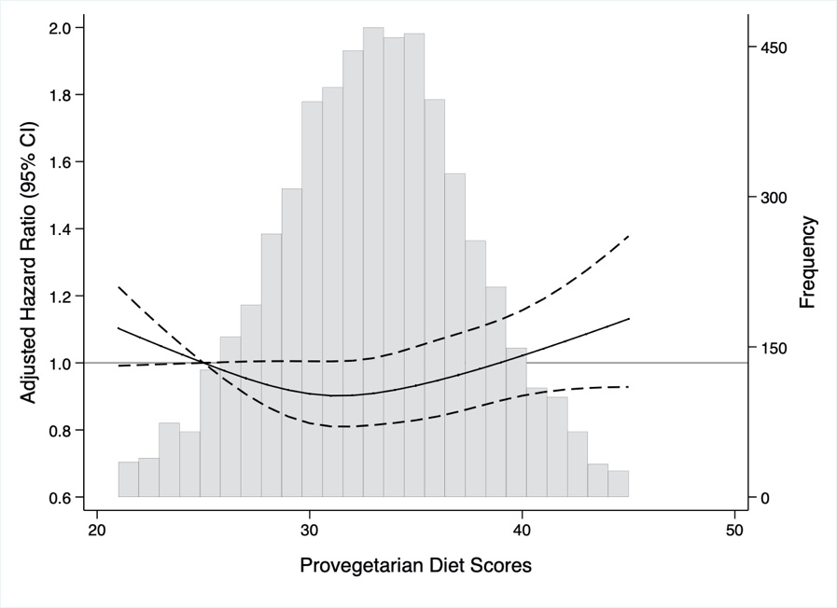

The histogram in gray shows the distribution of plant-based diet scores. The solid lines represent the adjusted hazard ratios for incident MetS, modeled using restricted cubic splines with 4 knots (5th, 35th, 65th, 95th percentiles). The reference was point was set at the 5th percentile of each score. The dashed lines represent 95% confidence intervals. Hazard ratios were adjusted for age, sex, total energy intake, education, physical activity, smoking status, alcohol intake, and body mass index.

