S1 Fig.
Supporting information - Study design

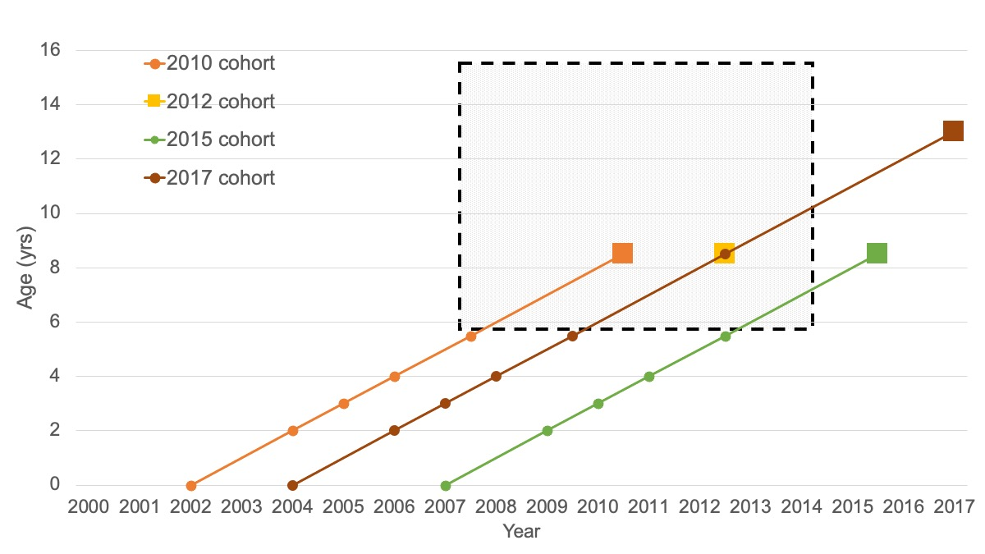
S1 Fig. Schematic of the quasi-natural experimental design. The dashed square indicates the period with the FFV policy; the squares indicate measurements in the NCGS (2010, 2012, and 2015) and NYGS (2017); and the dots indicate approximate (routine) measurements included in analysis.
FFV: Free fruit and vegetables; NCGS; Norwegian Childhood Growth Study; NYGS: Norwegian Youth Growth Study; yrs: years.

