Figure S2. Heatmap of Pearson correlation coefficients for selected Biocrates (left) and Metabolon (right) metabolites.
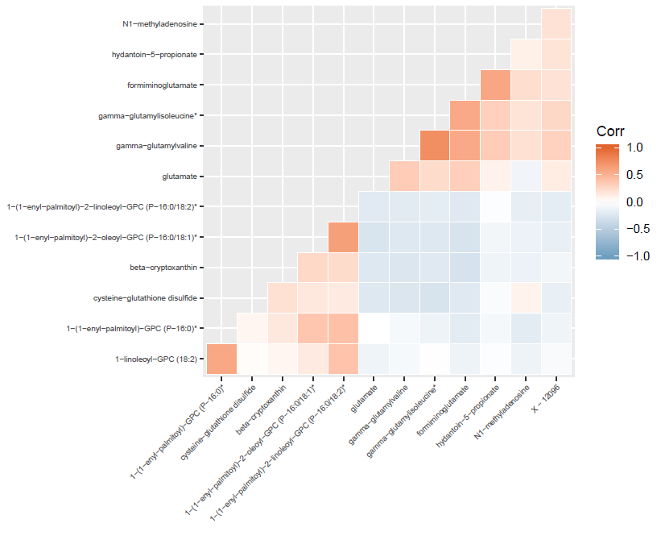
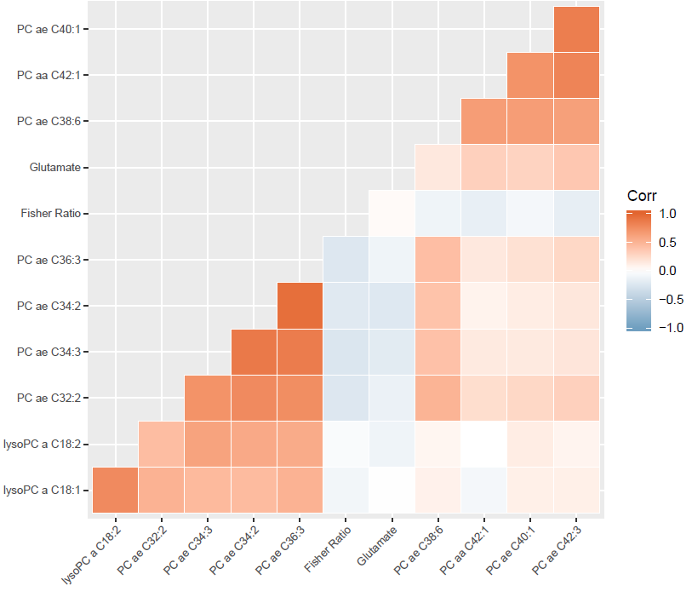

Corr: Pearson correlation coefficient

