Risk ratios (%) for taking BP medication by educational level, household wealth, marital status and employment status, for individuals not indicated for medication per WHO/ISH guidelines.
 | Primary school or higher education | Upper three wealth quintiles | Married/cohabiting | Working in past12 months
 |  | 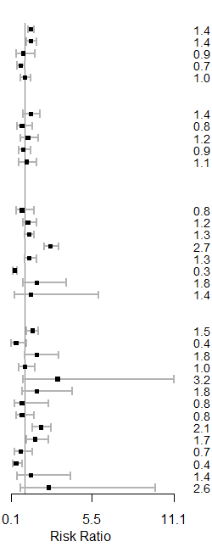 | 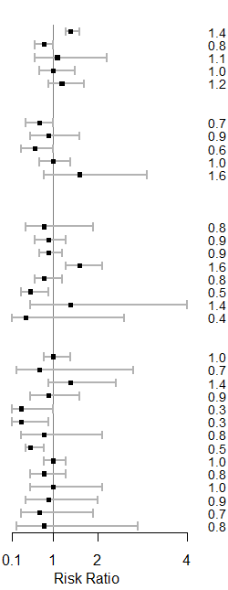 | 