Supplemental Figure 1: Density: Map of Iraq illustrating clusters (first sampling stage)
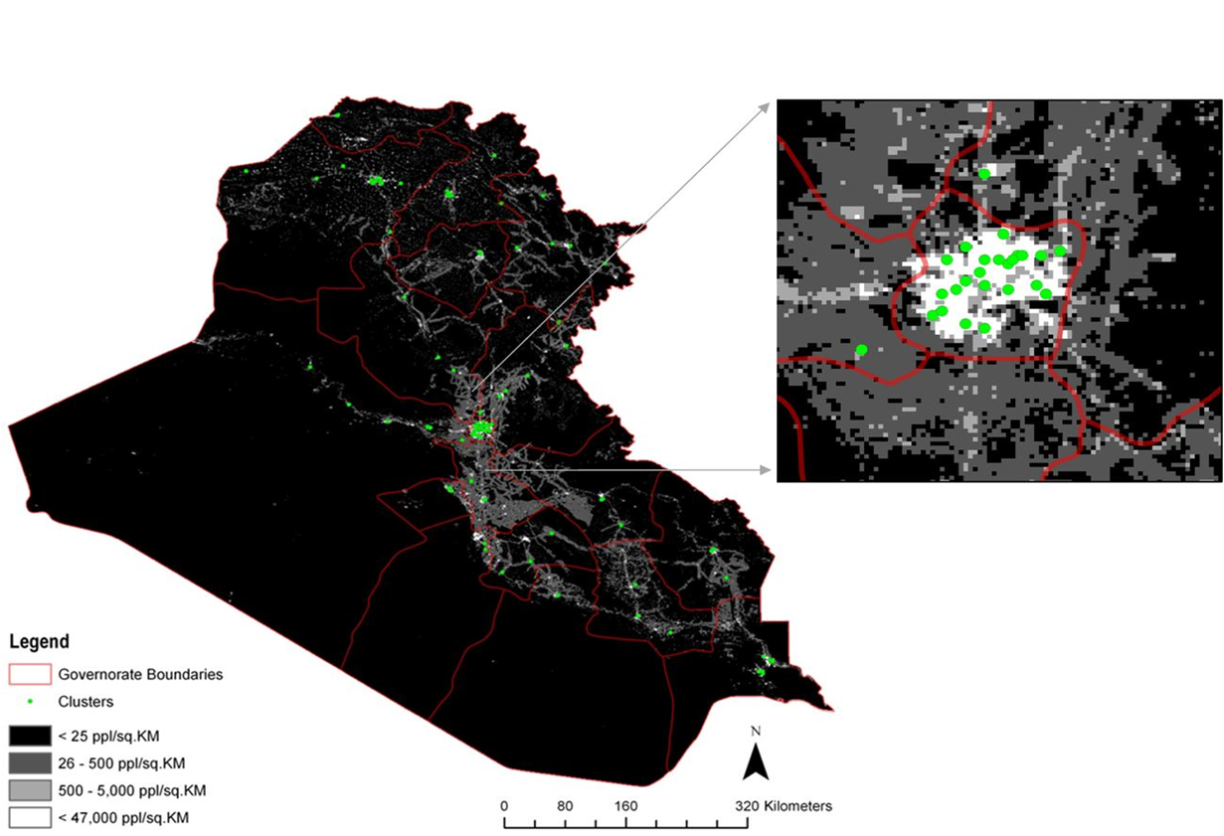

Illustration of the first stage of a two-stage cluster sampling method using gridded population data, a GIS, and Google EarthTM imagery in a population-based mortality survey in Iraq, as described elsewhere.

Citation: Galway LP, Bell N, Al- Shatari SAE, Flaxman A, Rajaratnam J, Weiss WM, et al. A two-stage cluster sampling method using gridded population data, a GIS, and Google EarthTM imagery in a population-based mortality survey in Iraq. Int J of Health Geographics. 2012.

