Supplementary figure 2. Baseline characteristics and malaria control measures in place at each study site, ordered by increasing malaria incidence (intention-to-treat population)
A. Children 5-17 months of age at enrollment |  | B. Infants 6-12 weeks of age at enrollment
Age (Months) |  | Age (Weeks)
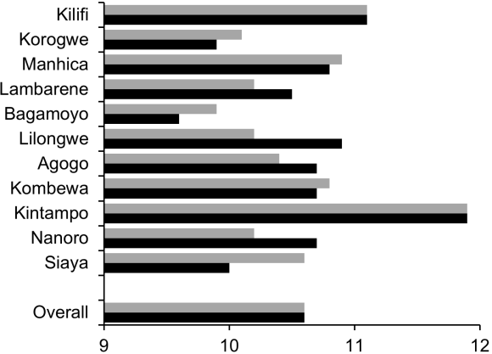 |  | 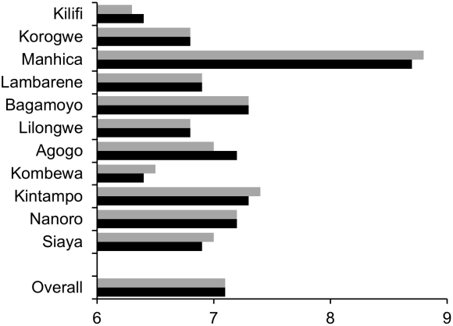
Gender (%Male) |  | Gender (%Male)
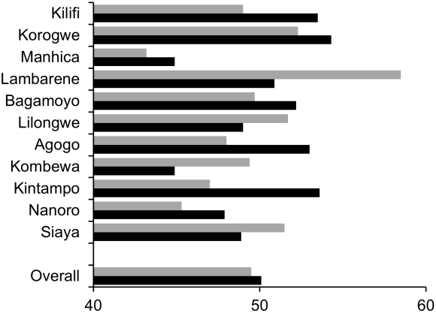 |  | 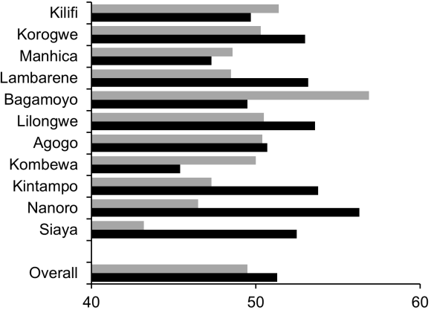
Height-for-age Z-score |  | Height-for-age Z-score
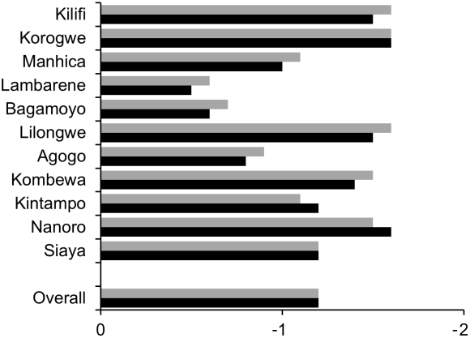 |  | 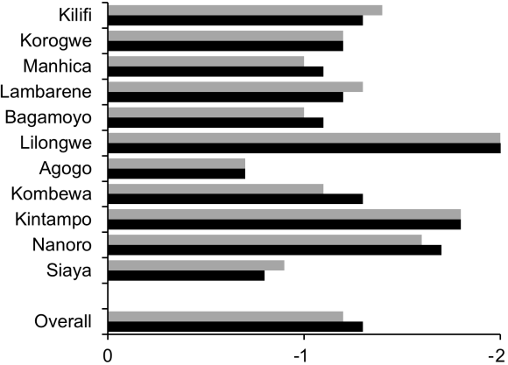
 | RTS,S/AS01 vaccine |  |  | Control vaccine
Figure continues on next page
A. Children 5-17 months of age at enrollment |  |  | B. Infants 6-12 weeks of age at enrollment
Weight-for-age Z-score |  |  | Weight-for-age Z-score
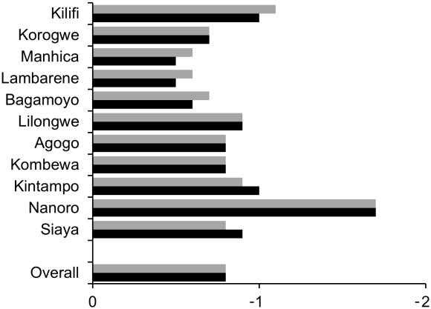 |  |  | 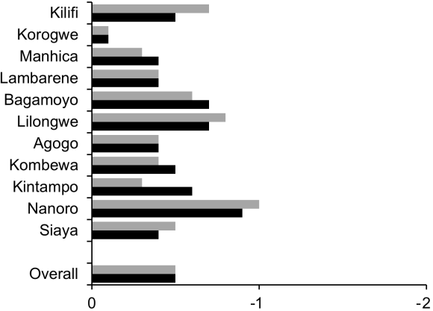
Distance from outpatient facility (km) |  |  | Distance from outpatient facility (km)
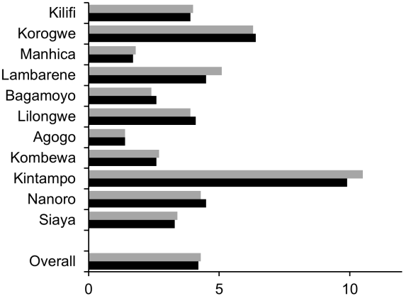 |  |  | 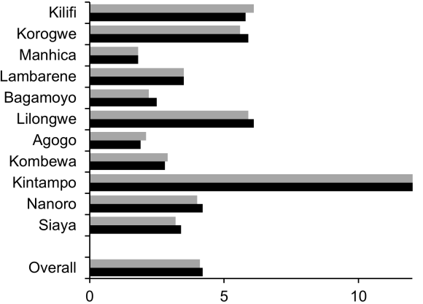
Distance from inpatient facility (km) |  |  | Distance from inpatient facility (km)
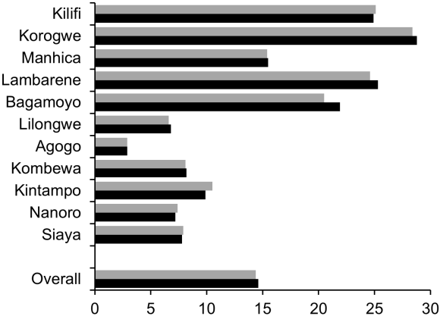 |  |  | 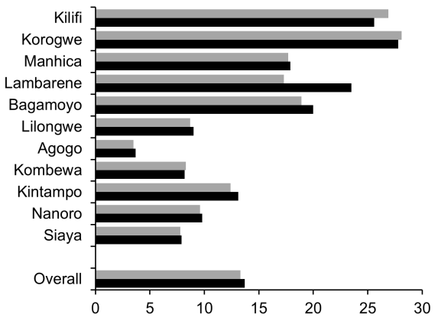
Hemoglobin at baseline (g/dL) |  |  | Hemoglobin at baseline (g/dL)
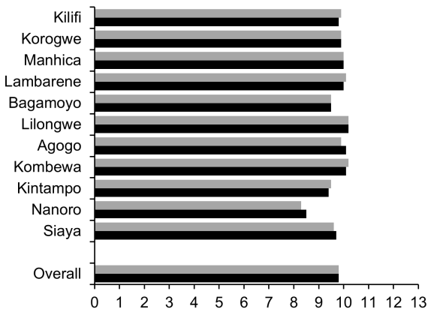 |  |  | 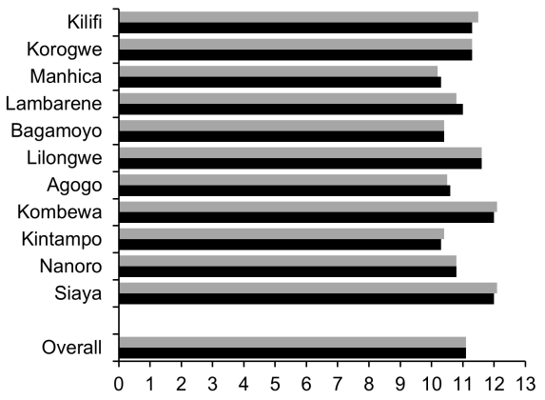
 | RTS,S/AS01 vaccine |  |  | Control vaccine
Figure continues on next page
A. Children 5-17 months of age at enrollment |  |  | B. Infants 6-12 weeks of age at enrollment
Prevalence of moderate anemia at enrollment (%) |  |  | Prevalence of moderate anemia at enrollment (%)
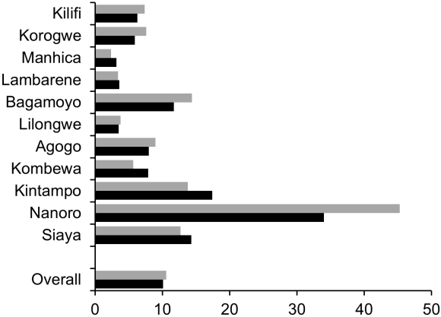 |  |  | 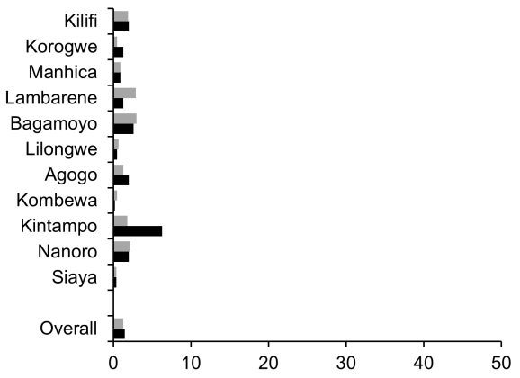
No prior HepB vaccination (%) |  |  | No prior HepB vaccination (%)
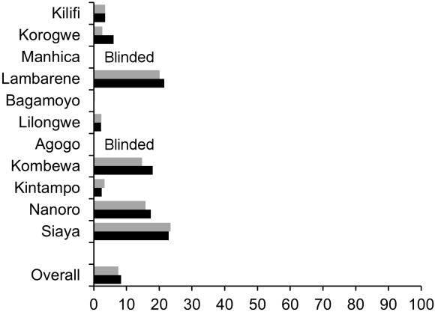 |  |  | 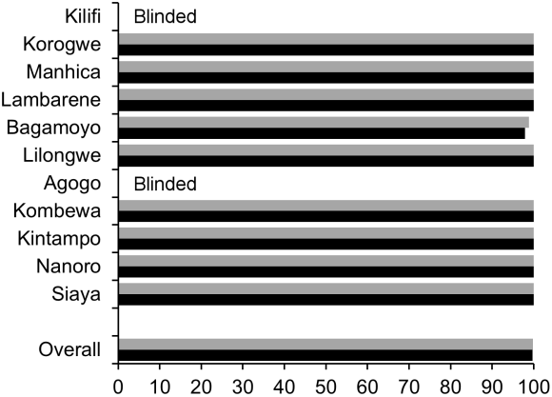
IPTi Coverage (%) |  |  | IPTi Coverage (%)
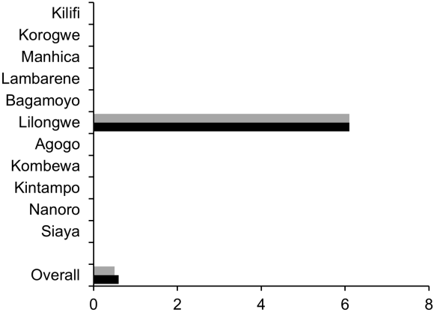 |  |  | 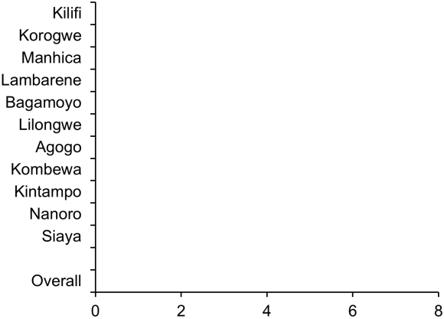
ITN Coverage (%) |  |  | ITN Coverage (%)
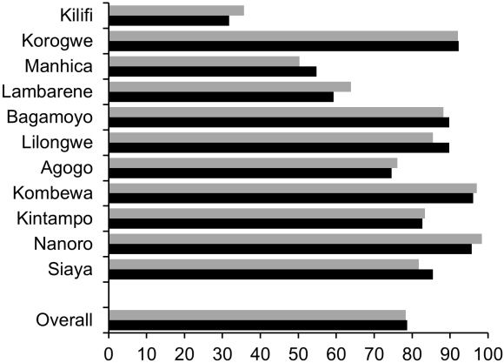 |  |  | 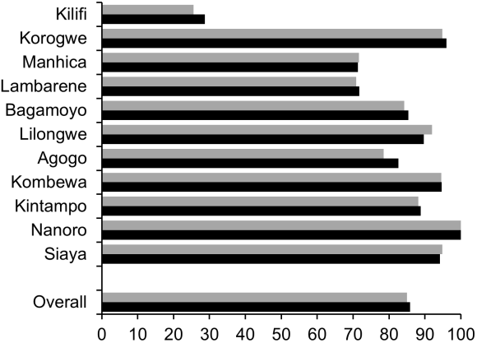
 | RTS,S/AS01 vaccine |  |  | Control vaccine
Figure continues on next page
A. Children 5-17 months of age at enrollment |  |  | B. Infants 6-12 weeks of age at enrollment
IRS Coverage (%) |  |  | IRS Coverage (%)
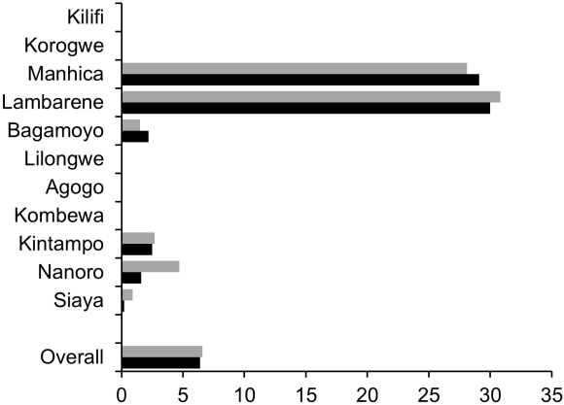 |  |  | 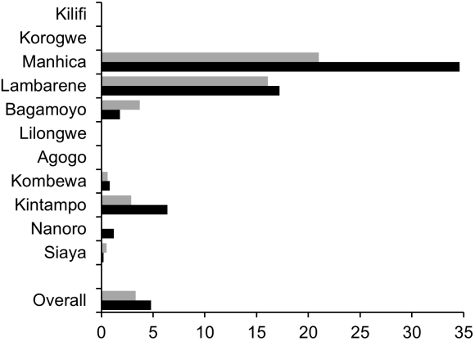
 | RTS,S/AS01 vaccine |  |  | Control vaccine
Study sites are ordered from lowest (Kilifi) to highest (Siaya) incidence of clinical malaria, defined as a measured or reported fever within previous 24h and parasite density >0 parasites per cubic millimeter (i.e. clinical malaria secondary case definition), measured in control infants 6-12 weeks of age at enrollment during 12 months of follow-up.
Blinded = data are not presented to maintain individual subject blinding.

