Figure S3.1- S3.8 - Sensitivity analyses using Hot season data (May - Oct, 2002-2011)

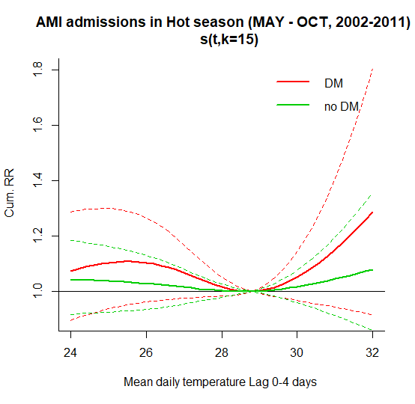
Figure S3.1 RR-temperature plot in hot season with degree of freedom (df = k-1 =4) for long term trend
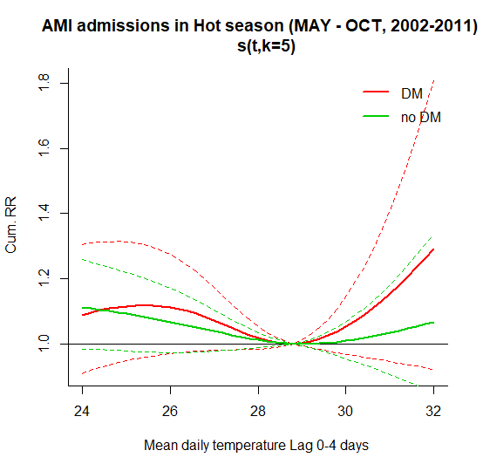
Figure S3.2 RR-temperature plot in hot season with degree of freedom (df = k-1 = 14) for long term trend

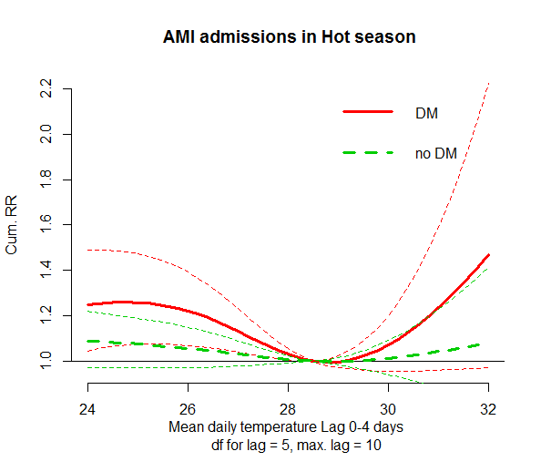
Figure S3.3 RR-temperature plot in hot season with degree of freedom for lag = 5
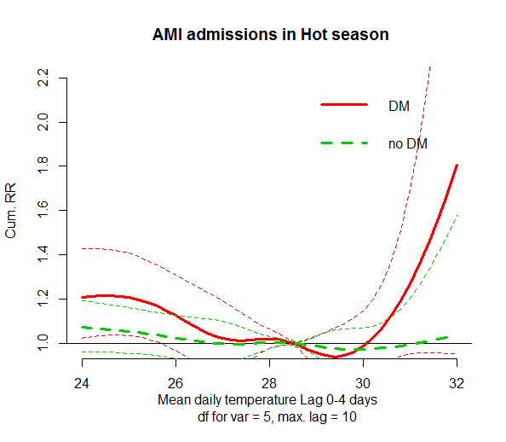
Figure S3.4 RR-temperature plot in hot season with degree of freedom for temperature = 5

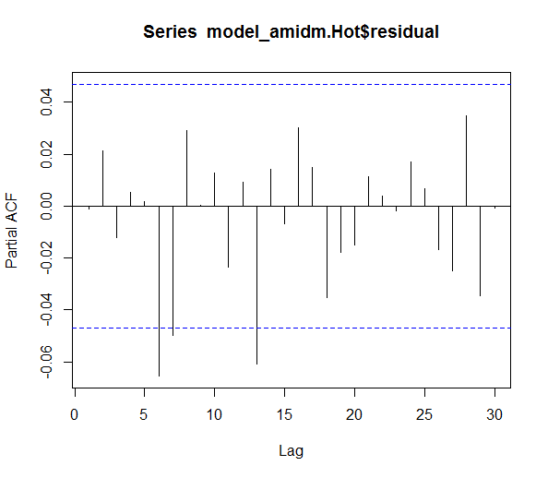
Figure S3.5 Partial Autocorrelation Function (PACF) plot in hot season for DM group.

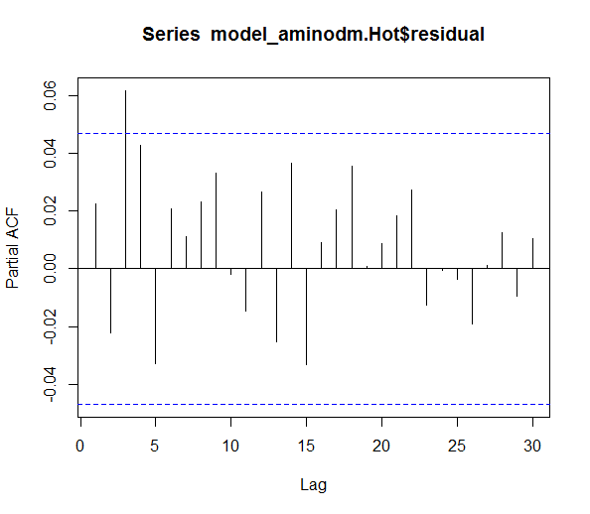
Figure S3.6 Partial Autocorrelation Function (PACF) plot in hot season for non-DM group.

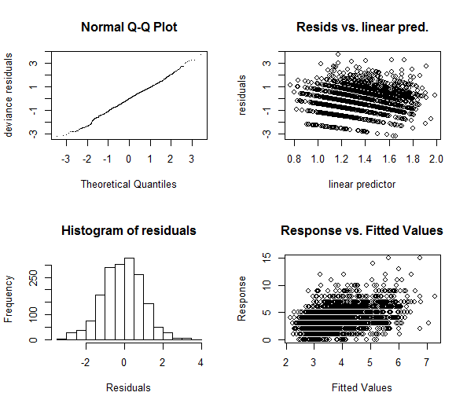
Figure S3.7 Residuals plots in hot season for DM group.
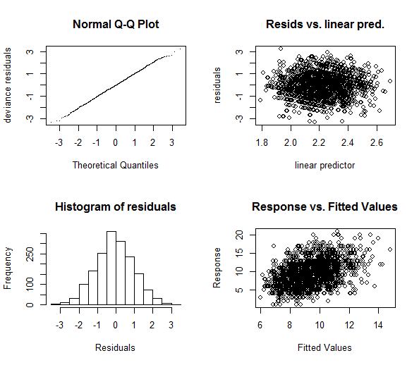
Figure S3.8 Residuals plots in hot season for non-DM group.

Figure S3.9- S3.16 - Sensitivity analyses using Cold season data (Nov – Apr, 2002-2011)
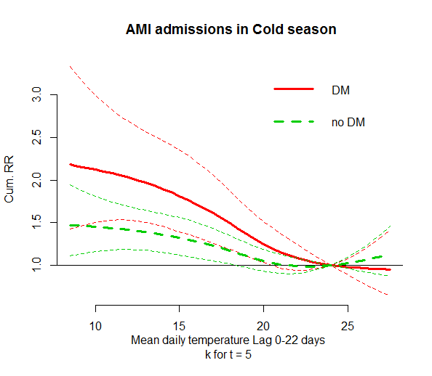
Figure S3.9 RR-temperature plot in cold season with degree of freedom (df = k-1 =4) for long term trend

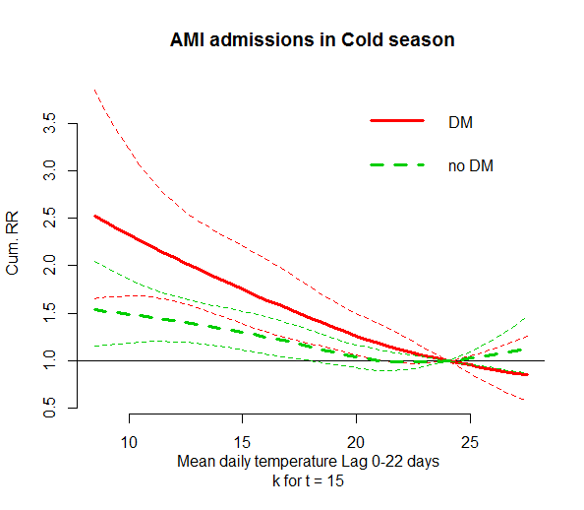
Figure S3.10 RR-temperature plot in cold season with degree of freedom (df = k-1 =14) for long term trend

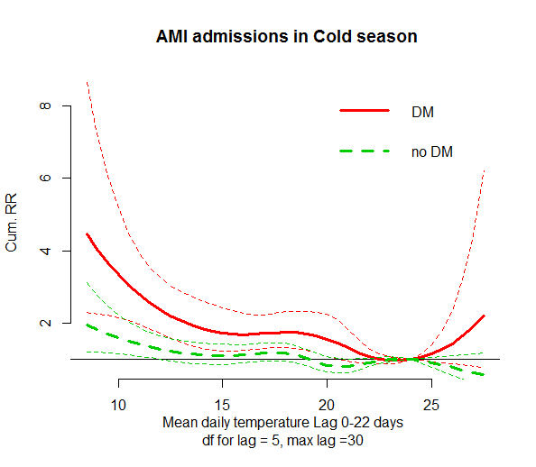
Figure S3.11 RR-temperature plot in cold season with degree of freedom for lag = 5
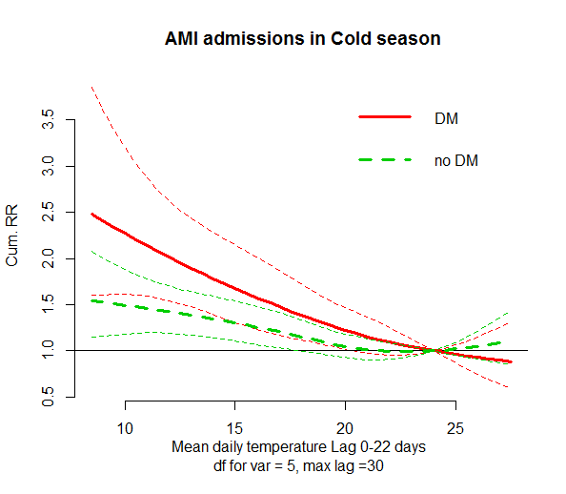
Figure S3.12 RR-temperature plot in cold season with degree of freedom for temperature = 5

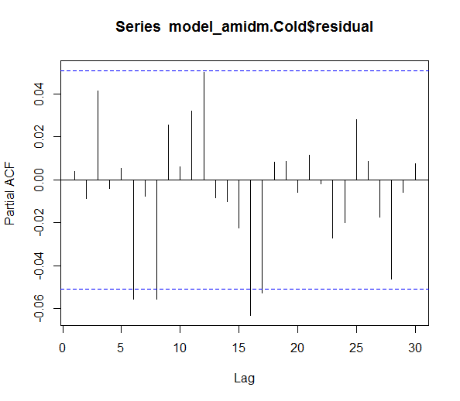
Figure S3.13 Partial Autocorrelation Function (PACF) plot in cold season for DM group.

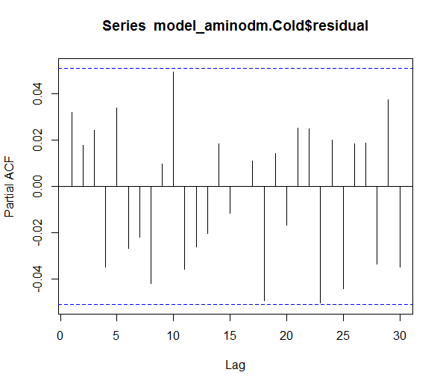
Figure S3.14 Partial Autocorrelation Function (PACF) plot in cold season for DM group.

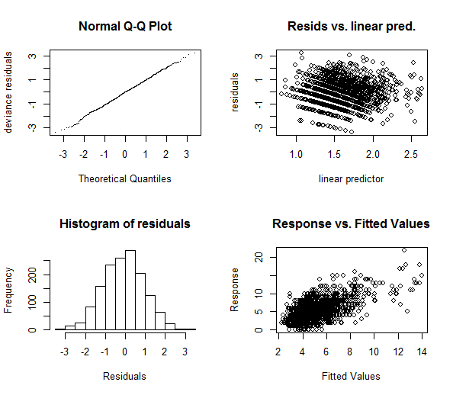
Figure S3.15 Residuals plots in cold season for DM group.
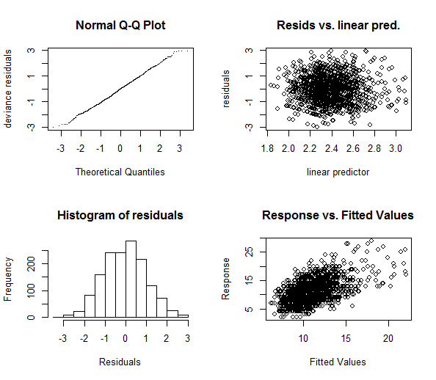
Figure S3.16 Residuals plots in cold season for non-DM group.

