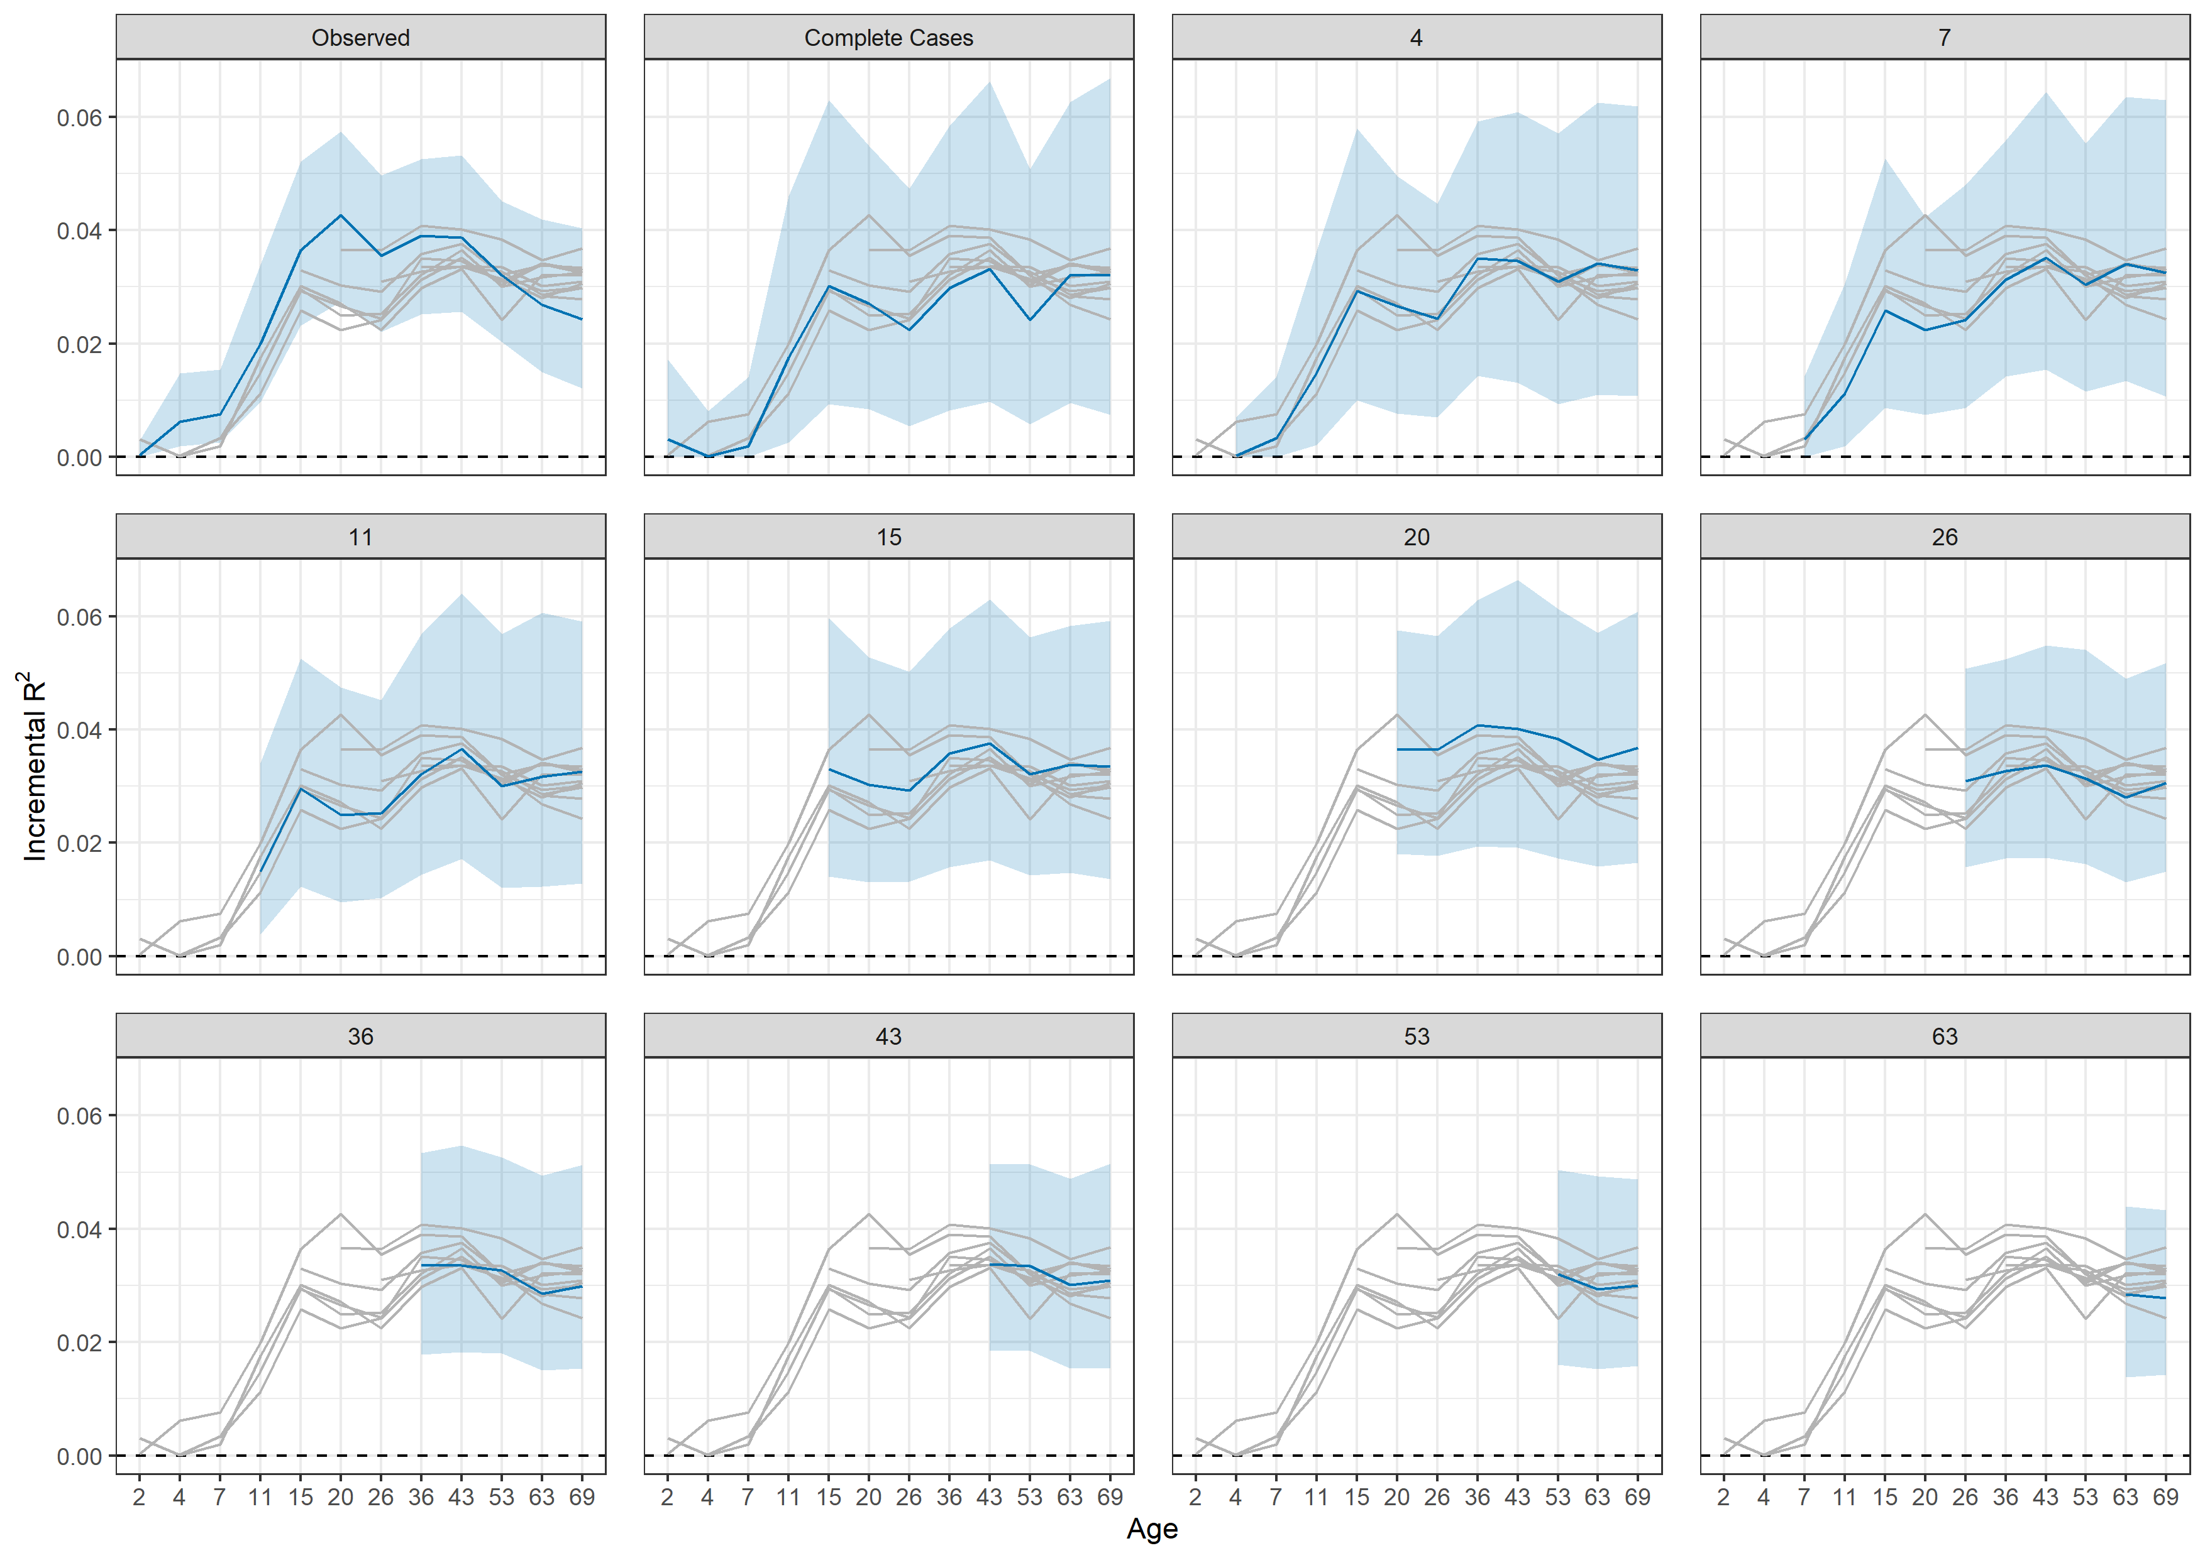
S20 Fig. Incremental proportion of variance in (absolute) BMI explained by Richardson et al. (2020) adult polygenic index. Drawn from OLS regressions compared solely adjusting for sex and first 10 principal components. Regression models repeated at each follow up using observed sample and samples of participants interviewed at each sweep following a given age (panels). Confidence intervals derived from 500 bootstrap replications using the percentile method.

