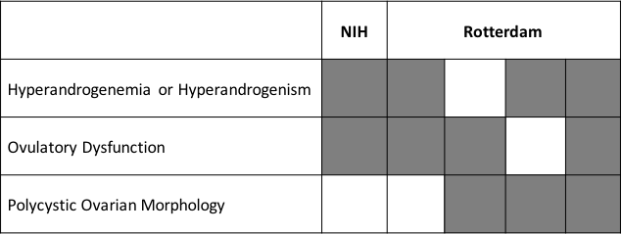
Supplementary Figure 1. Diagnostic criteria of PCOS. Columns represent the diagnostic phenotypes that result from different diagnostic criteria. Grey squares indicate required traits for diagnosis within each diagnostic phenotype.

