**Figure S2. Coded allele frequency across PAGE study sites, by population. European Americans**

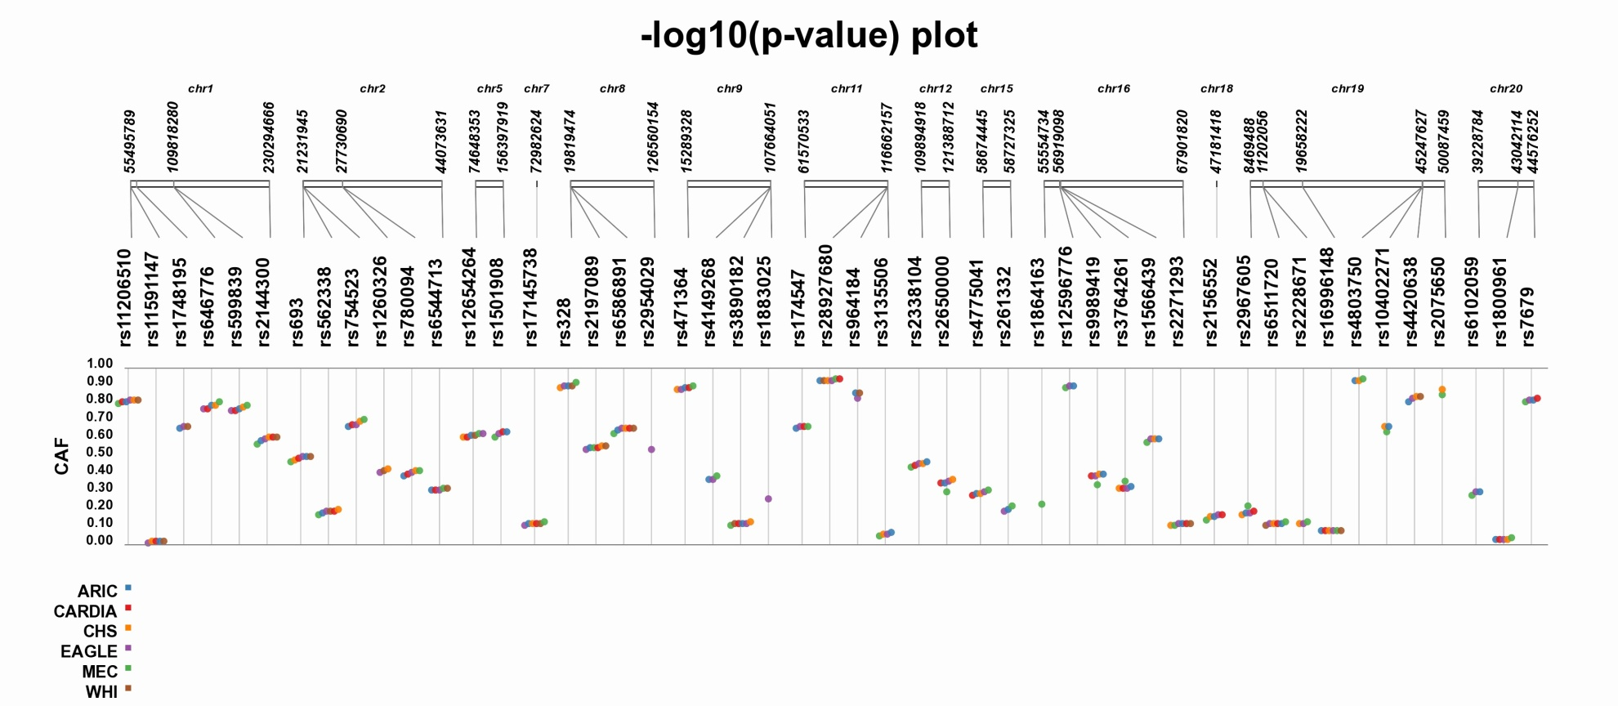

1. **African Americans**

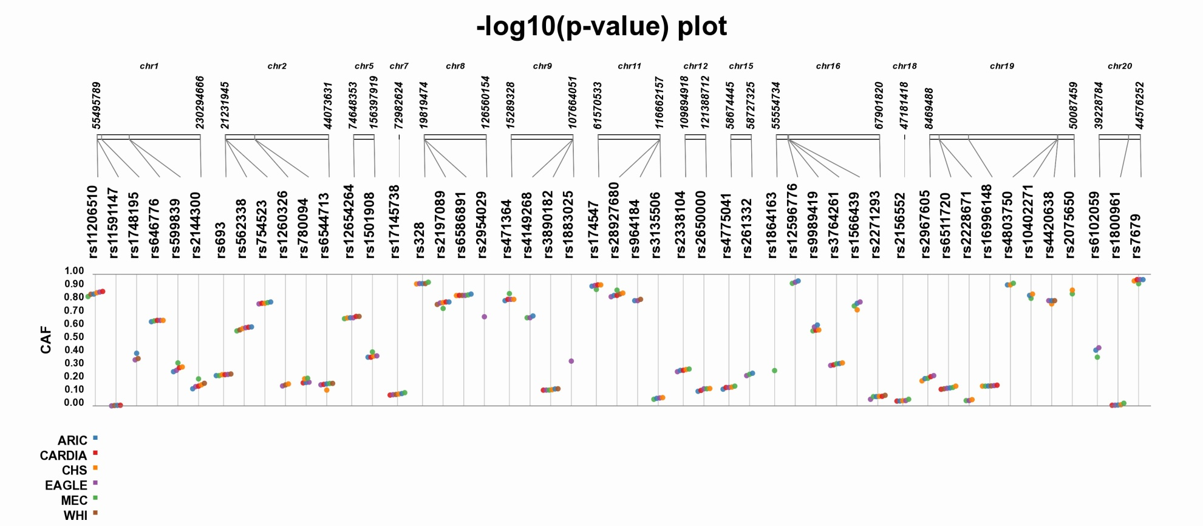

1. **American Indians**

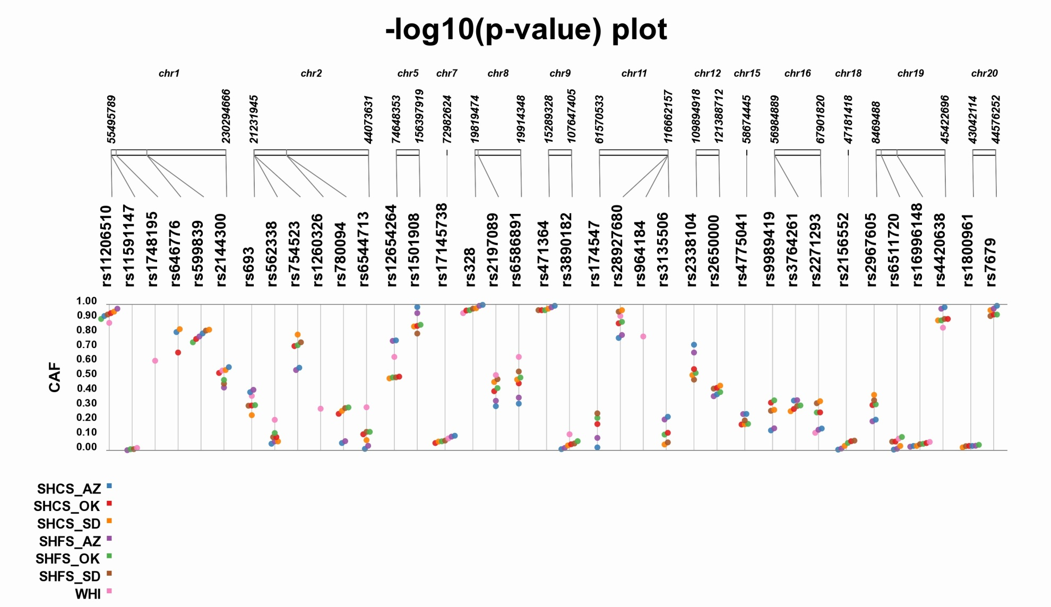

1. **Mexican Americans/Hispanics**

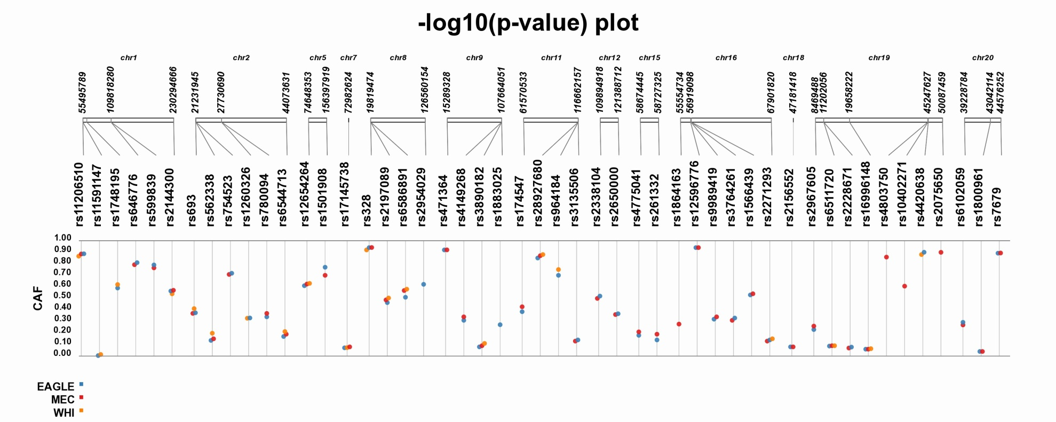

1. **Japanese/East Asians**

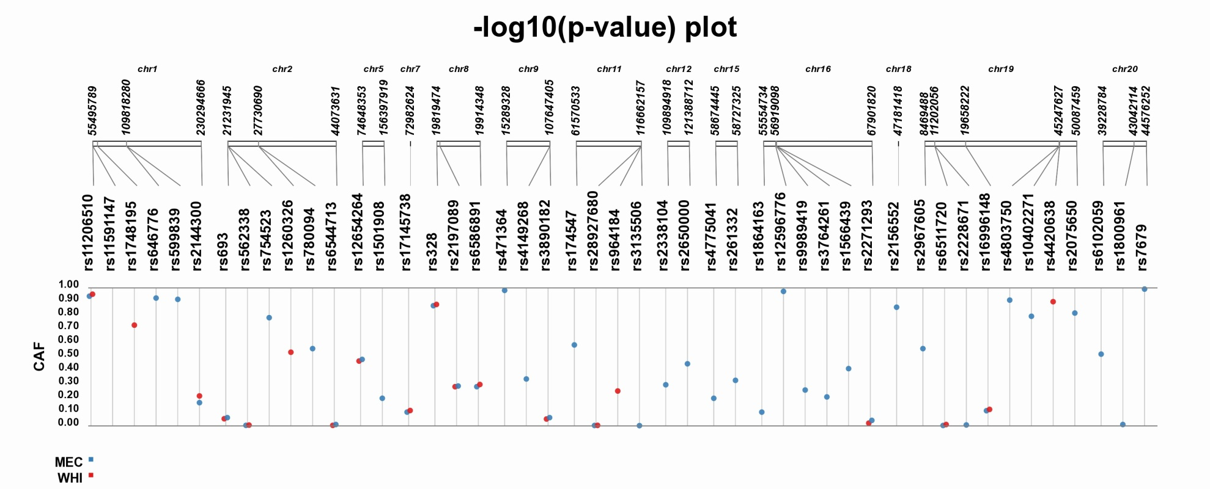

1. **Native Hawaiians/Pacific Islanders**

