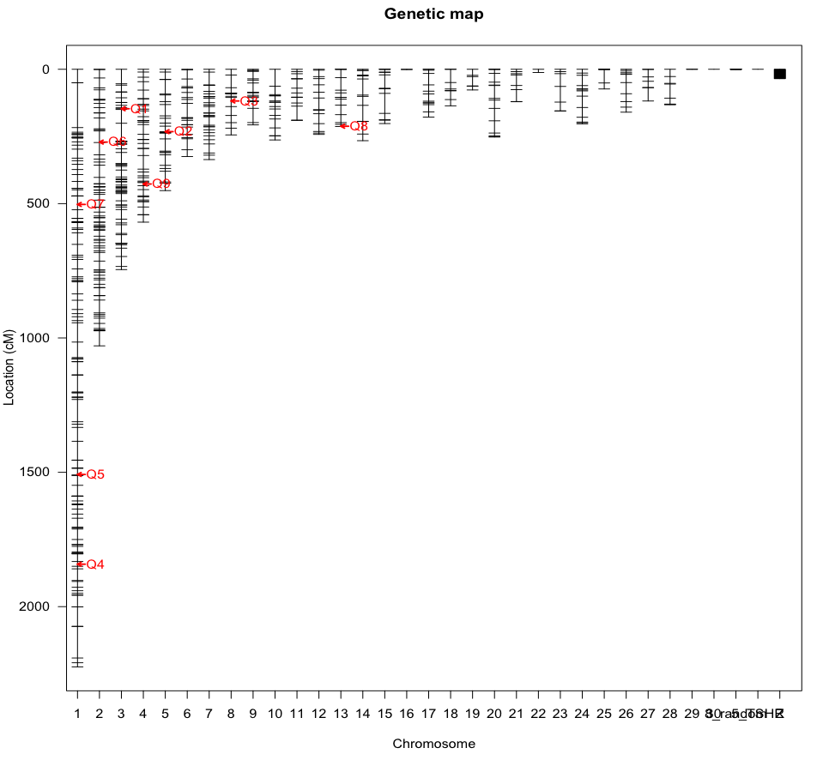Supplementary figure 1

**Q4**

**Q10**

**Q9**

**Q8**

**Q7**

**Q6**

**Q5**

**Q5**

**Q4**

**Q3**

**Q2**

**Q1**

**Q1**

**Q3**

**Q2**

Comb QTL:

F2-L13 = 5 QTL

F2-OS = 10 QTL

F8-L13 = 9 QTL

Overlap of detected QTL between the three different crossing populations P=0.0016

F8-L13 = Red

F2-L13 = Blue

F2-OS = Black