S6 Fig. Plot indicating the number of heterogeneous SNP instruments on chromosome 9 from biomarkers identified in the respiratory support/death as a result of COVID-19 GWAS
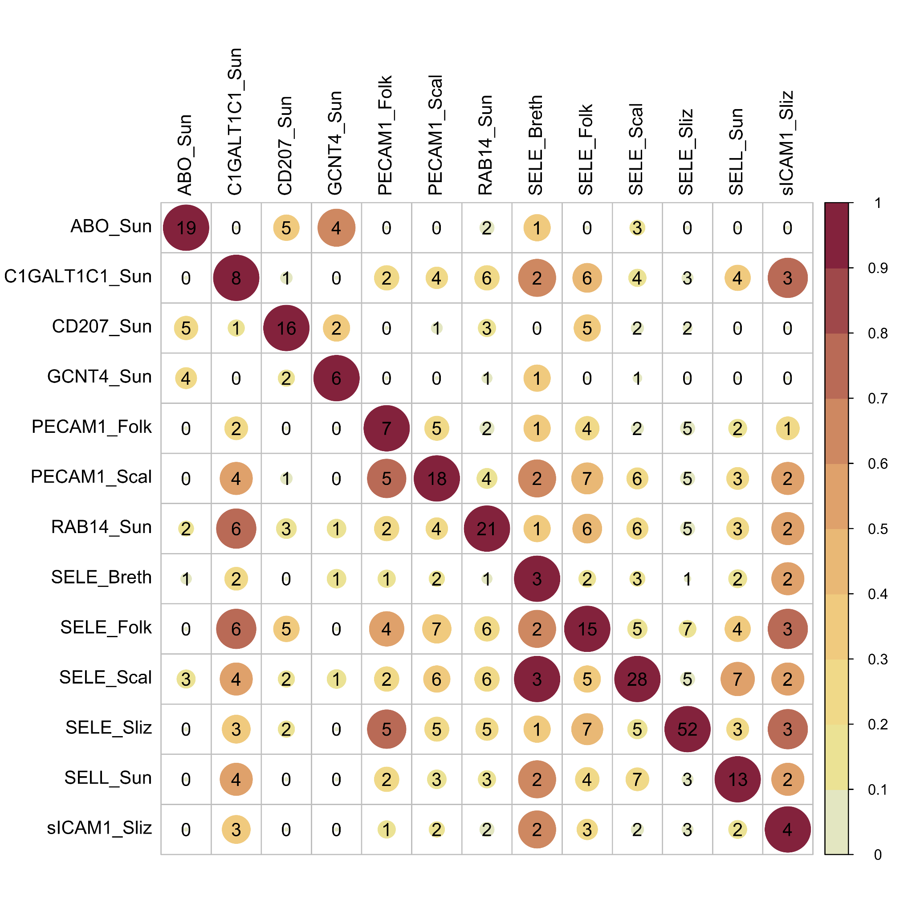

This plot displays the number of SNPs in high linkage disequilibrium (r2>0.6) used as instruments in blood proteins associated with higher/lower odds of espiratory support/death as a result of COVID-19, located on chromosome 9 between different blood markers. The diagonal indicates the total number of instruments for each marker on chromosome 9. The colour and size of the circles indicates which proportion of SNPs shared between the marker in each row and the corresponding column marker. ABO = ABO system transferase; C1GALT1C1 = C1GALT1 specific chaperone 1; CD207 = langerin; GCNT4 = glucosaminyl (N-Acetyl) transferase 4; LCTL = Lactase-like protein; PECAM1 = platelet endothelial cell adhesion molecule; RAB14 = ras-related protein rab-14; SELE = E-selectin; SELL = L-selectin; sICAM1= Soluble intercellular adhesion molecule-1.

