***Figure S2.***

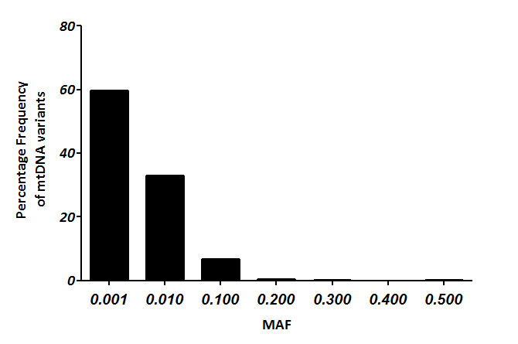

40.41% of variants with MAF>0.01