**S2 Text.** Product ion spectra of identified metabolites in the Swedish cohorts (upper spectrum) and their corresponding standards (lower spectrum) on a UPLC-QTOFMS operated in ESI positive ion mode, as well as for tentatively identified metabolites based on comparisons to public database reference standards.

**Panel 1:** Metabolite eluting at 7.78 min represented by [2M + K]+ = 603.467 identified as oleic acid.

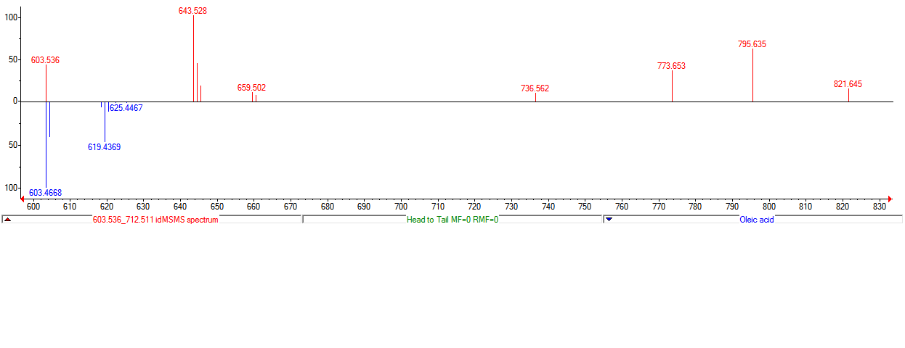

**Panel 2:** Metabolite eluting at 0.73 min represented by a fragment ion at *m/z* 166.058 identified as L-tyrosine.

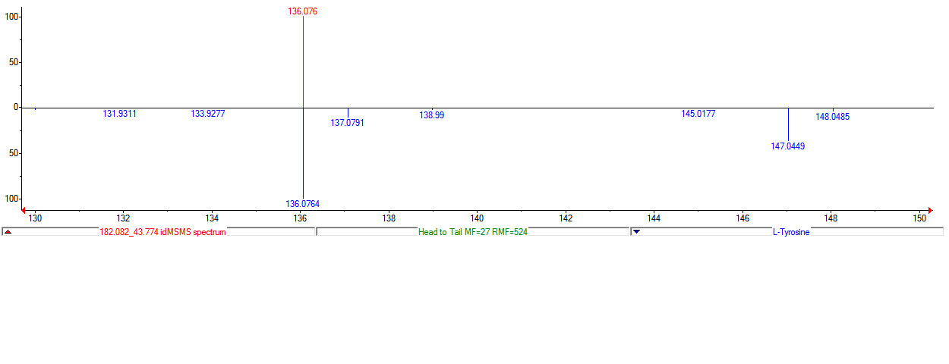

**Panel 3:** Metabolite eluting at 1.90 min represented by [M + H]+ = 202.048 identified as hippuric acid. 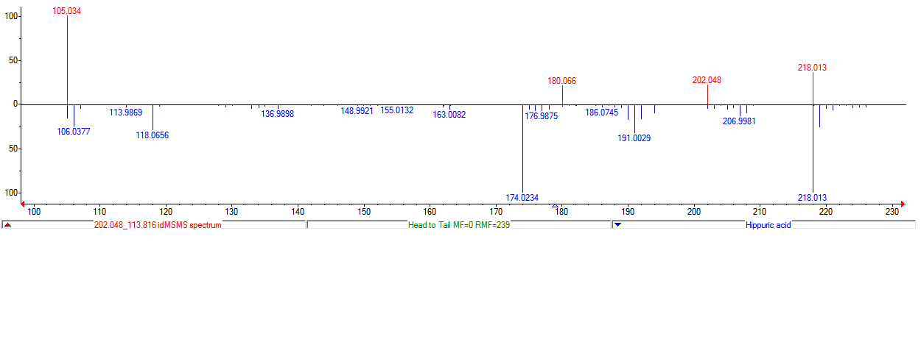**Panel 4:** Metabolite eluting at 4.66 min represented by [M + Na]+ = 431.277 identified as 3a,6b,7b-trihydroxy-5b-cholanoic acid.

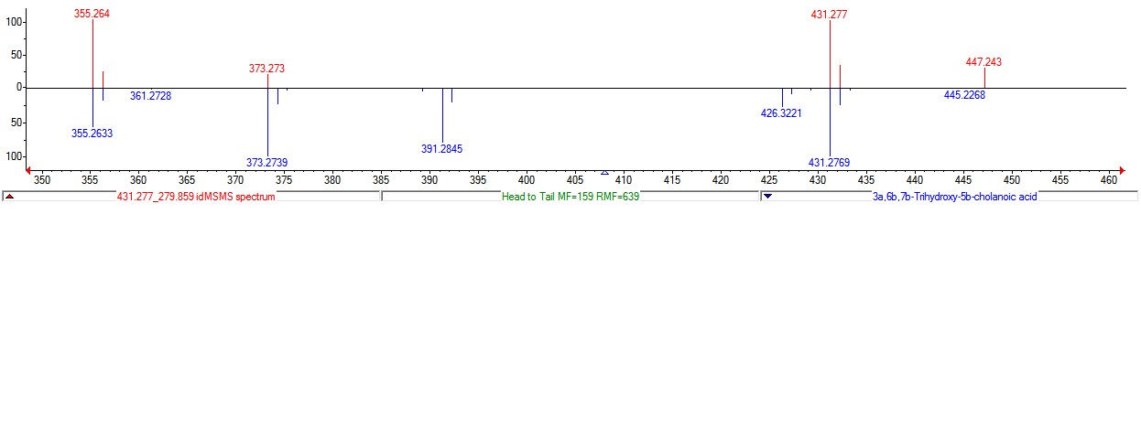

**Panel 5:** Mass spectrum of tentatively identified lysophosphatidylcholine 20:3 (C28H52NO7P, MW = 545.348 Da) and its fragmentation pattern using a UPLC-QTOFMS operated in ESI positive ion mode, where the protonated molecule [M + H]+ = 546.356 and the adduct and fragment ions at *m/z* 568.338 and *m/z* 184.074 are represented by the adduct [M + Na]+ as well as the loss of a phosphocholine group [C5H14NO4P]+, respectively.

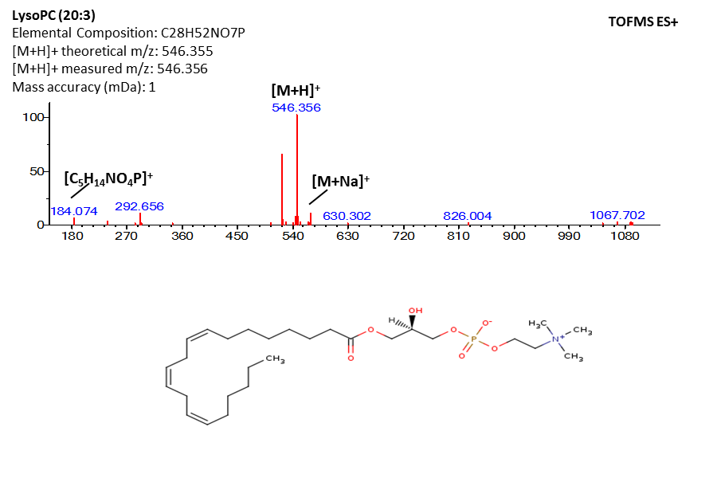

**Panel 6:** Mass spectrum of tentatively identified palmitoleic acid (C16H30O2, MW = 254.224 Da) and its fragmentation pattern using a UPLC-QTOFMS operated in ESI ion positive mode, where the protonated molecule [M + H]+ = 255.232 and the adduct and fragment ions at m/z 293.3179, m/z 277.202, m/z 237.222, m/z 219.211 are represented by adduct formation [M + K]+ and [M + Na]+ as well as the loss of water [M + H - H2O] and [M + H - 2H2O].

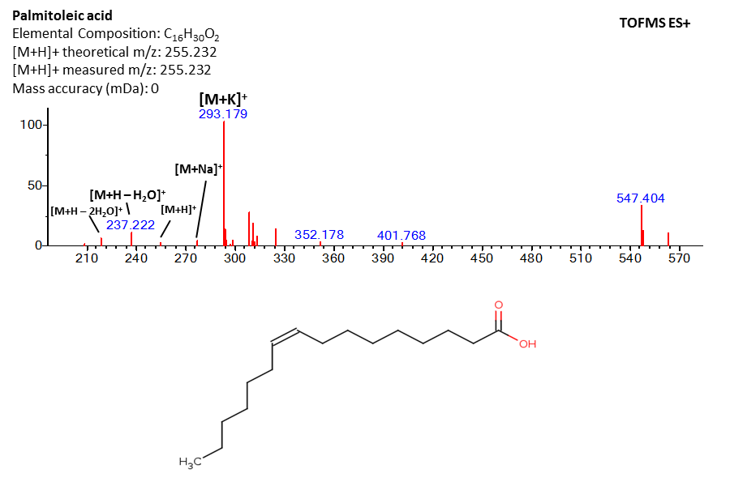

**Panel 7**: Metabolite eluting at 9.66 min represented by [M + H]+ = 431.388 tentatively identified as gamma-tocopherol.

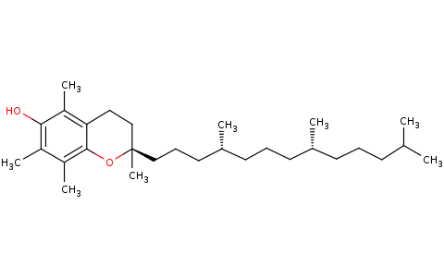

**Gamma-Tocopherol**

Elemental Composition: C28H48O2 [M+H]+ theoretical m/z: 431.388 [M+H]+ measured m/z: 431.388

Mass accuracy (mDa): 0

**TOFMS ES+**

**[M+H]+**

**Panel 8**: Metabolite eluting at 2.39 min represented by [M + H]+ = 585.271 tentativeley identified as bilirubin.



**Bilirubin**

Elemental Composition: C33H36N4O6 [M+H]+ theoretical m/z: 585.271 [M+H]+ measured m/z: 585.271

Mass accuracy (mDa): 0

**TOFMS ES+**

**[M+H]+**

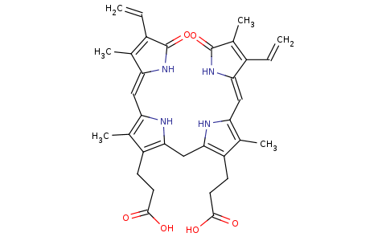

**299**

**Panel 9:** Metabolite eluting at 5.42 min represented by [M + Na]+ = 325.235 identified as monoacylglycerol (14:0).



**Panel 10:** Metabolite eluting at 7.20 min represented by [M + Na]+ = 379.282 identified as monoacylglycerol (18:1).



**Panel 11:** Metabolite eluting at 6.62 min represented by [M + H - H2O]+ = 337.273 identified as monoacylglycerol(18:2).

