**Figure S6** Regional plots of 4 interested regions. Results (-log10 *P*) are shown for SNPs for the region of ﬂanking 400 kb on either side of the marker SNPs. The marker SNPs are shown in purple and the *r* 2 values of the rest of the SNPs are indicated by different colors. The genes within the interested region are annotated and shown as arrows.

(A)



-log10(p-value)

(B)



-log10(p-value)

(C)



-log10(p-value)

(D)

-log10(p-value)

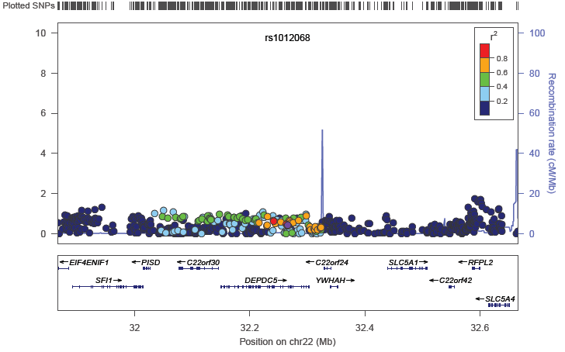

-log10(p-value)