S1 Fig. Effect plots of blood markers associated with an increase in hospitalized COVID-19 risk
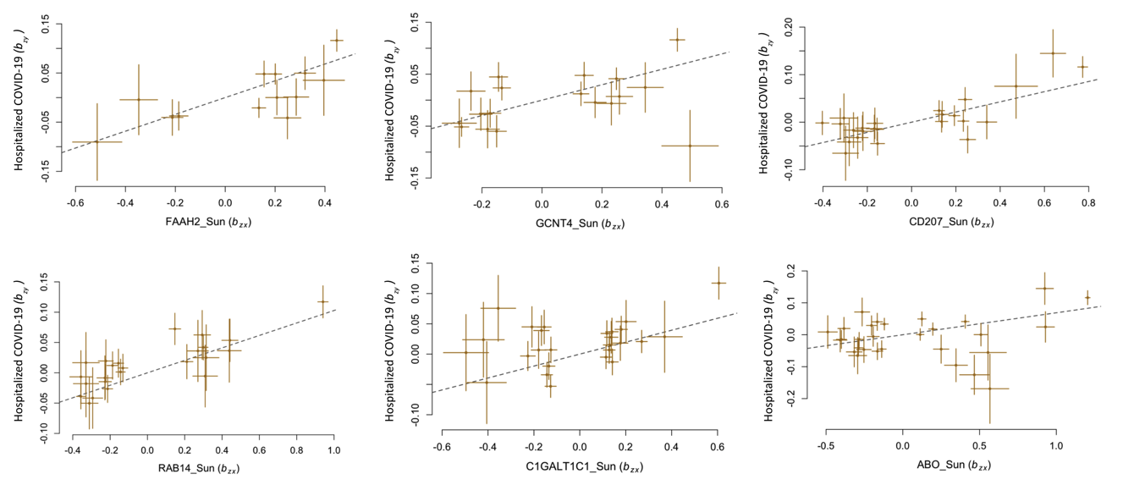

This figure illustrates the SNP effect relationship between significant blood markers (exposure) and an increased risk of hospitalization as a result of COVID-19 (outcome). SNP effects associated with blood markers are displayed on the x-axis and SNP effects associated with hospitalization as a result of COVID-19 are displayed on the y-axis. Each point represents the beta coefficient of these two traits. The horizontal line on each point represents the standard error associated with the exposure and the vertical line on each point represents the standard error associated with the outcome. The dotted line represents the regression line between these two traits.

