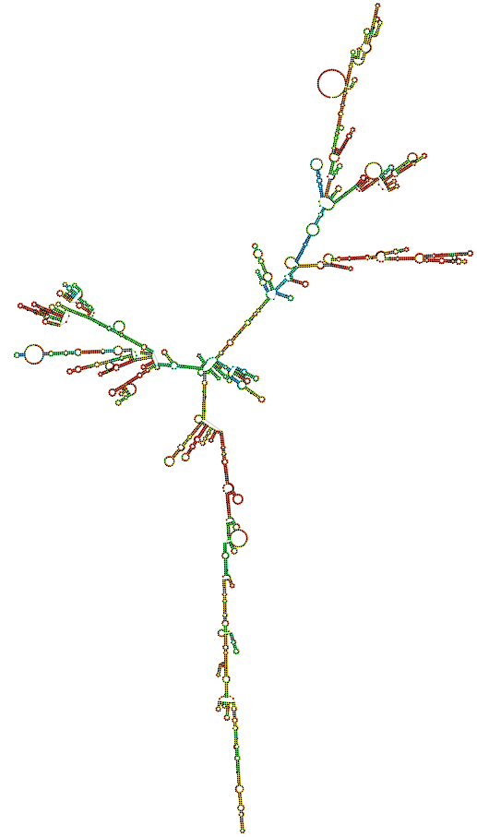
Fig S25. Secondary structure of Rffl-lnc1 transcript 2 in 19bp knock-in targeted rescue model.

