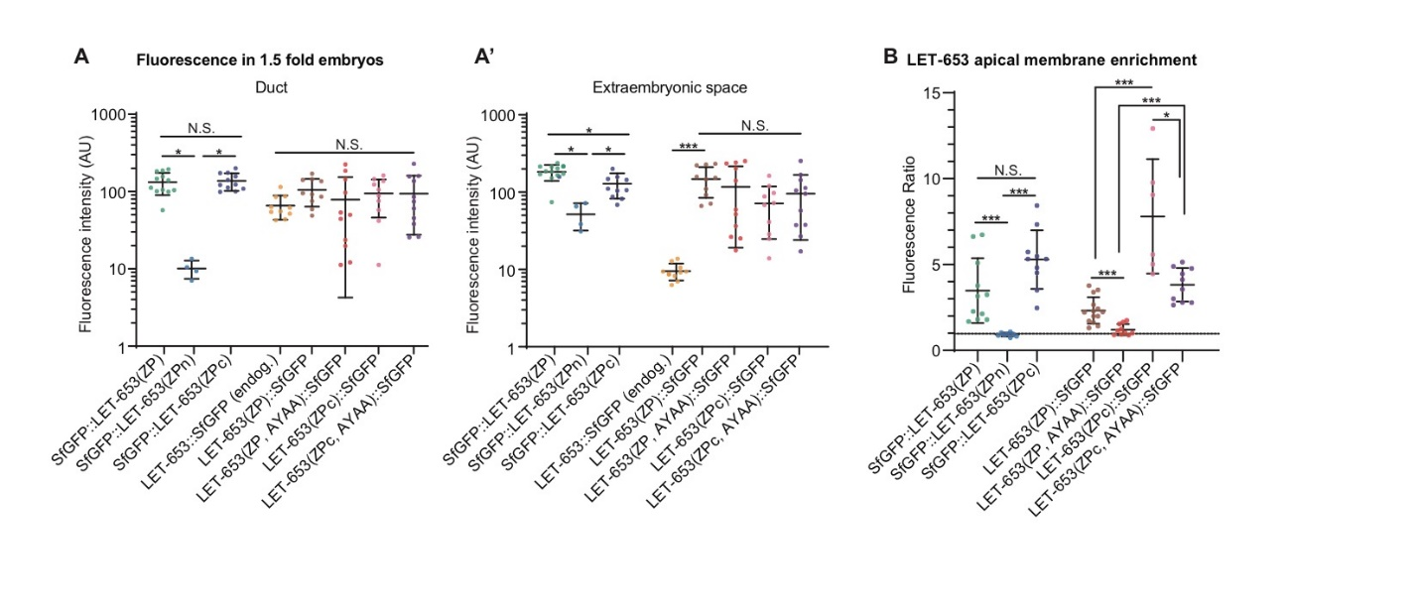
S1 Fig. Method of measuring LET-653 in embryos and vulva
A-A’) Levels of LET-653 fluorescence in the 1.5 fold embryo. Functional transgenes were generally expressed at similar levels to endogenous LET-653 in the duct lumen, but accumulated to much higher levels in the extraembryonic space. Error bars; standard error. B) Quantification of membrane-associated vs. luminal LET-653 in the mid-L4 vulva for all groups. C-terminally and N-terminally tagged LET-653(ZP) and LET-653(ZPc) are not significantly different from one another. However, LET-653(ZPc, AYAA) is significantly more enriched at the apical membrane than LET-653(ZP, AYAA), and this result correlates with increased function in LET-653(ZPc, AYAA) vs LET-653(ZP, AYAA) (Figures 4-5). Dashed line indicates a ratio of 1, where membrane fluorescence is equal to luminal fluorescence. Error bars; standard error.

