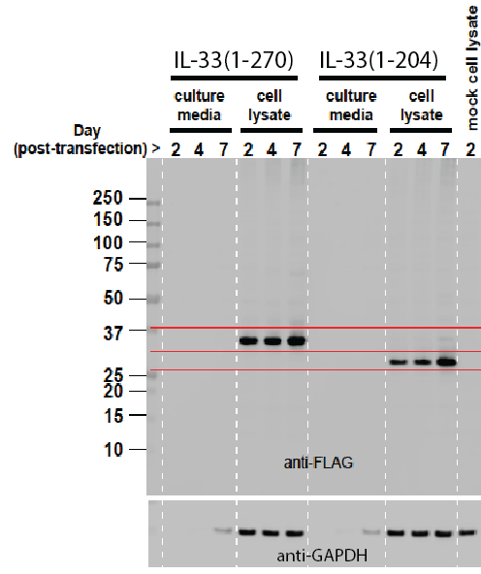

S3 Fig. Western blot of mammalian cell-expressed human (FLAG-tagged) IL-33 protein variants. Molecular weight markers (in kD) are indicated on left. After SDS-PAGE separation and transfer to nitrocellulose of samples that were collected at day 2, 4 or 7 following transfection, membranes were stained with anti-FLAG antibody to indicate IL-33 and anti-GAPDH to control for protein loading.

