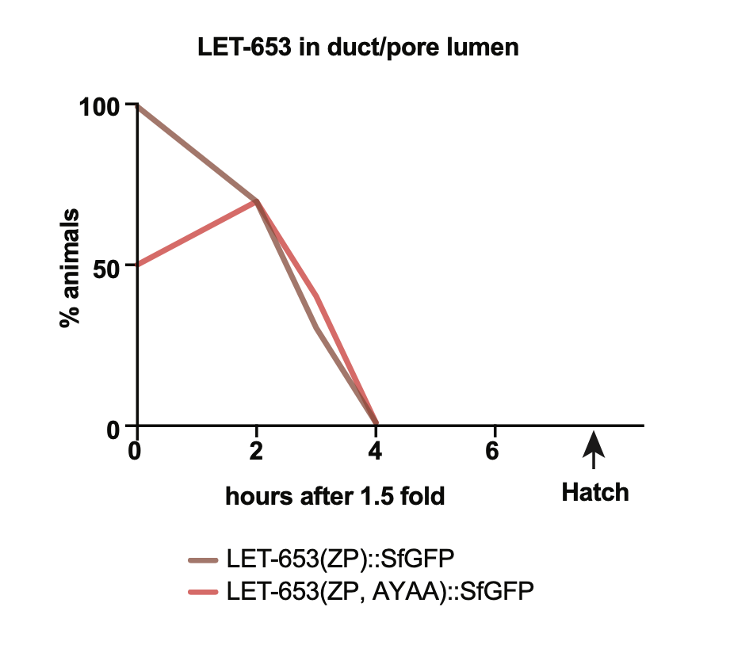
S2 Fig. LET-653(ZP, AYAA) is cleared normally from the embryonic duct.
LET-653(ZP) and LET-653(ZP, AYAA) are both present in the duct lumen at 1.5 fold stage but are gradually cleared over several hours. Presence of LET-653 in the duct lumen was assessed visually via epifluorescence microscopy. LET-653(ZP, AYAA) was sometimes too faint to be detected within the duct lumen at the 1.5 fold stage. n = 20 for each time point.

