Results from two sample MR for height as exposure and BP as outcome
Table A3-1. Results from two sample MR for 326 and 312 SNPs.
Method | 326 instruments |  |  | 312 instruments
 | b | se | pval | b | se | pval
Inverse variance weighted | 0.098 | 0.023 | 4.2E-05 | 0.088 | 0.021 | 3.0E-05
MR Egger | 0.088 | 0.067 | 0.19 | 0.086 | 0.060 | 0.15
Weighted median | 0.127 | 0.032 | 5.3E-05 | 0.127 | 0.033 | 0.0001
Weighted mode | 0.156 | 0.064 | 0.015 | 0.162 | 0.074 | 0.028

Table A3-2. Results of heterogeneity test.
Number of instruments | Q | Q_df | Q_pval | I²
326 | 499.35 | 325 | <1e-22 | 0.35
312 | 355.33 | 311 | 0.04 | 0.12

Table A3-3. Results of test for directional horizontal pleiotropy.
Number of instruments | egger_intercept | se | pval
326 | 3.1E-04 | 0.002 | 8.8E-01
312 | 9.0E-05 | 0.002 | 9.6E-01

Figure A3-1. Forest plots of single SNP MR before (A) and after (B) removing outliers.
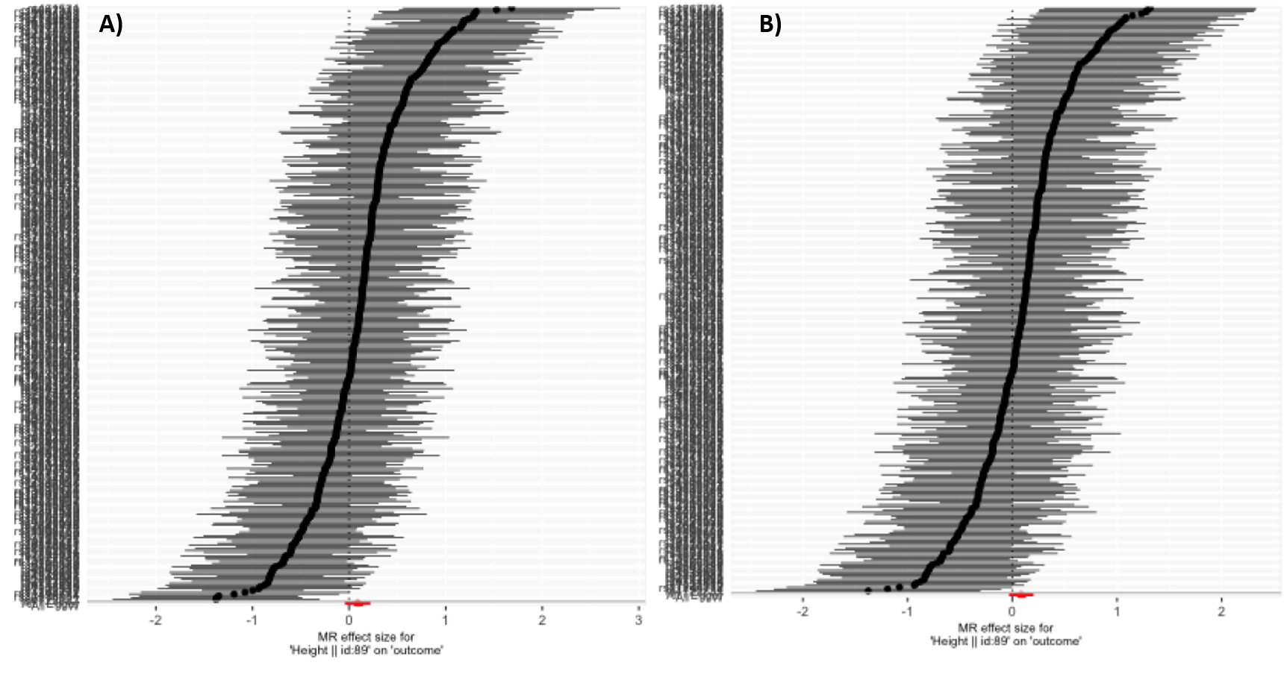

Figures A3-2. Funnel plots before (A) and after (B) removing outliers.
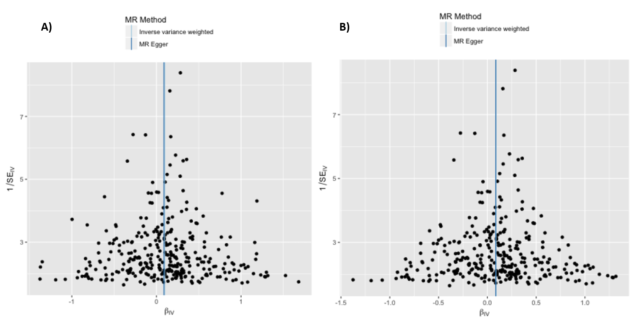

Figures A3-3. Leave-one-out sensitivity analysis before (A) and after (B) removing outliers.
