Supplementary Figure S5: Populated locations (points) and Population sizes in (A) Brazil, (B) Chile, (C) Colombia, (D) México and (E) Perú.

Settlement point locations and population sizes were obtained from GRUMP (http://sedac.ciesin.columbia.edu/data/set/grump-v1-settlement-points/). Population numbers from year 1990 are used, as the median age in our data ranges between 20-25 for each country.
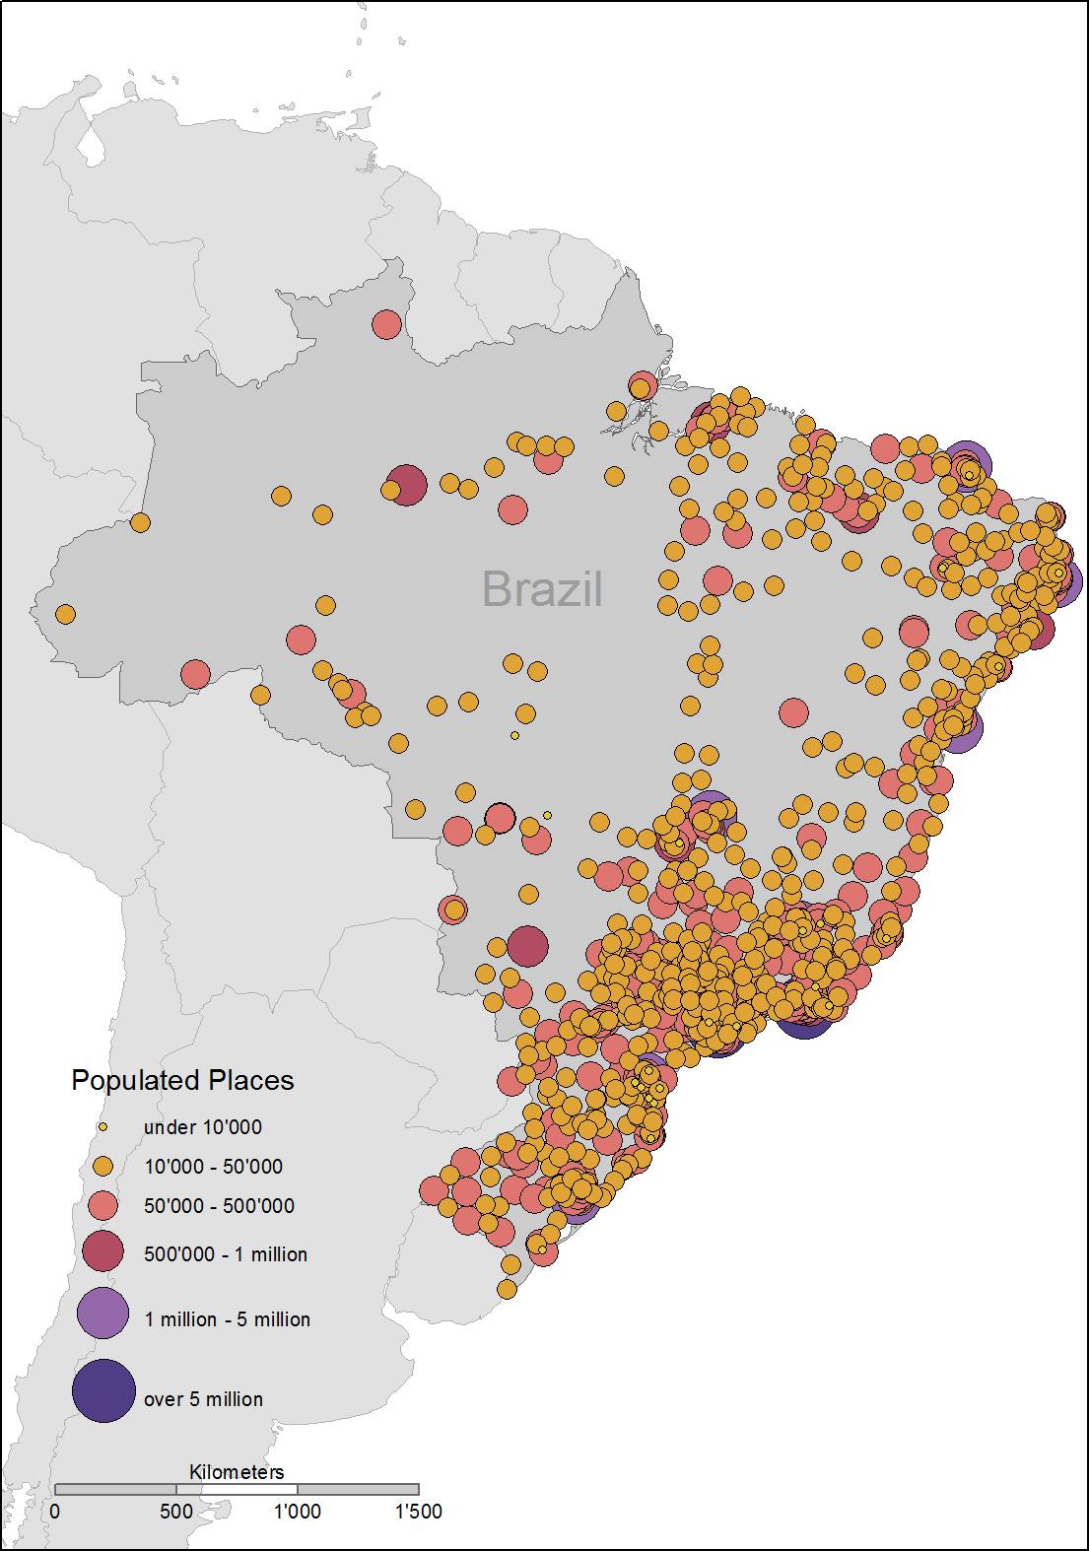
(A) Brazil

(B) Chile
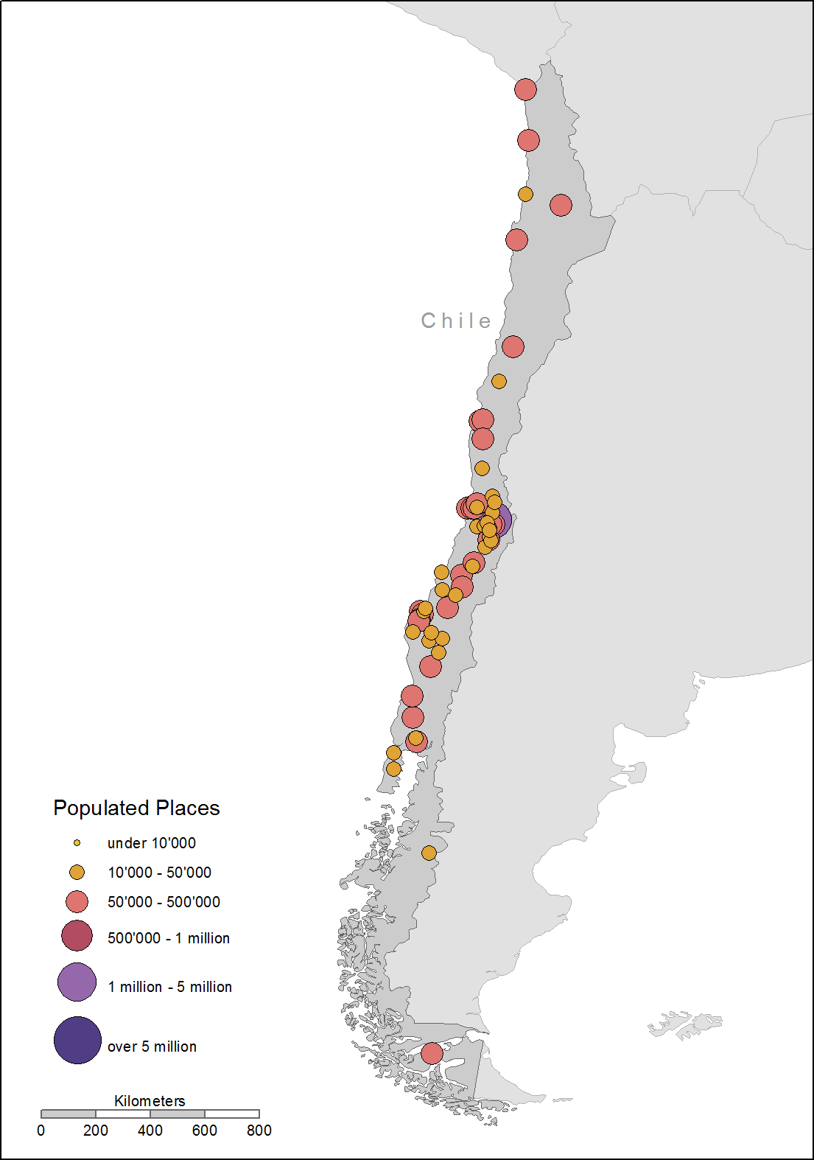

(C) Colombia
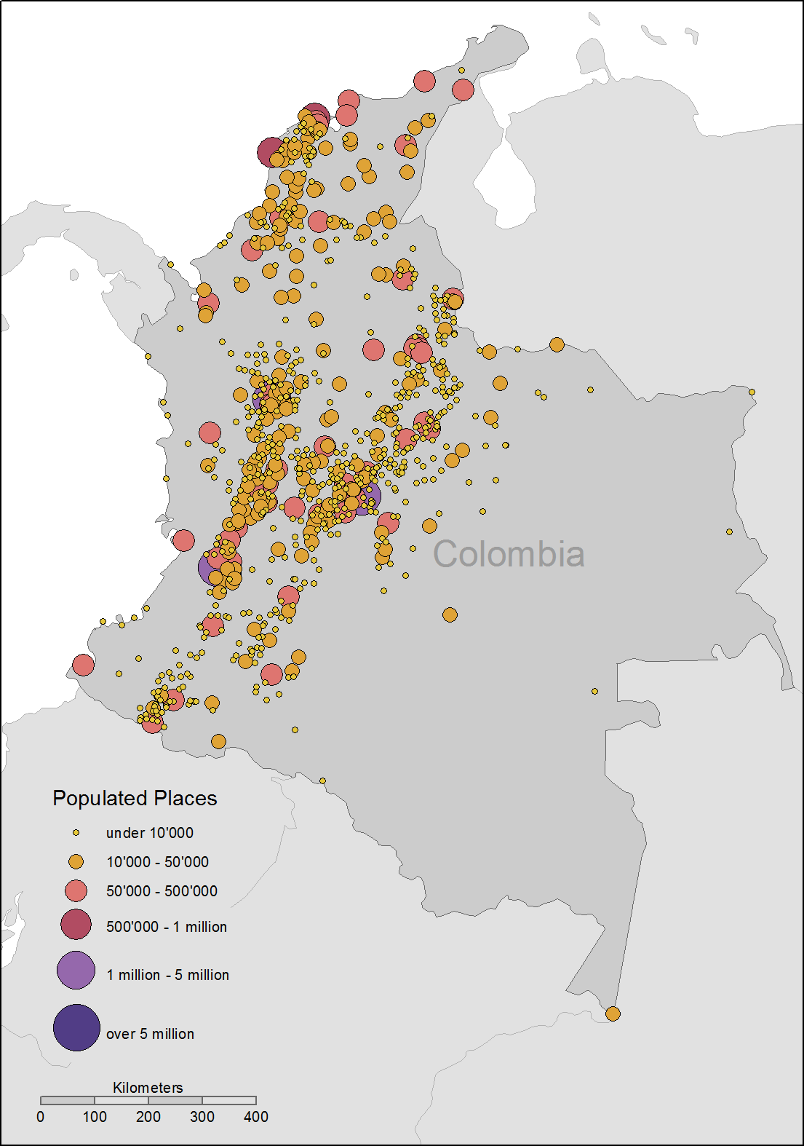
(D) Mexico
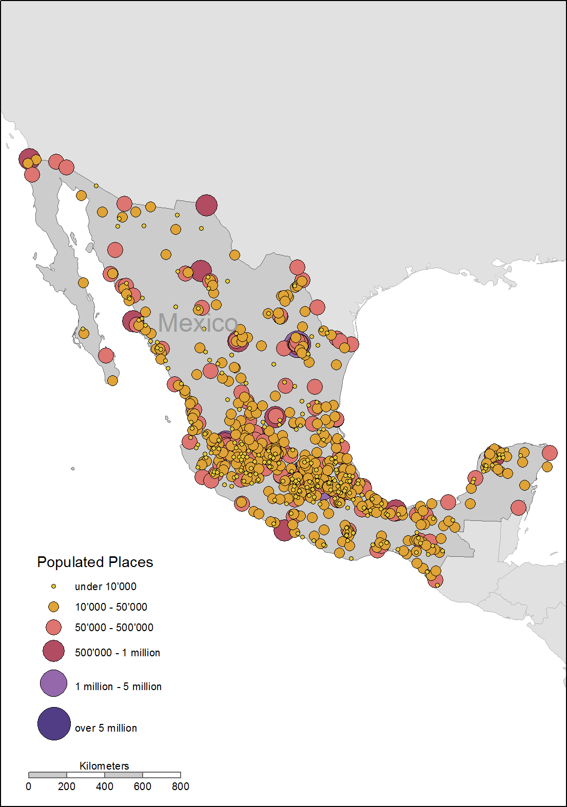
(E) Perú
