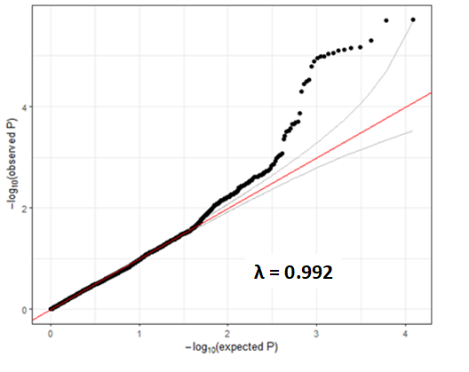
Supporting Information Figure 1: QQ plot and the lambda value of the interaction term in the primary logistic regression model.

