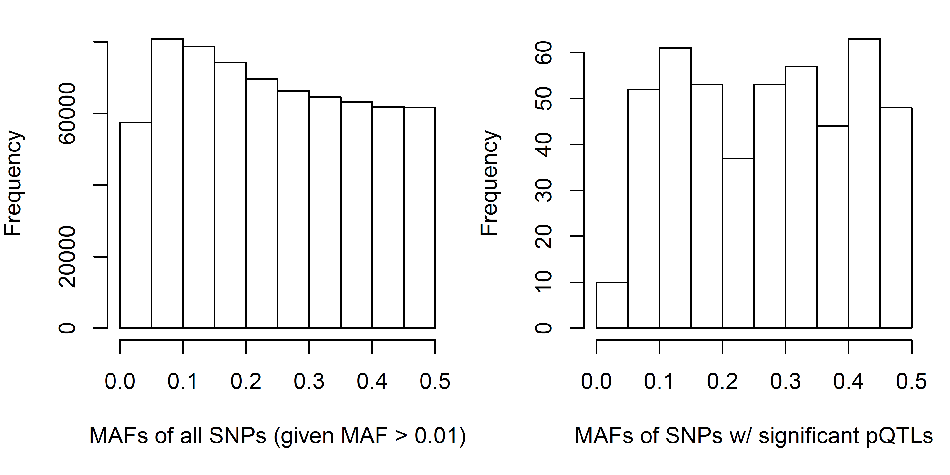
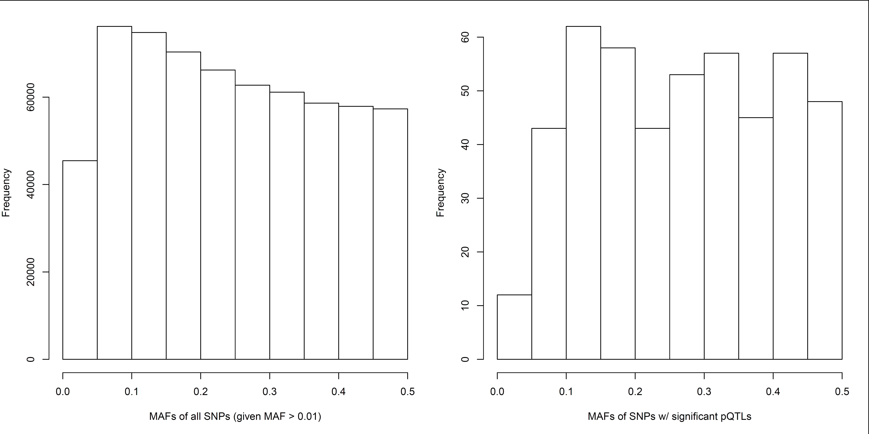
S6 Fig. The highly significant pQTL SNPs (right panels) represent a distribution of minor allele frequencies similar in distribution to all SNPs in the study (left panels). SPIROMICS (top panel); COPDGene (bottom panel).

