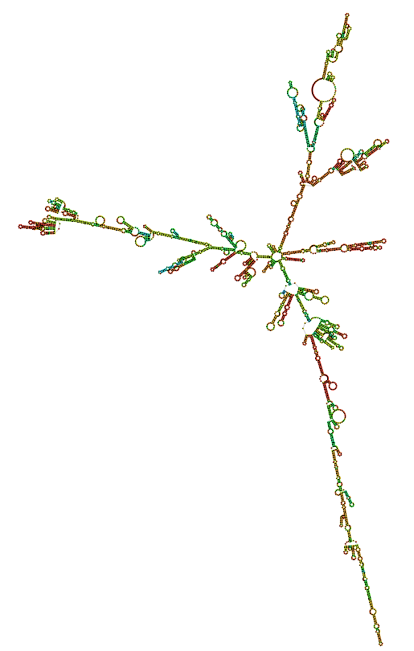
Fig S6. Secondary structure of Rffl-lnc1 transcript 4 in Dahl S rat.

