Supporting Information 2: Effects of chronic AF remodelling on single cell electrophysiology

The functional impact of the mutations on single-cell AP morphology in chronic AF (cAF) conditions was consistent between groups of mutations and cell models: gain-of-function mutations shortened the APD whereas loss-of-function mutations prolonged the APD compared to the remodelled WT (Figure A).
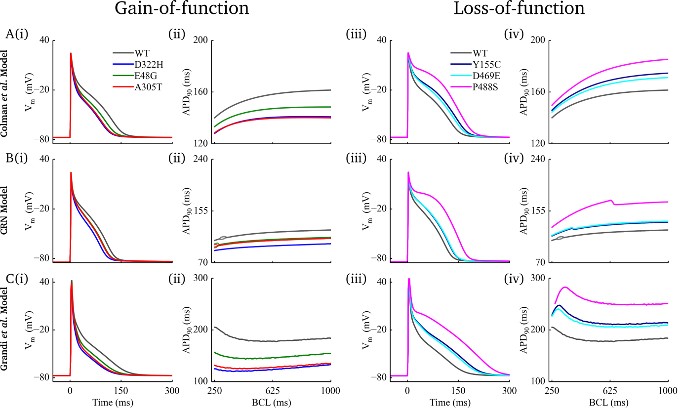
Figure A. Effects of KCNA5 mutations on AP and APD restitution in the presence of cAF remodelling in the three cell models. The three rows show results obtained using (A) Colman et al., (B) Courtemanche et al. (CRN) and (C) Grandi et al. models.

