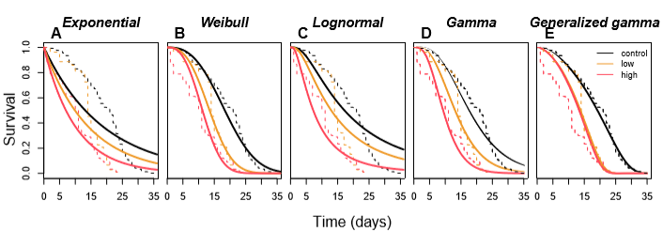

S3 Fig. Estimated dose effects of an experimental SR product containing transfluthrin on mosquito longevity. (A) exponential, (B) Weibull, (C) lognormal, (D) gamma, and (E) generalized gamma models. The dashed lines depict the Kaplan-Meier curves at associated dosages (control, low, high).

