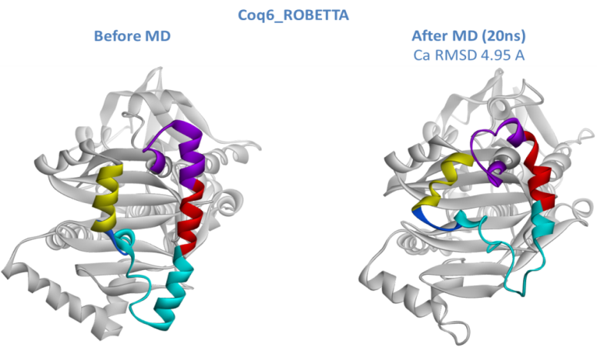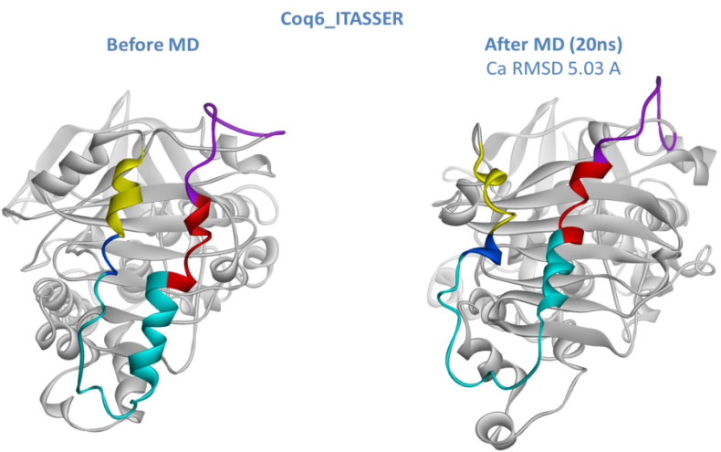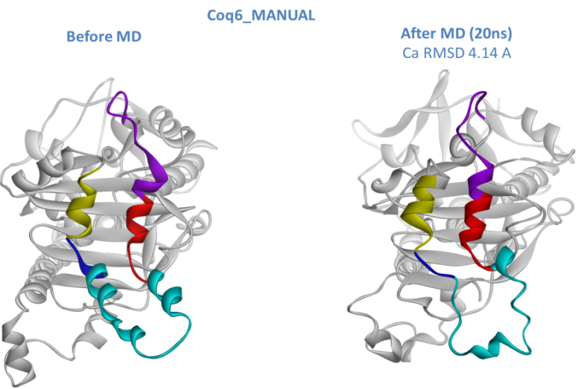
helix8
insertion N-terminal side
ascending
element
insertion C-terminal side
Coq6_MODELLER

S11 Fig. Comparison of conformations of the three Coq6p models before and after 20 ns MD. Colors refer to helix 8 (yellow) and sub-sections of the Coq6p insert (N-terminal side of the insert in cyan, ascending part in red, C-terminal side of the insert in purple) as annotated in the alignment with 2X3N shown below. FAD is not shown for clarity.

