A
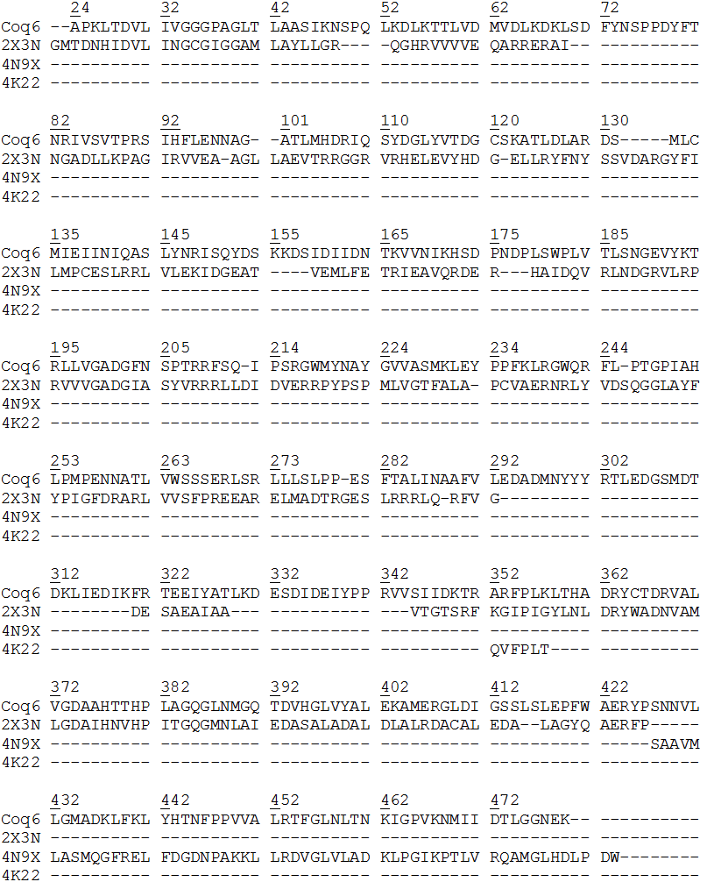
B
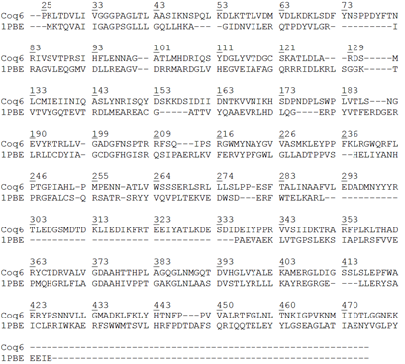
S6 Fig A-B. Alignments used for the generation of the Coq6p homology models. A) Manually curated alignment used for the construction of Coq6p_MODELLER model. B) ROBETTA template construction alignment.

C
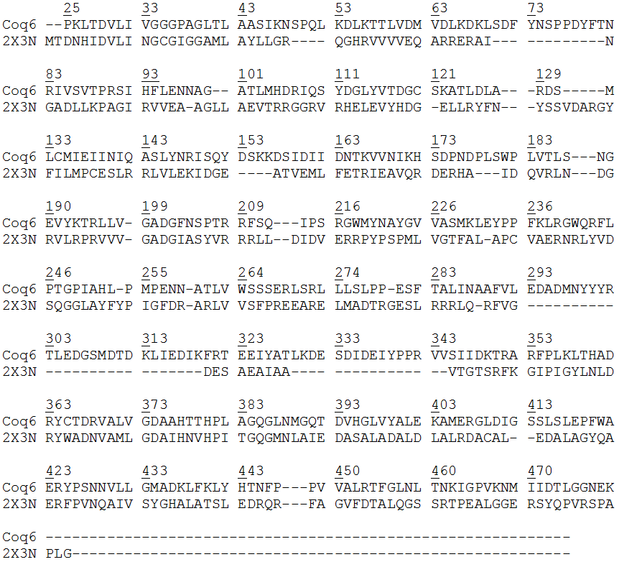
S6 Fig C. Alignments used for the generation of the Coq6p homology models. I-TASSER template construction alignment.

