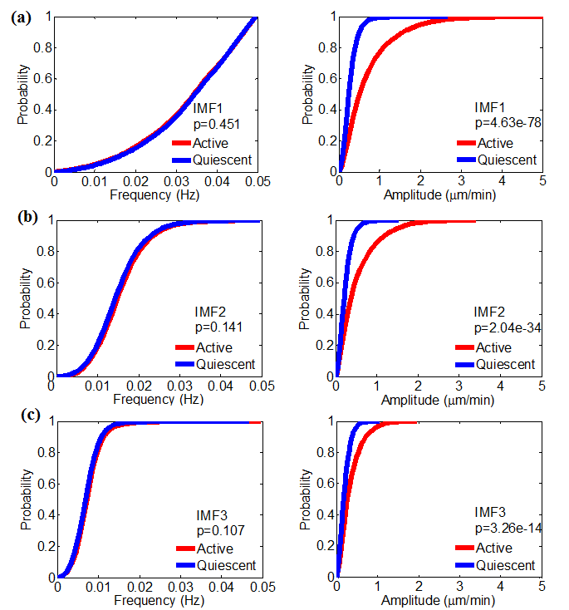
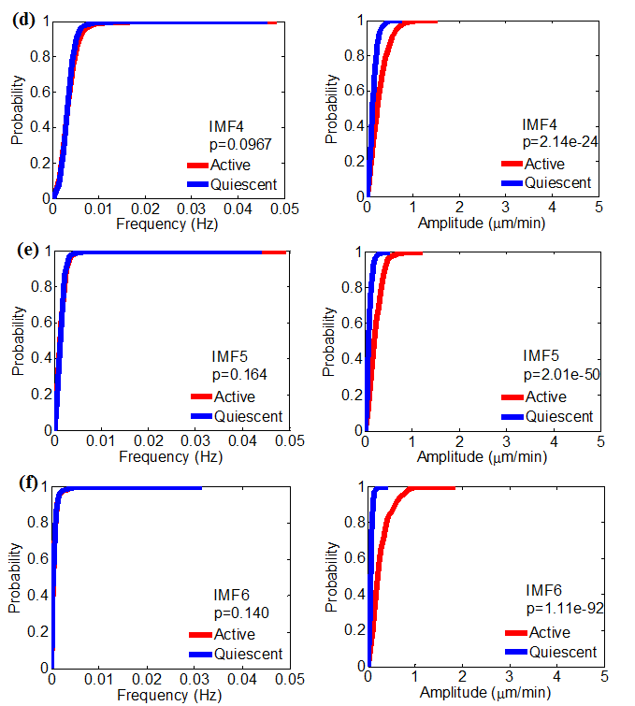S3 Fig Cumulative distribution function (CDF) comparison of instantaneous frequency distributions for all intrinsic mode functions (IMFs) between an active and a quiescent Cos7 cell. P-value is calculated by Kolmogorov–Smirnov (K-S) test. From (a) to (f), results of IMF1 till IMF6 are presented. Left: CDFs of instantaneous frequency; Right: CDFs of instantaneous amplitude.

