Supplementary Material: S1 Fig
Modelling thalamocortical circuitry shows visually induced LTP changes laminar connectivity in human visual cortex

Event Related Potential Maximum Intensity Projection

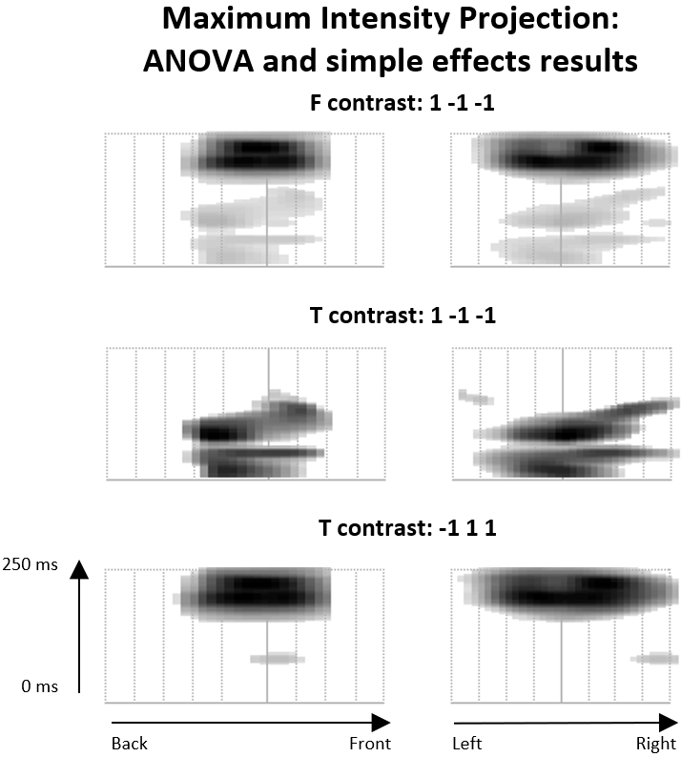

Maximum intensity projection (MIP) image from SPM12 family-wise error corrected results shows spatial and temporal distribution of the significant clusters. Note: Standard glass brain MIP not shown as occipital-parietal selection of electrodes is not rendered accurately on the glass brain.

