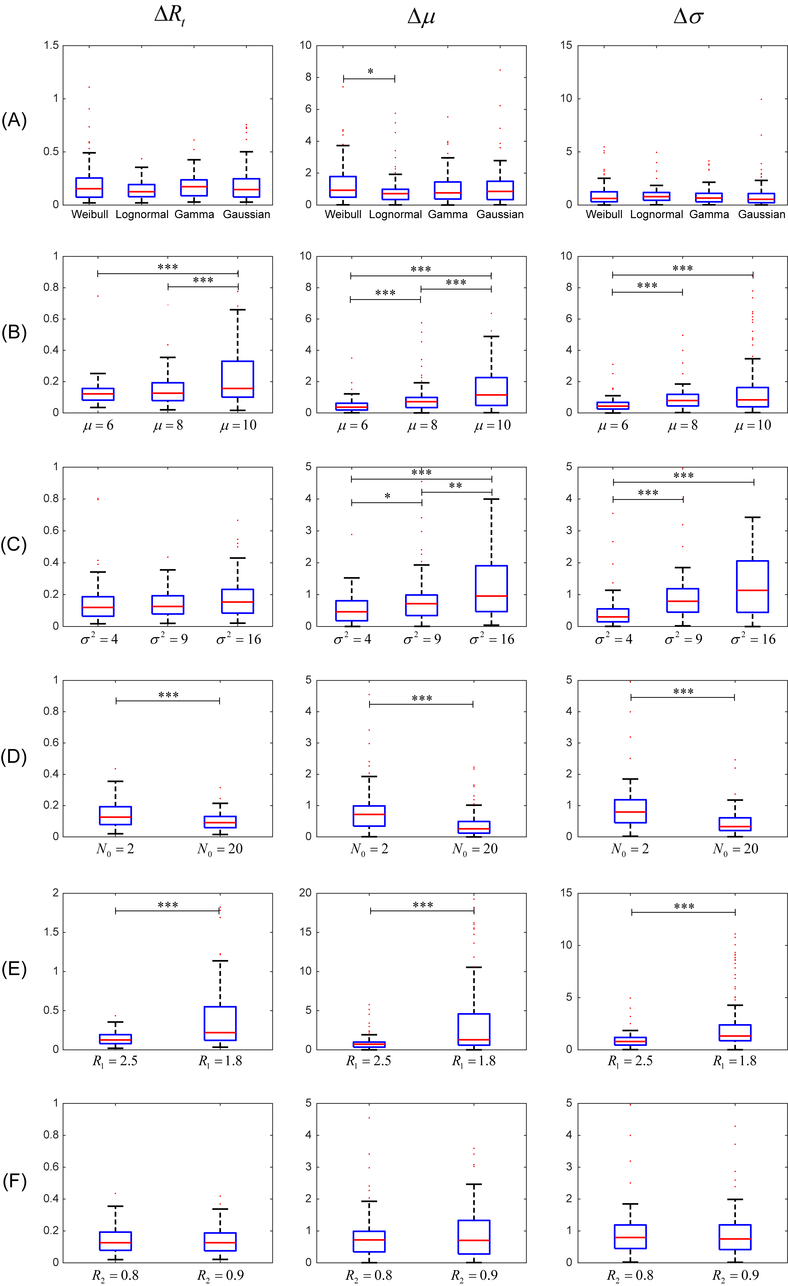

S3 Fig. The performance of our method after varying different parameters. The left, middle and right panels present the results for , , and , respectively. (A) Serial interval distribution. (B) Mean value of the serial interval. (C) Standard deviation of the serial interval. (D) The number of initial cases. (E) The epidemic severity R₁. (F) The effectiveness of control measures R₂. Simulations were performed based on the assumptions that the number of initial cases was 2, the serial interval exhibited a lognormal distribution with a mean and variance of 8 and 9, respectively, and a constant R before (R₁=2.5) and after (R₂=0.9) a control measure on day 40. When we varied a parameter to study its effects, the others were kept unchanged. *: P<0.05, **: P<0.01, and ***: P<0.001.

