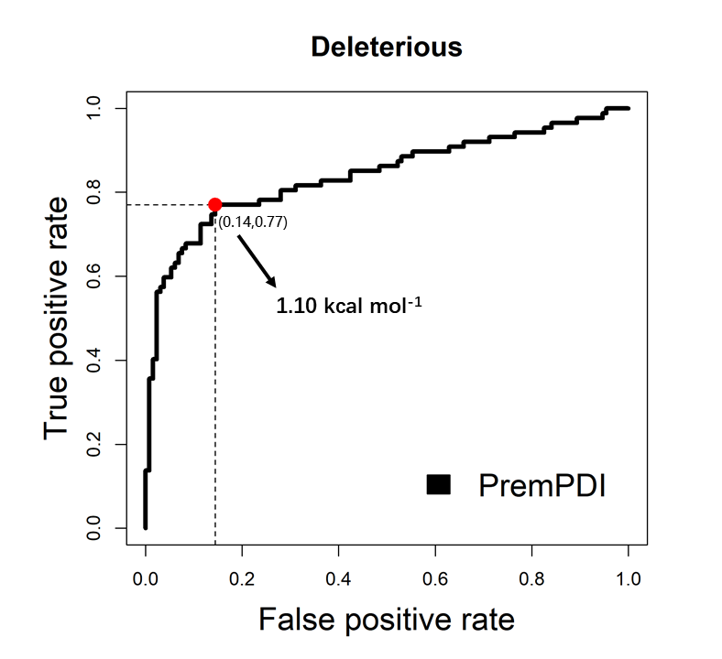

Fig S3. ROC curve for predicting deleterious mutations by applying PremPDI on the training set of “Prempdi”. Red point corresponds to the minimization of the value of error ER=$\sqrt{{(1-TPR)}^{2}+{FPR}^{2}}$.

