Supporting Information 10: 3D anatomical model of the human atria

The anatomical atrial model is derived from the visible human dataset [1] and segmented into the major differentiated anatomical regions [1,2]. A reconstruction of the SAN [3] was previously incorporated into the model (Figure A, Ai-ii). It successfully reproduces normal atrial activation patterns observed in the human atria (Figure A, Bi-ii), with conduction velocities of 1.3 m/s in CT and 0.7 m/s in RA, in accordance with experimental values [2]. These velocities are reduced to 0.8 and 0.46 m/s in the most severe remodelling case (40 % D). In the 3D simulations, the atria were paced from the SAN region (shown in red in Figure A, Ai).
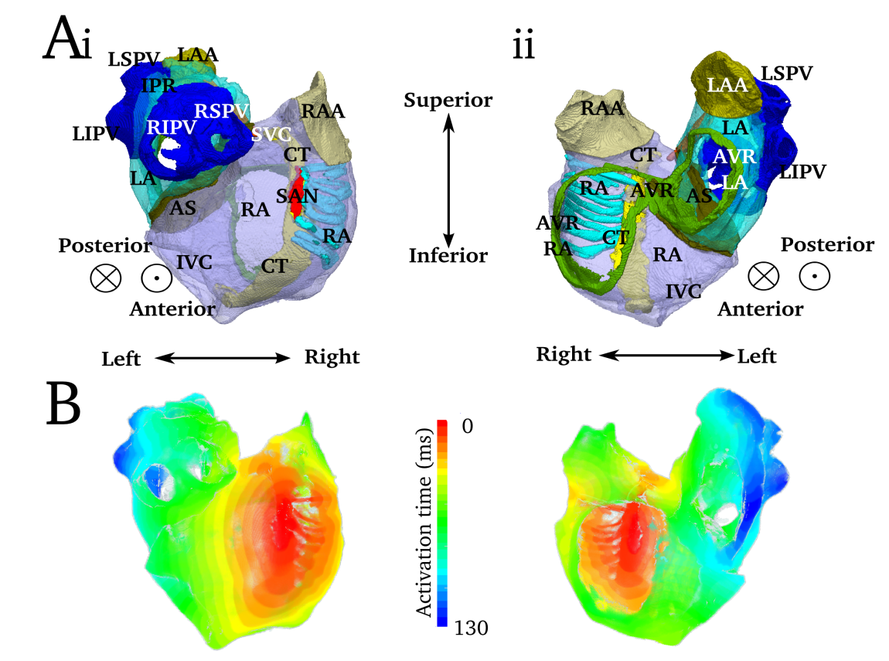
Figure A. Segmented anatomical reconstruction of the human atria (A) and the activation pattern under sinus rhythm (B) from two different views (i,ii). RA = right atrium, LA = left atrium, PV = pulmonary vein (Right/Left and Inferior/Superior), IPR = inter pulmonary region, LAA/RAA = left/right atrial appendage, SVC/IVC = superior/inferior vena cava, AVR = atrio-ventricular ring, CT = crista terminalis, SAN = sino-atrial node, AS = atrial septum.

Reference
1. Seemann G, Höper C, Sachse FB, Dössel O, Holden AV, Zhang H. Heterogeneous three-dimensional anatomical and electrophysiological model of human atria. Philos Transact A Math Phys Eng Sci. 2006;364: 1465–1481. doi:10.1098/rsta.2006.1781
2. Colman MA, Aslanidi OV, Kharche S, Boyett MR, Garratt C, Hancox JC, et al. Pro-arrhythmogenic Effects of Atrial Fibrillation Induced Electrical Remodelling- Insights from the 3D Virtual Human Atria. J Physiol. 2013;591: 4249–4272. doi:10.1113/jphysiol.2013.254987
3. Chandler N, Aslanidi O, Buckley D, Inada S, Birchall S, Atkinson A, et al. Computer three-dimensional anatomical reconstruction of the human sinus node and a novel paranodal area. Anat Rec Hoboken NJ 2007. 2011;294: 970–979. doi:10.1002/ar.21379

