Supplements
Dynamics of the Heat Stress Response of Ceramides with Different Fatty-Acyl Chain Lengths in Baker’s Yeast
Po-Wei Chen, Luis L. Fonseca, Yusuf A. Hannun, Eberhard O. Voit

S3 Text: Magnitudes of enzyme activities
It was already mentioned in the main text that the actual enzyme amounts and rate constants are not known. As it is typical, we assume that enzyme activities enter a flux representation in a linear manner. With this assumption we obtain coarse estimates of the product of the rate constant and the enzyme activity. This product corresponds to a V_{max} value, which by definition consists of the product of k_{cat} and the total enzyme concentration. Coarse estimates of the ceramide synthase activities are presented in the main text; all other enzyme activities are shown here. Gray dots (which merge into a grey region in each plot) show the individual simulation results; blue lines indicate the means; vertical blue bars correspond to the 20th and 80th percentiles; black asterisks are medians. It is clear that the means and medians are quite similar.

Ceramide Synthase
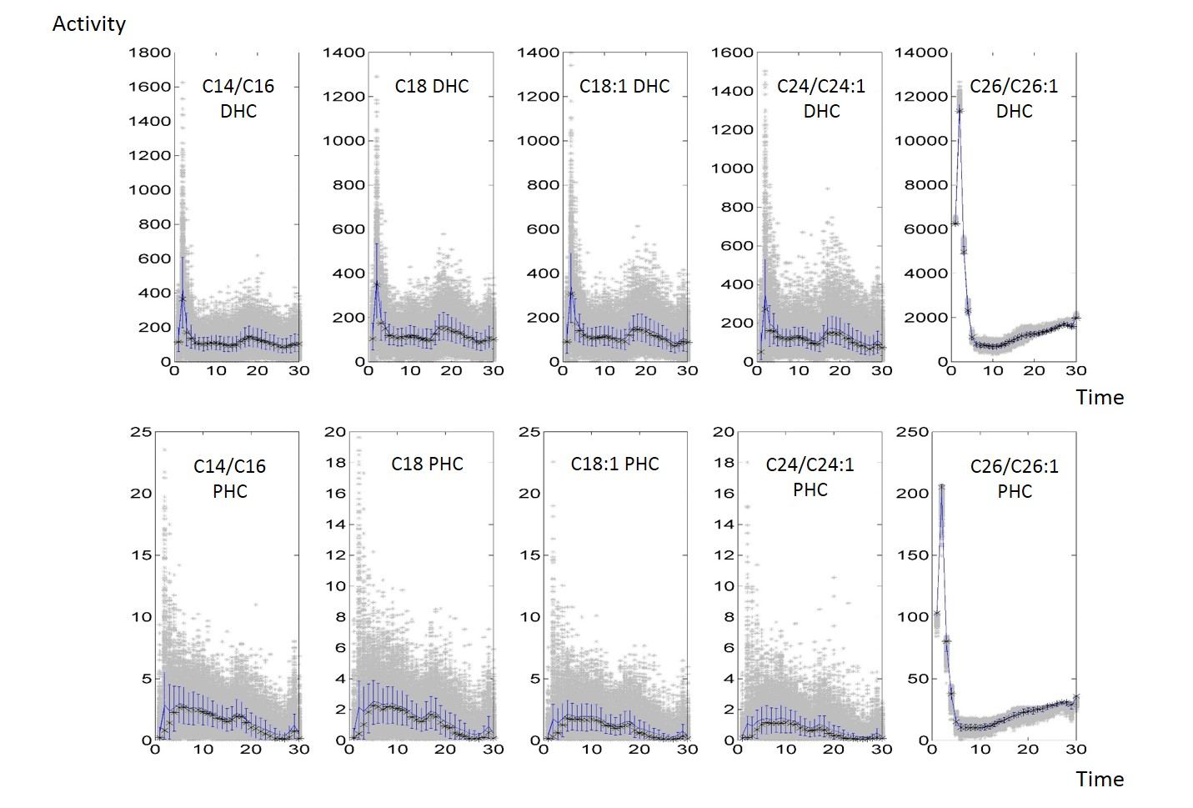
Dihydroceramidase & Phytoceramidase
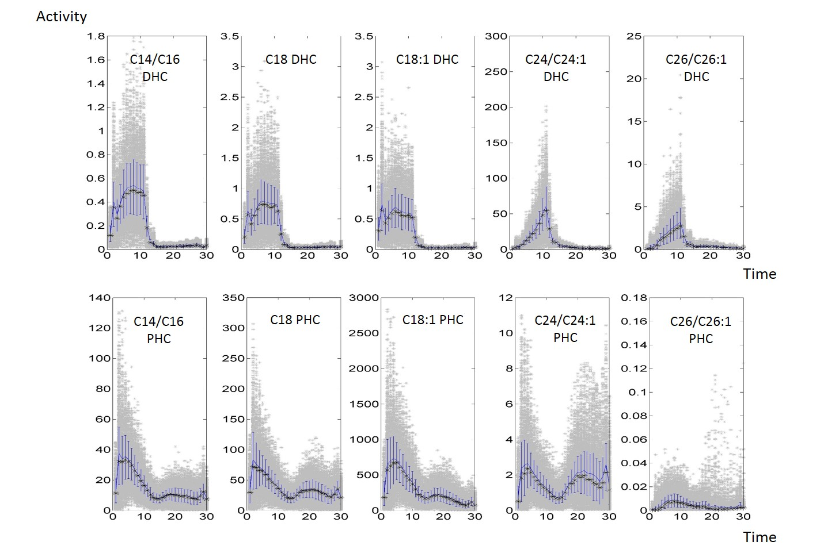
IPC synthase
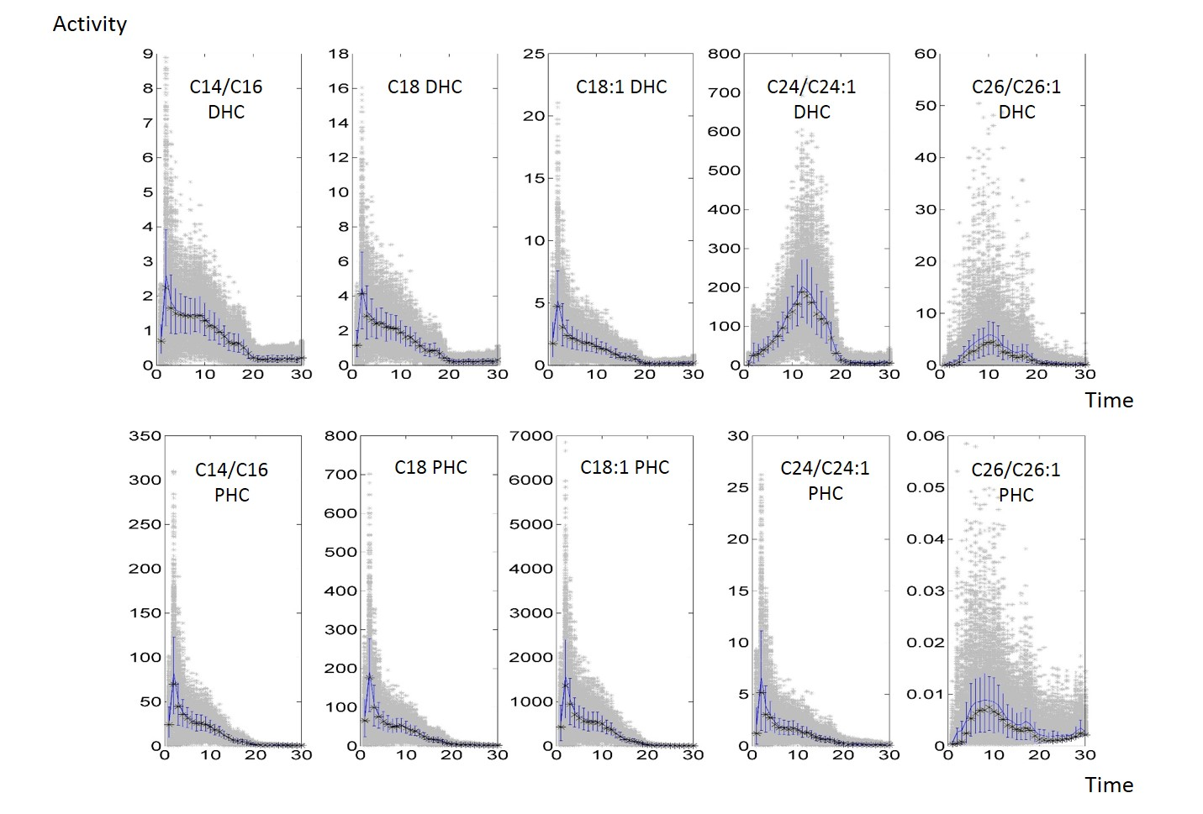
IPCase
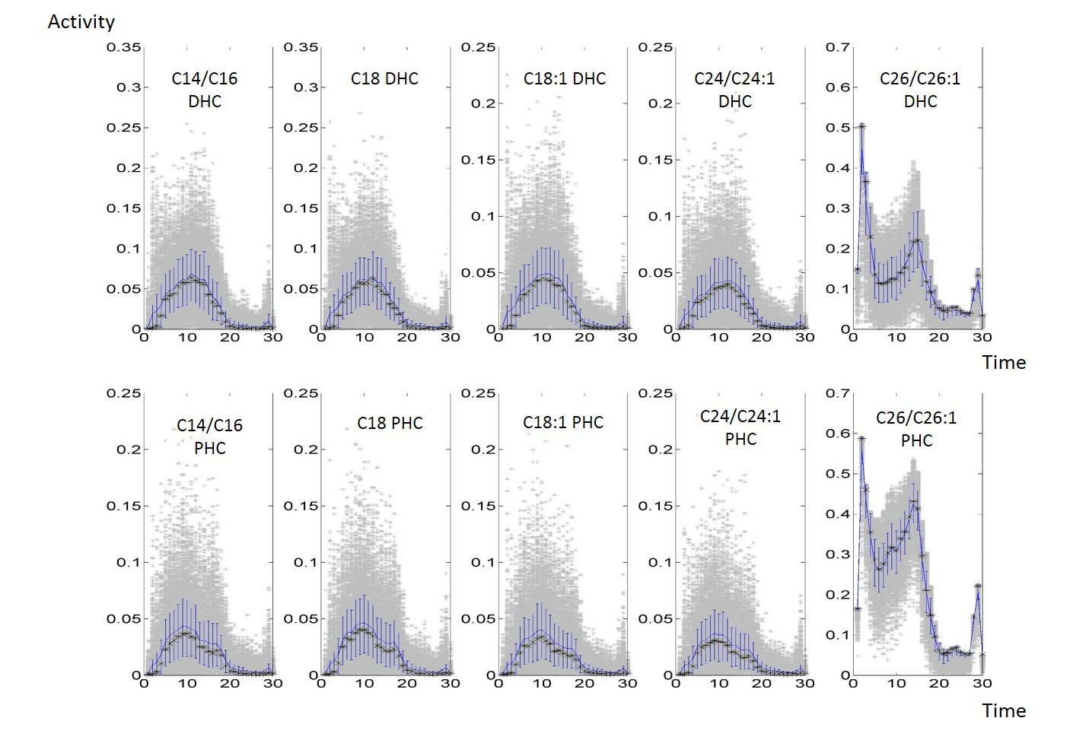

Hydroxylase
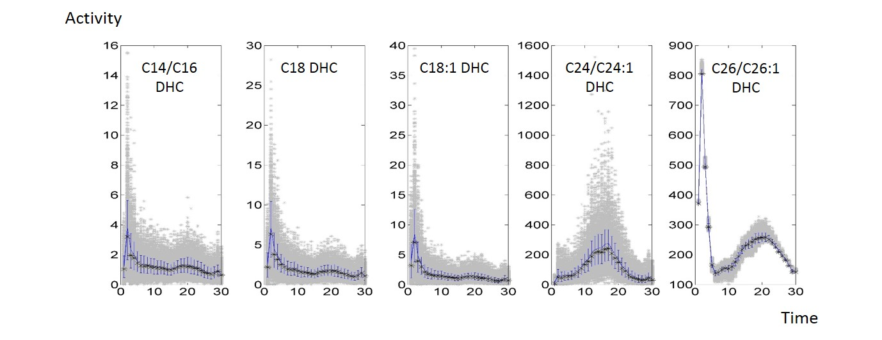

Elongases 1, 2, 3, Remodelase, and Desaturase
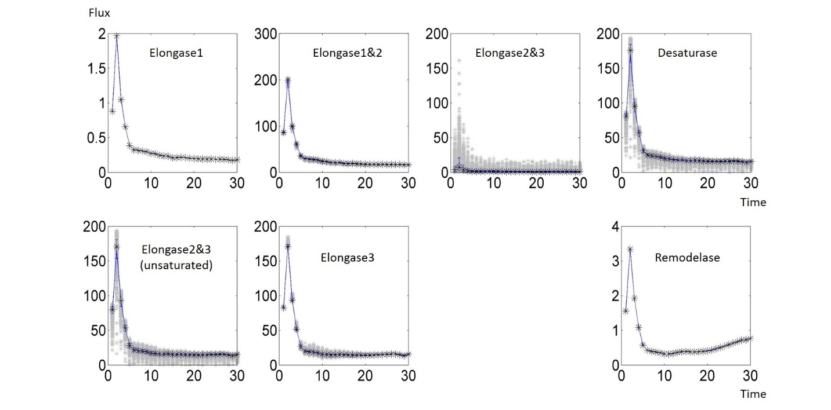
Figure S2: Simulation results for enzyme activities over time, as well as means (blue), medians (black asterisks), and 20th and 80th percentiles (blue bars). Compare with Fig. 11 in the Text.

