Supplemental file 7
C. Brandon Ogbunugafor and Daniel L. Hartl
A New Take on John Maynard Smith's Concept of Protein-Space for Understanding Molecular Evolution

Two letter U.S. state abbreviation 1-grams example

To further illustrate how the Google Books Ngram Viewer can be used to rewire the John Maynard Smith analogy into a way to explore the adaptive landscape concept, we can use a simple example: transitions between two-letter 1-grams involving abbreviations for U.S. States. We’ll use the transition from WV, the abbreviation for the state of West Virginia, into NY, the abbreviation for the state of New York.

WVNY

We can also represent these n-grams in bit string notation:

0011

Where WV = 00 and NY = 11.

In this scenario, there will be N! pathways between 00 and 11, or 2 for a two letter 1-gram (2!). For this transition, we can represent all “pathways” between the WV and NY with:

000111 = WVWYNY
001011 = WVNVNY

For this example, both pathways appear accessible, as the intermediates (WY and NV) correspond to actual state abbreviations (Wyoming and Nevada, respectively). The problem is that the original JMS analogy didn’t intend to discuss the concept of the adaptive landscape, and so offered no means of differentiating between the likelihood of these two pathways.

Using the Google Books Ngram Viewer described above (and in Box 1), we can create a table of n-gram fitness values (n-gram frequencies) for the individual two-letter 1-grams from 1800 to 2000 (Table S1). From this, we can reconstruct the n-grams into discrete pathways (S1 Fig.). A pathway is accessible if each step consisted of a word (1-gram) that was used more frequently than the previous word in the path. We can observe that in the year 2000, both pathways between WVNY are feasible, but to a slightly different degree: In 2000, NV (Nevada) has higher n-gram fitness than Wyoming (WY), and is therefore a higher fitness intermediate, making its pathway (WVNVNY) more likely. Note, however, that in our data set, the 1800 and 1900 trajectories present a different scenario: neither NV nor WY have a higher fitness than WV, suggesting that routes to NY are unlikely in either of these environments. This is another illustration of a key point: how gene by environment interactions (G x E) create changes in adaptive landscape structure and alter the feasibility of certain trajectories (as discussed in the main text).

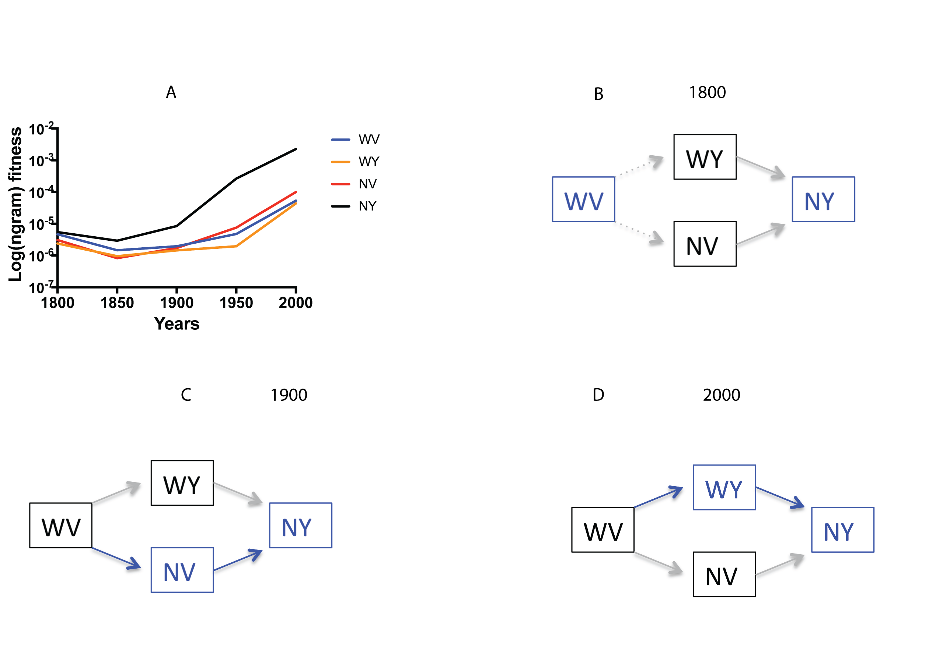
S7A-D Fig. Creating a model two-letter 1-gram adaptive trajectory: WVNY. (A) Ngram Fitness values for the alleles composing the landscape across environments (year), plotted on a log scale (y-axis). From the information in (A), we can identify probable pathways between 1-grams in (B) 1800, (C) 1900 and (D) 2000. In this example, we observe that the transition between WVNY is unlikely at 1800 and 1900 because WV has higher n-gram fitness than either intermediate (WY or NV). By 2000 this has changed, with NV having high n-gram fitness than the starting “allele,” WV (and higher than that of WY), revealing an accessible pathway through sequence space between WV and NY: WVNVNY. Note that in 2000, WVWYNY is also accessible by our criteria (increasing fitness with Hamming distance from WV to NY). However, because NV has higher n-gram fitness than WY, the more probable pathway is WVNVNY. In Supplemental File 3, we discuss how to examine this scenario using simulations of evolution.

State Abbreviation | 1-gram frequency score  (Year 1800) | 1-gram frequency core  (Year 1850) | 1-gram frequency score  (Year 1900) | 1-gram frequency score  (Year 1950) | 1-gram frequency score  (Year 2000)
WV | 4.69E-06 | 1.48E-06 | 1.97E-06 | 4.81E-06 | 5.38E-05
WY | 2.40E-06 | 9.58E-07 | 1.46E-06 | 1.96E-06 | 4.39E-05
NV | 3.10E-06 | 8.29E-07 | 1.73E-06 | 7.64E-06 | 1.01E-04
NY | 5.49E-06 | 2.94E-06 | 8.57 E-06 | 2.68E-04 | 2.27E-03

S7 Table. N-gram frequency scores (Ngram fitness) for several U.S. state abbreviations (WV, WY, NV, NY) for five different years from (1800, 1850, 1900, 1950, 2000). Note that these frequency scores apply to the case sensitive versions of the words, because state abbreviations, written correctly, are always uppercase.

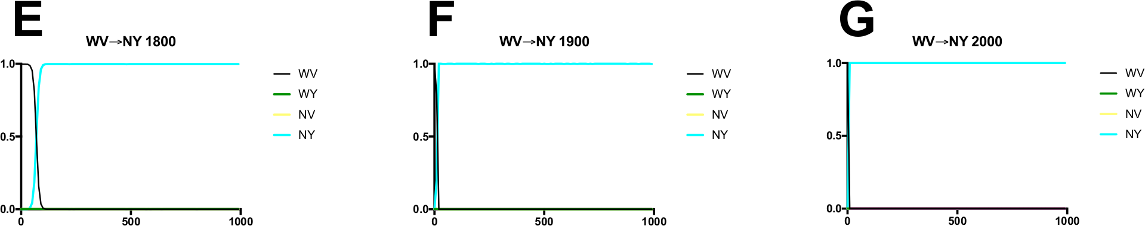

S7E-G Figs. Simulations of evolution across the WVNY landscape. These are illustrative examples of the results of simulations of evolution from WV to NY across several environments: (A) 1800, (B) 1900 (C) 2000, using simuPOP, as mentioned in Supplemental File 3. The mutation rate in this experiment is on the order of 1 mutation per replication, and they were run for 1000 generations (100,000 individuals). We can observe that leaving the WV peak is slightly more difficult to do in 1800 than in 1900 or 2000, as it takes slightly longer for the NY “allele” to take over the population.

