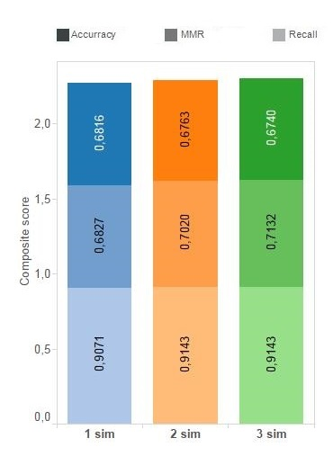
S1 Fig. Effect of the number of considered simulations on qualitative predictions. The increase in the number of simulation runs considered in SiComPre shows only a slight improvement of MMR and recall, but the accuracy decreases after two runs. This was checked only for the yeast data as the annotation of human complexes is much sparser.

