S6 Table
Compound | Structure |  | Glide Score
1 | 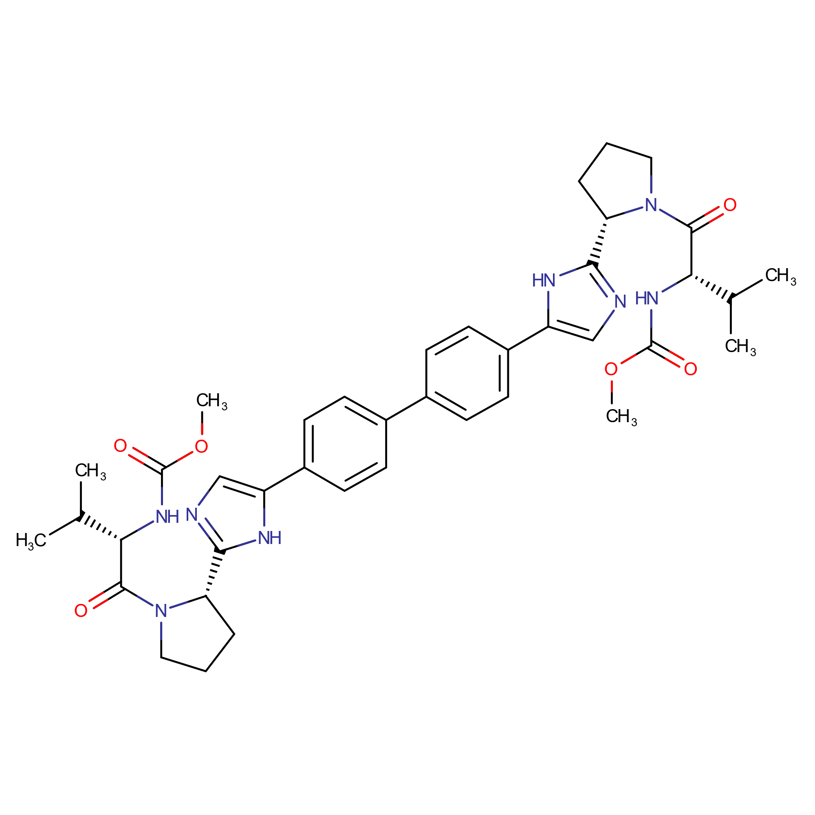 | -5.6
2 | 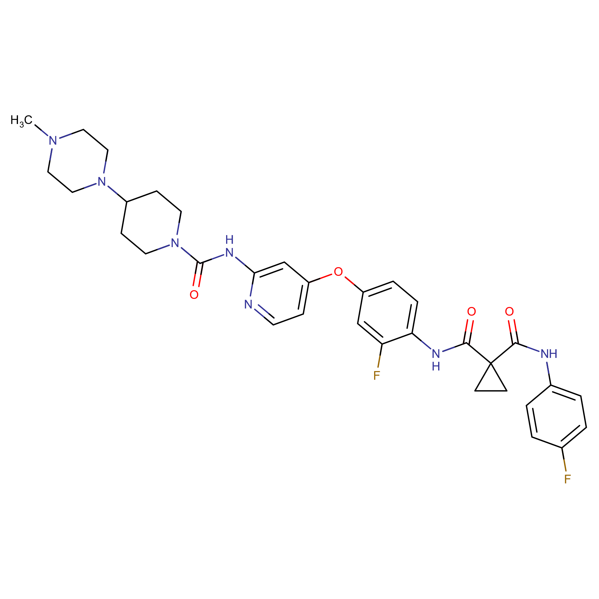 | -5.9
3 | 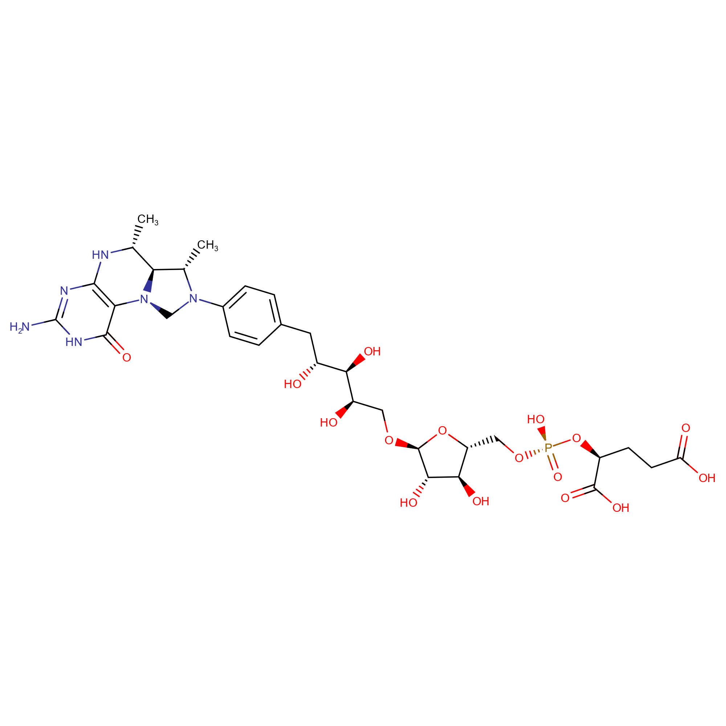 | -9.4
4 | 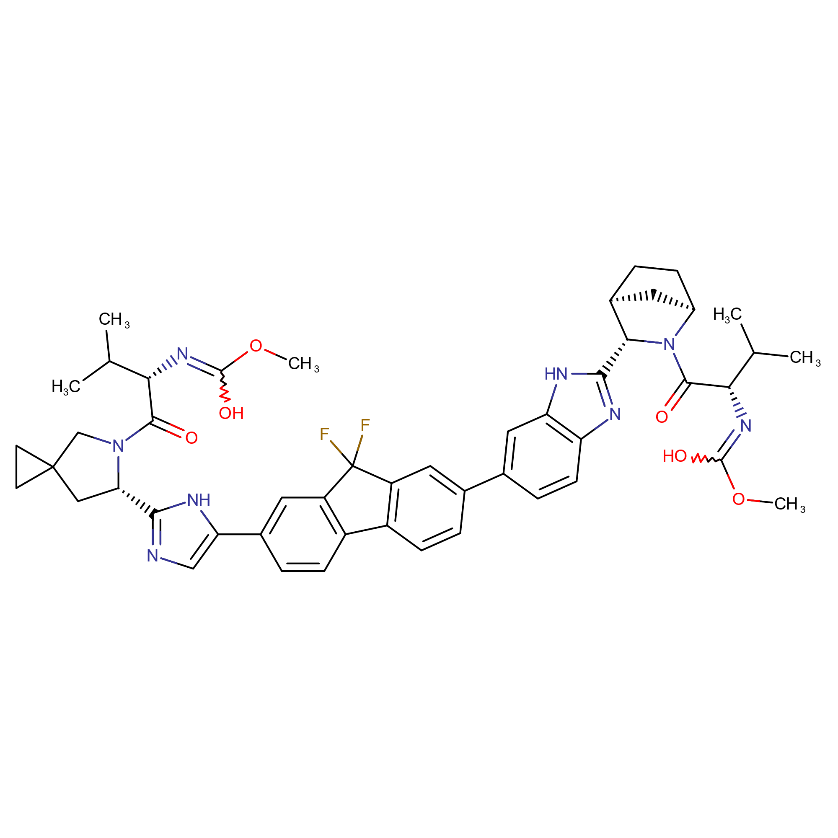 | -6.3

