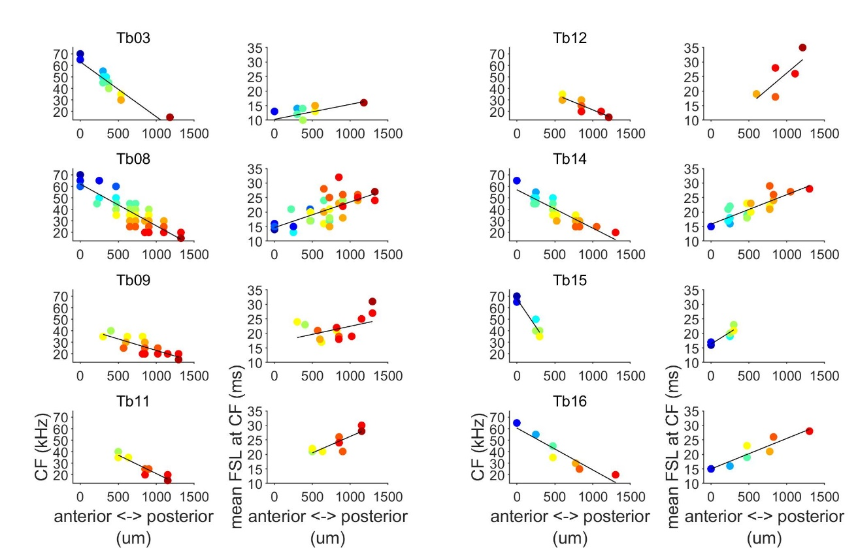
S1. Fig. Topography of characteristic frequency (CF) and mean first spike latency (FSL) in the A1. CF and mean FSL as a function of the cortical anterior-posterior position in each bat included in this study. CF is color coded similar to Fig. 2. Black lines represent the best fitted curves of the linear regression analyses. Data underlying this figure can be found at https://doi.org/10.18738/T8/GLVN1J

